Connecting to Spark

Let’s take a stab at running Spark on Docker. As part of this effort, we will also attempt to set up Jupyter Notebook on AWS EC2.

**EC2 Instance With Internet Connection** **2**

Properly Configuring EC2 2

SSH into EC2 and Starting a Webserver 6

**Installing Docker on EC2** **8**

Install Docker 8

Install Docker-Compose 9

**Jupyter Notebook and Apache Spark** **10**

Run jupyter/pyspark-notebook Image 10

Tweaking Docker Settings 12

Installing Dependencies in Jupyter 16

**Simple CitiBike Analysis** **16**

Pandas Analysis 16

# 

# 

# 

# 

# 

# 

# 

# 

# EC2 Instance With Internet Connection

First, we begin by configuring and building an EC2 instance that can connect to the internet. By “connect to the internet”, we mean that the EC2’s public IP address (the thing we use to SSH into the devices) must be accessible via the web browser.

## Properly Configuring EC2

We begin by creating a new EC2 instance. First, sign in to AWS and navigate to the EC2 landing page. Then, launch a new instance.

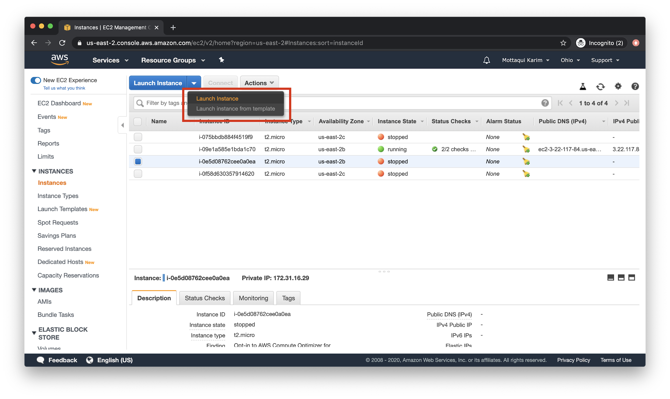

Next, as per usual - pick the instance type. Let’s go with the **free tier**only options and **Ubuntu 18**.

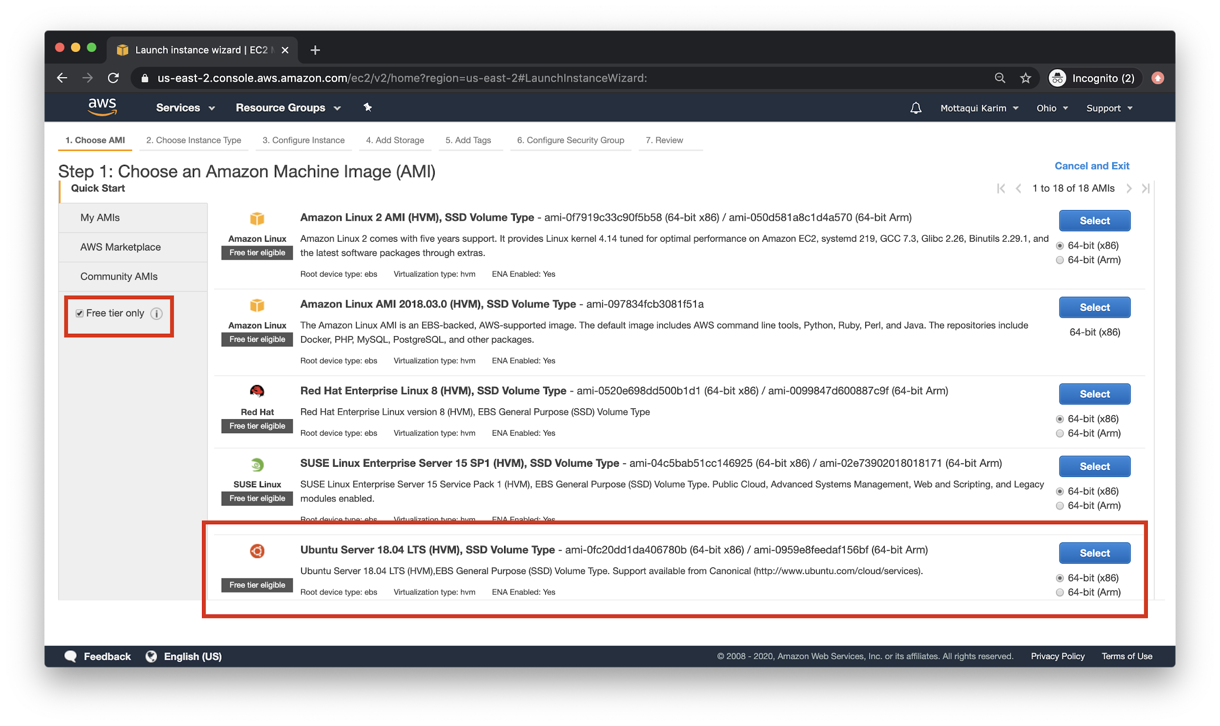

After that - choose an instance type. Again, let’s pick the free tier eligible option. Once chosen, click on the top bar step **6. Configure Security Group**.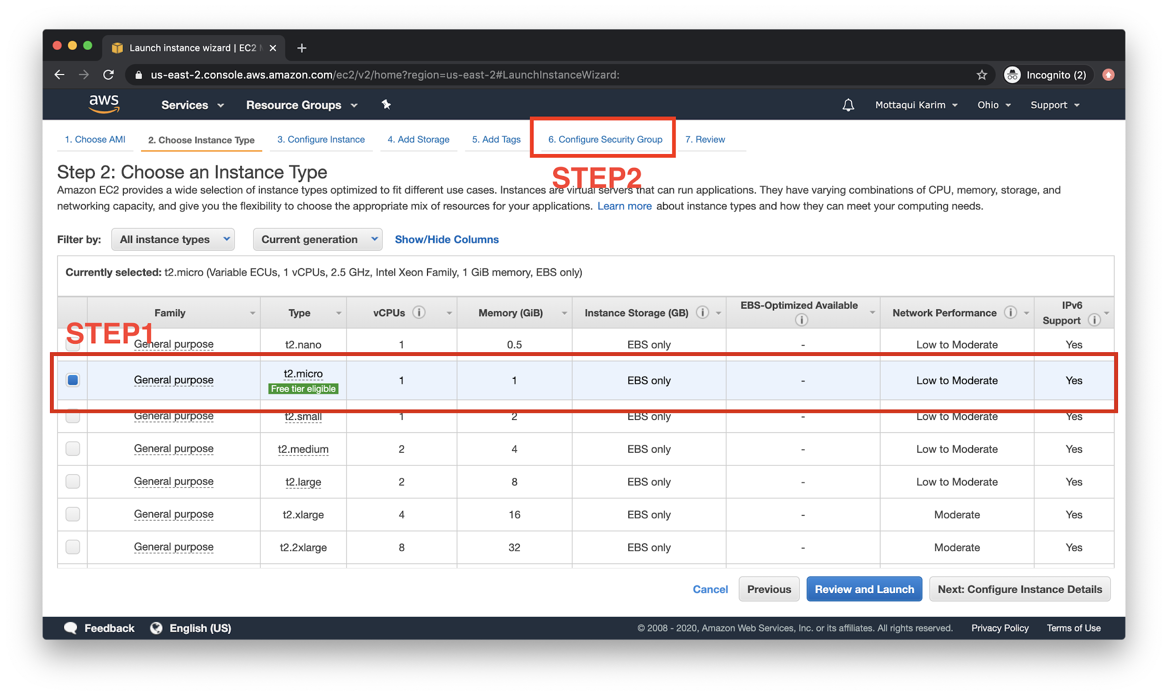

Next, name your security group something familiar: I went with **spark-ec2**.

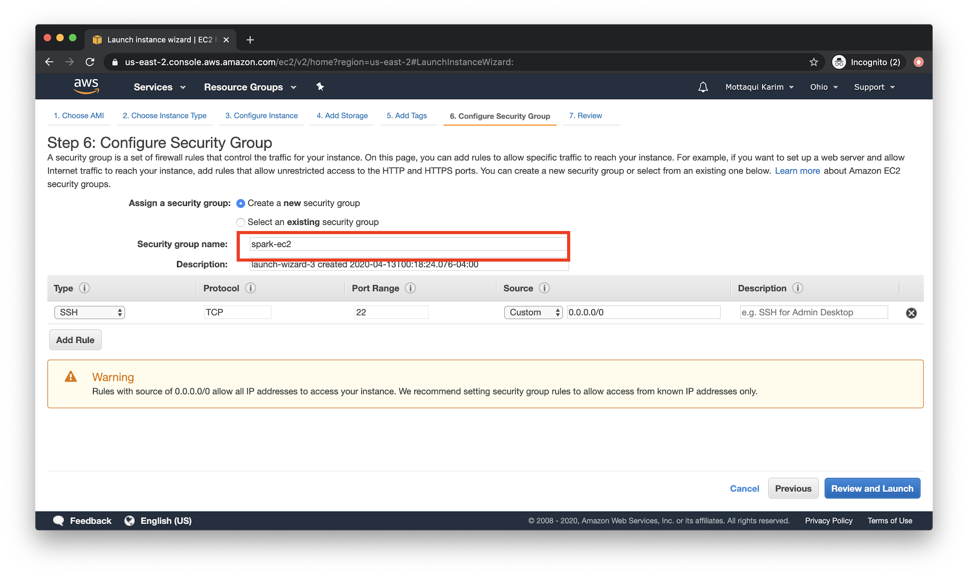

Ok, here comes the most important parts: setting up rules:

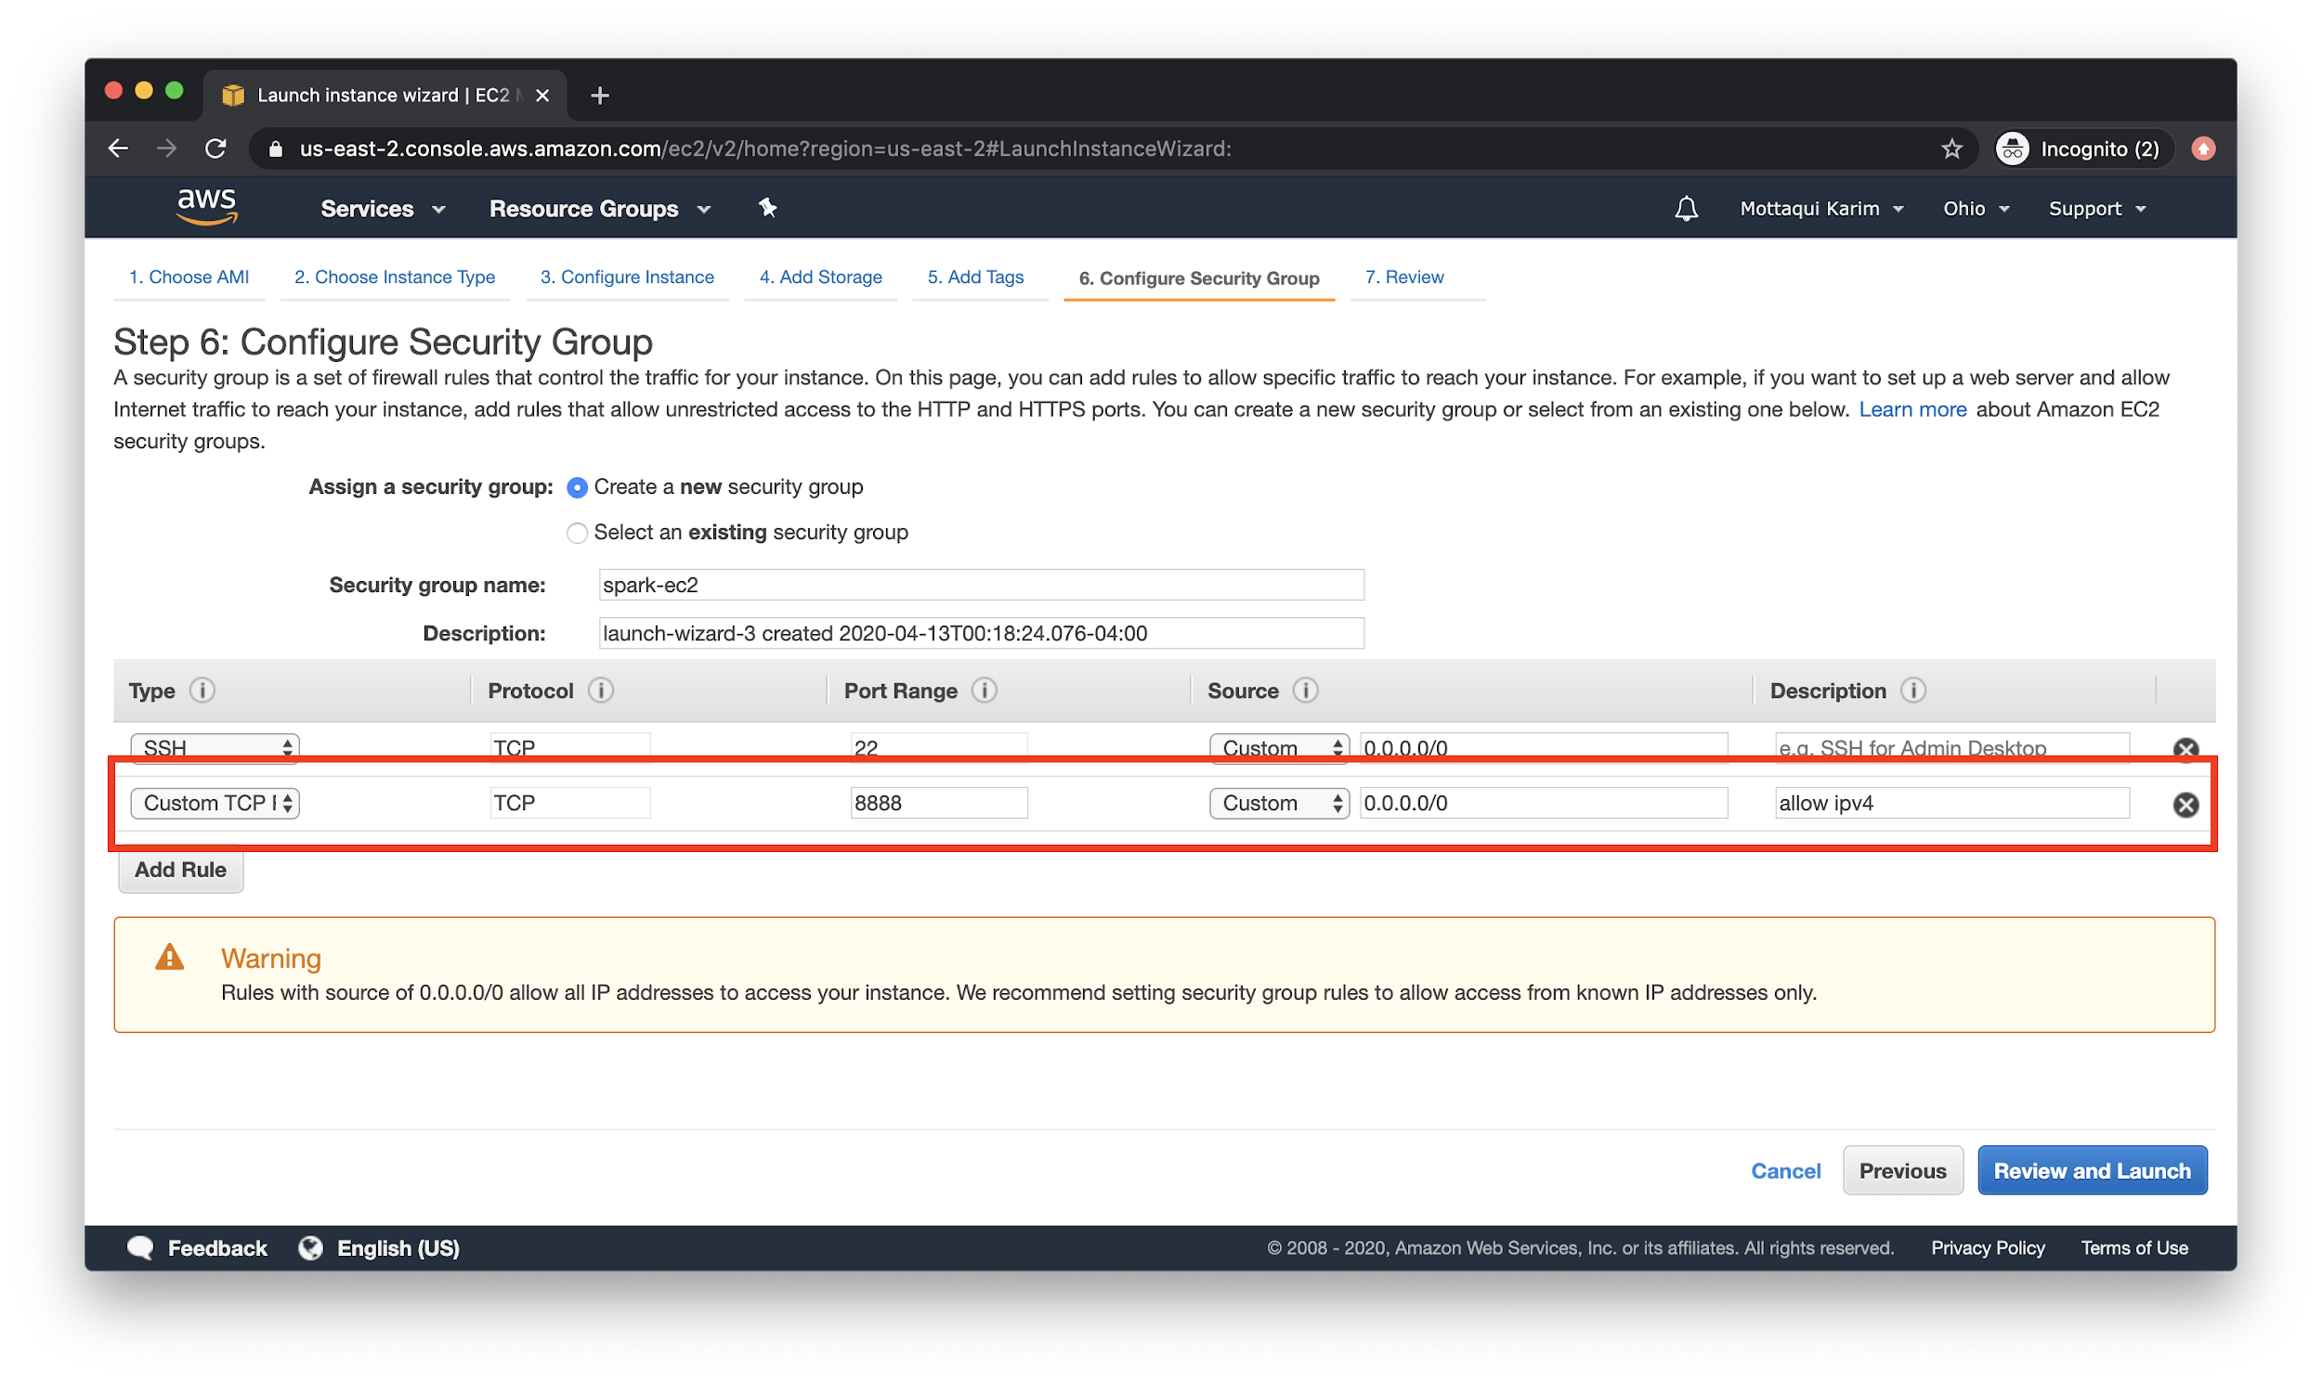

You want to paste this in **exactly**. Here it is in tabular form:

|  |  |  |  |  |
| --- | --- | --- | --- | --- |
| **Custom TCP** | TCP | 8888 | 0.0.0.0/0 | desc |

This will allow the “outside” world to access your EC2 instance at a specific port, in this case **8888.** If you wanted to listen on multiple ports (for instance, if you wanted your EC2 instance to support multiple webpages or pipelines) then you would add a line item per port, as seen above.

Now repeat, but for **ipv6**:

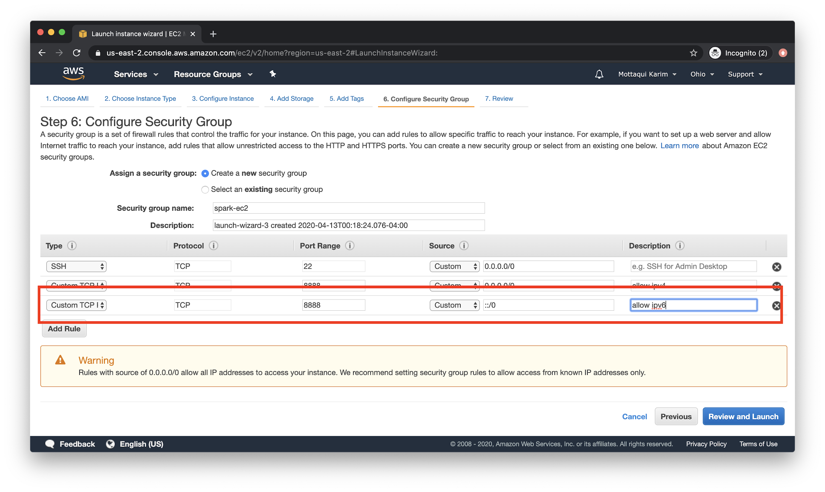

Again, in table form:

|  |  |  |  |  |
| --- | --- | --- | --- | --- |
| **Custom TCP** | TCP | 8888 | ::/0 | desc |

Great, double check these values again! If you’re certain you are good to go, then go on to **Review and Launch**:

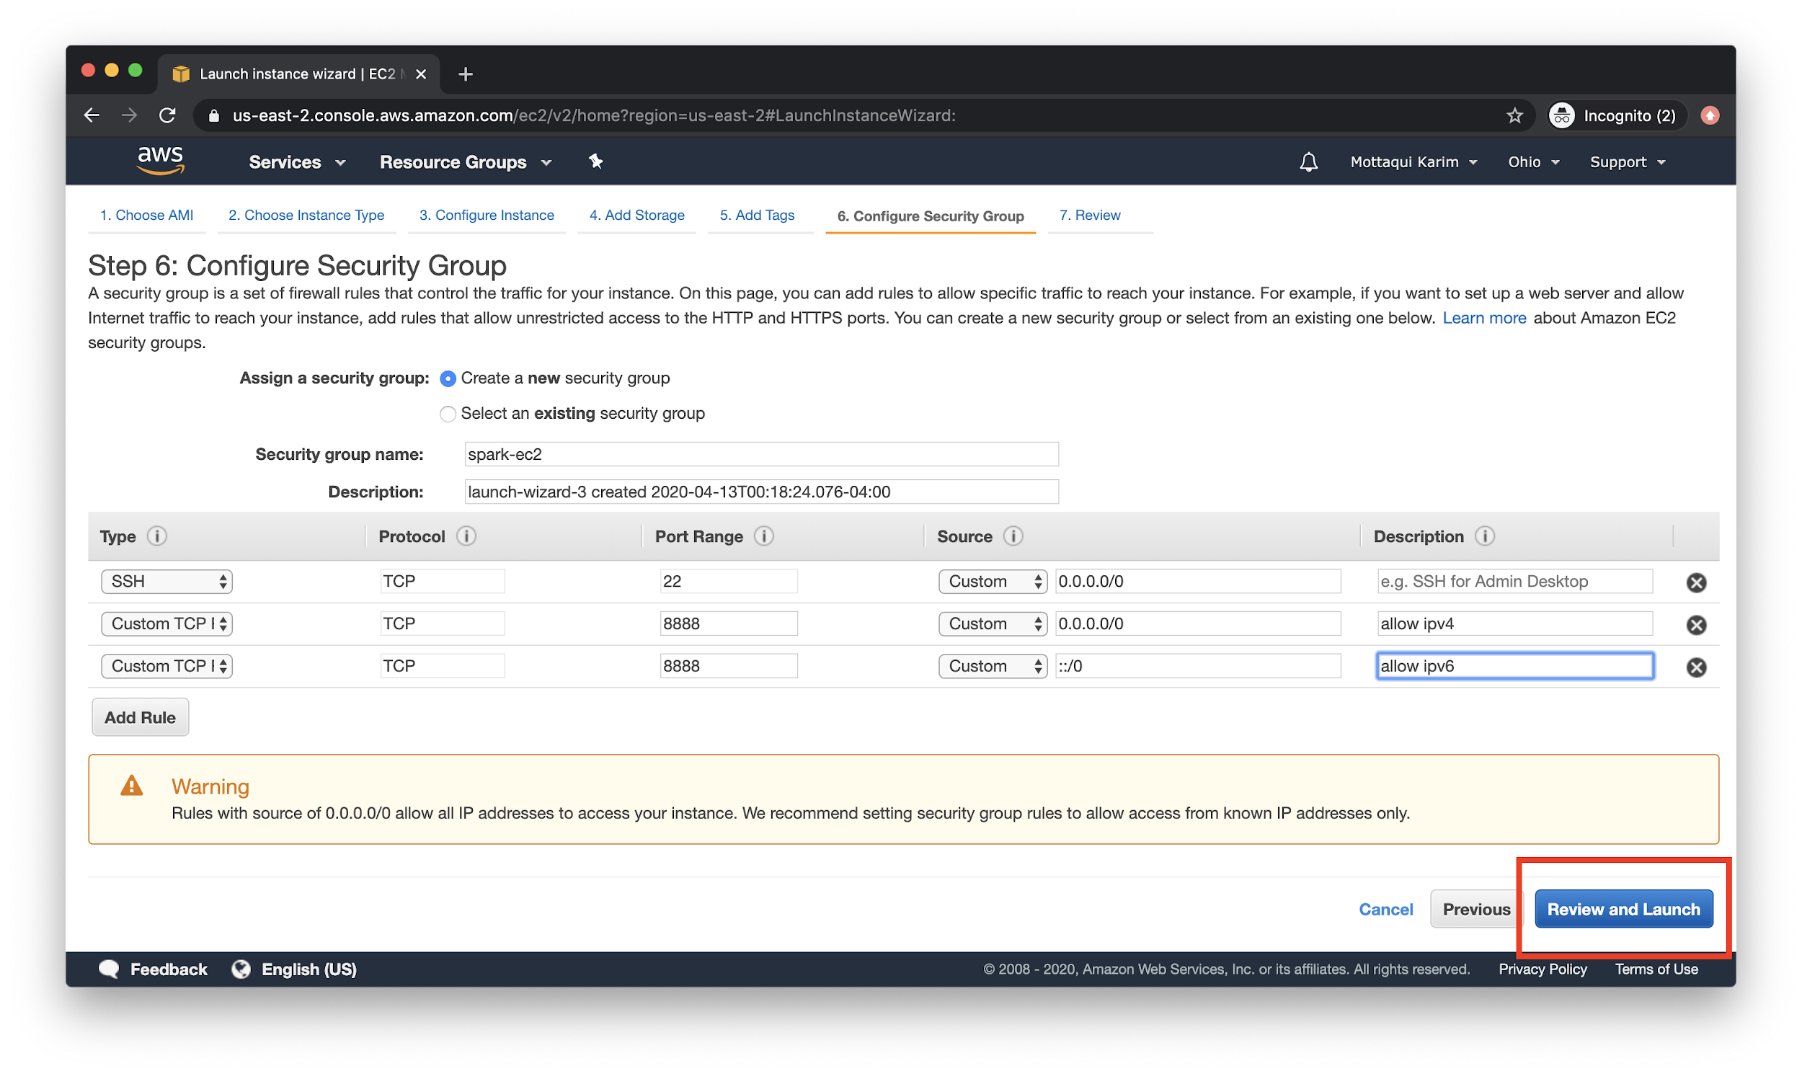

If you did it correctly, you should see a dire warning from Amazon about how your instance is open to the world. For now, this is fine and actually expected - as you are setting up a website that will be available from browsers anywhere! Hit **Launch**, it’s time to start this instance..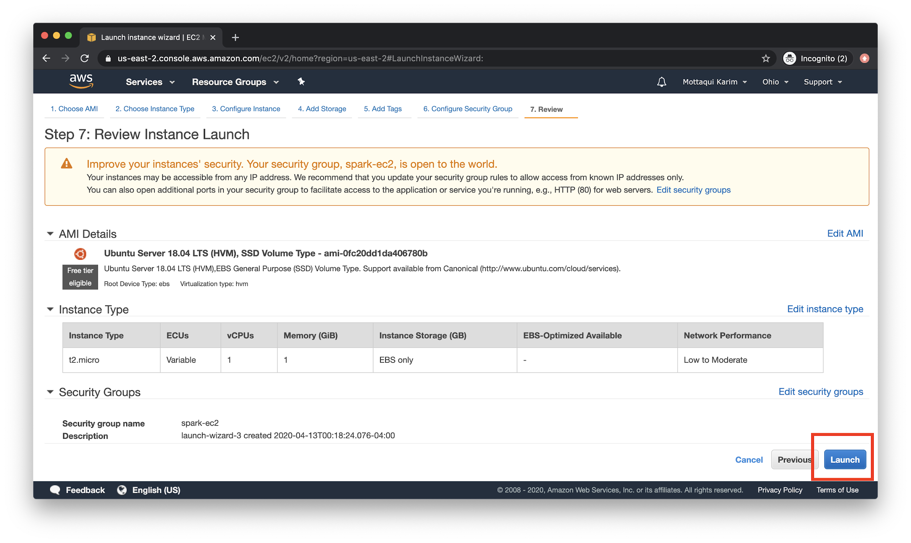

You will be prompted to create or choose a key pair. Remember, **you can only do this once**. As such, if you are not sure where you downloaded the **.pem** files last - just recreated a new one. **Don’t forget to download it** and store it in a place you can easily find it again later, like **Desktop** or **Downloads**.

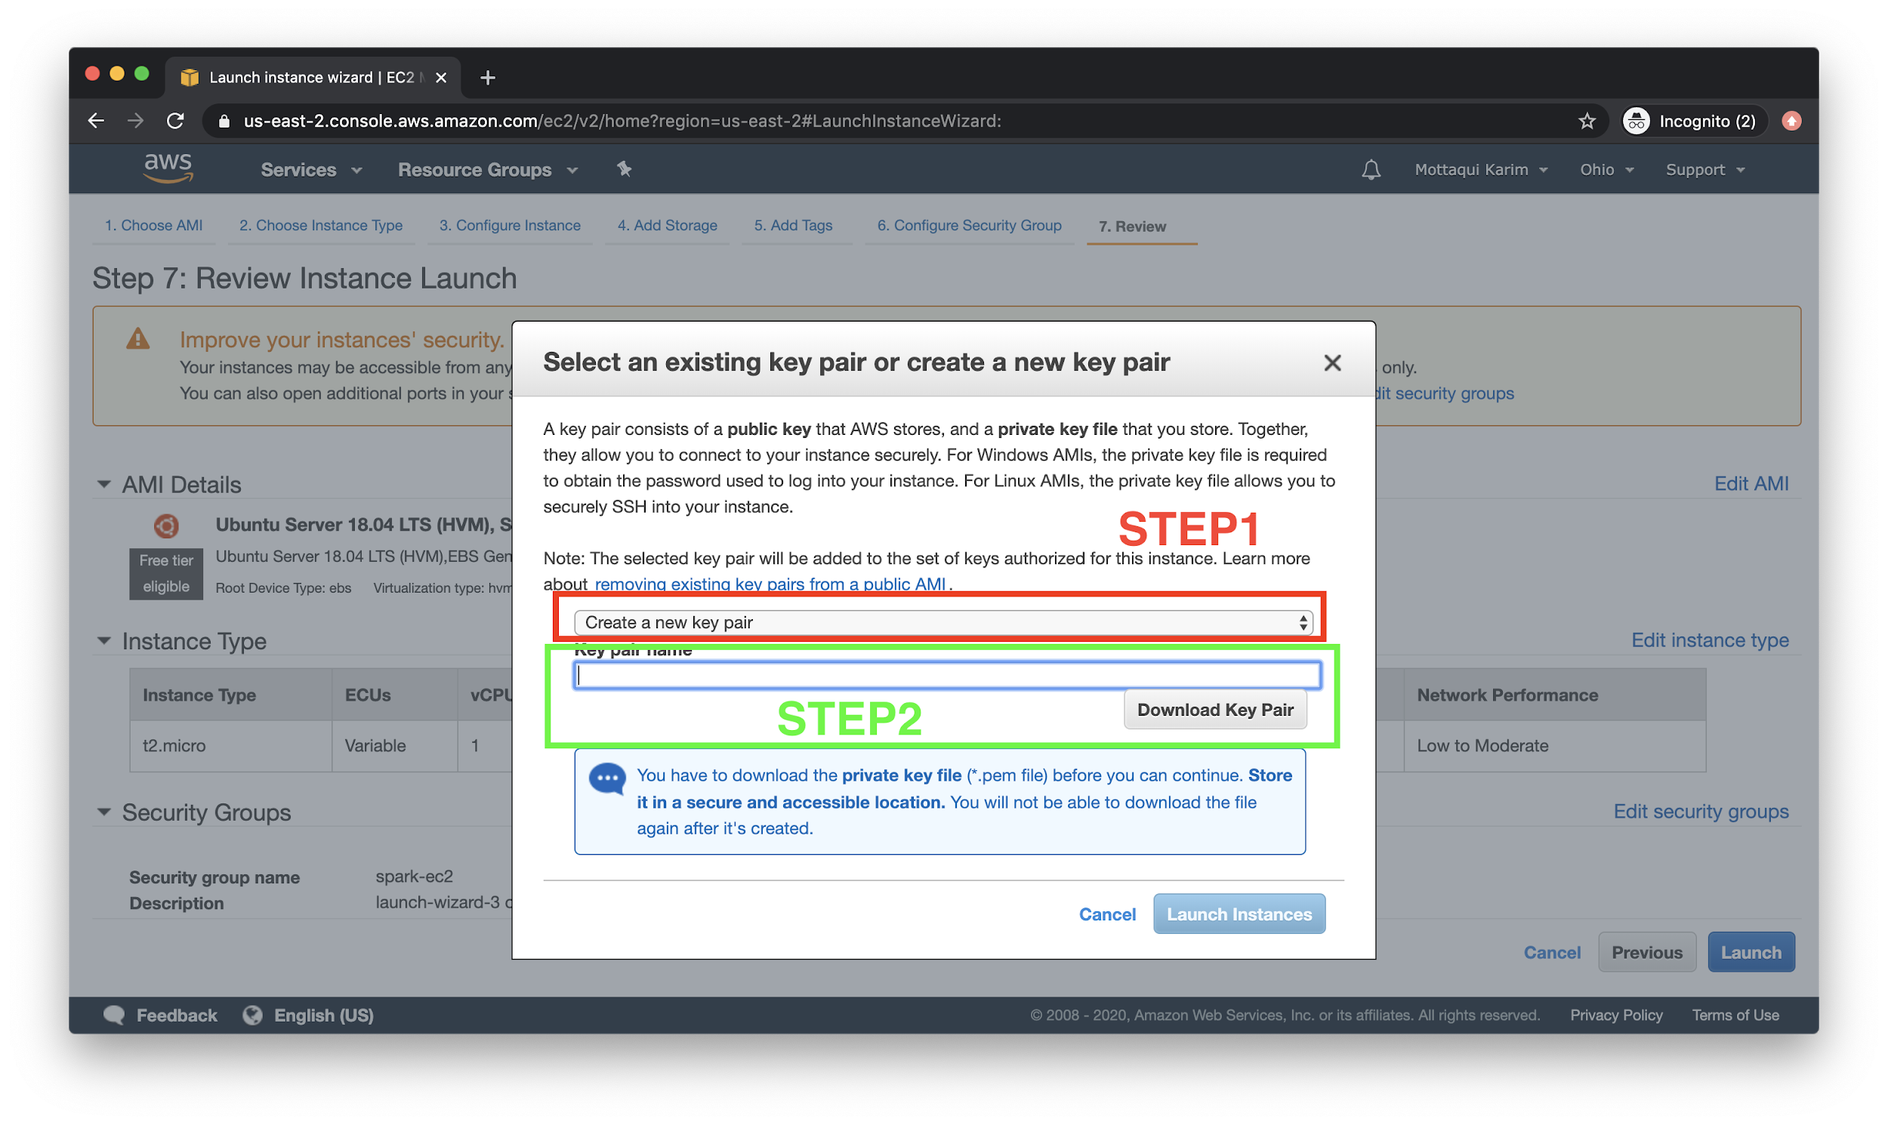

If all is said and done, you should see a screen like below. Click on the EC2 ID to go back to the EC2 homepage, which should now display your instance as it is booting.

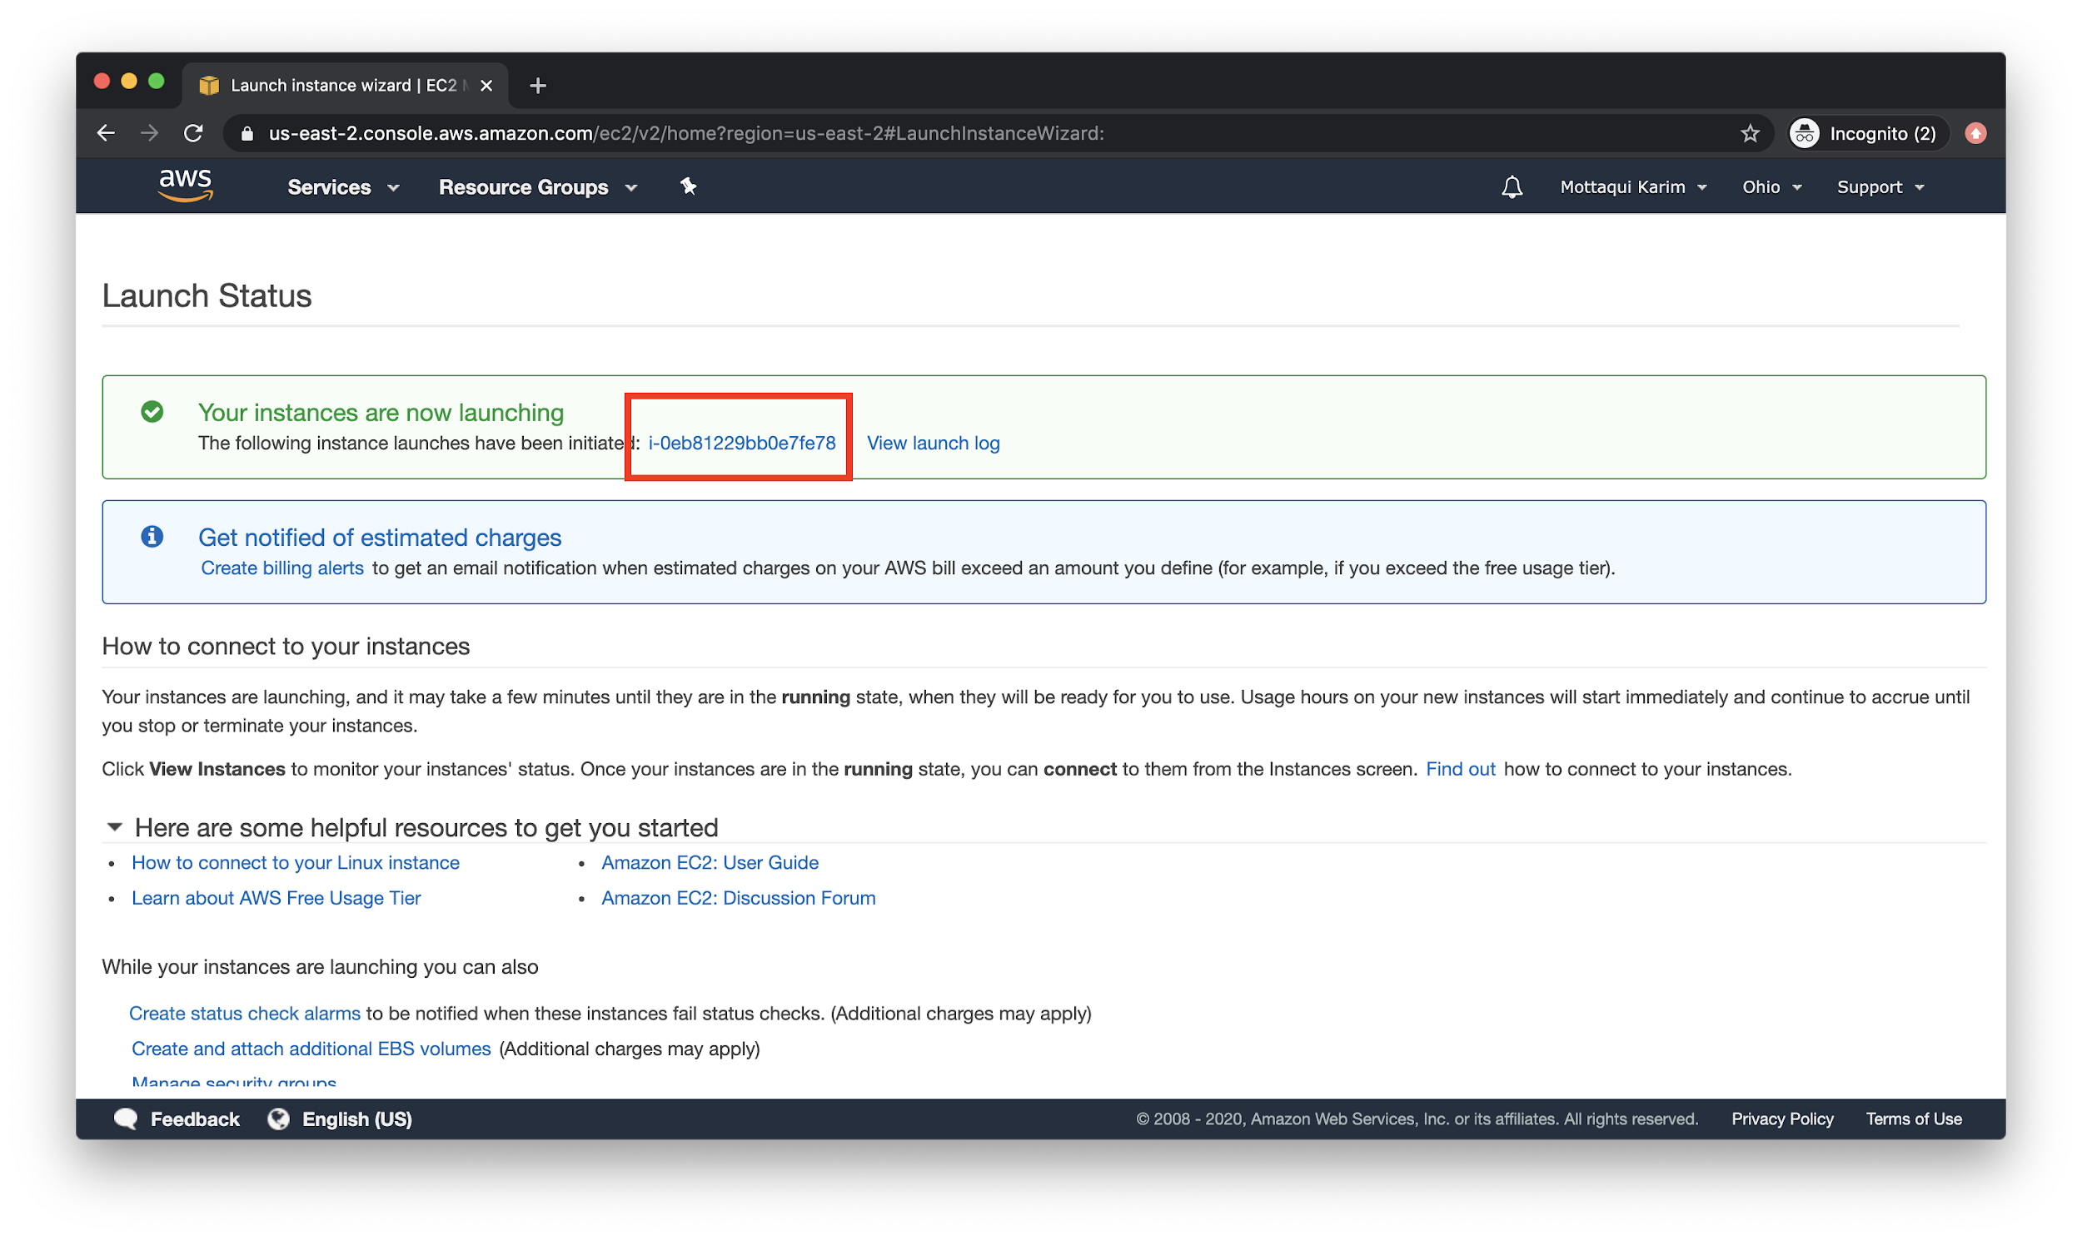

Now, grab the **public IP address** of your instance, it is time to SSH in to our machine and set up a simple webpage.

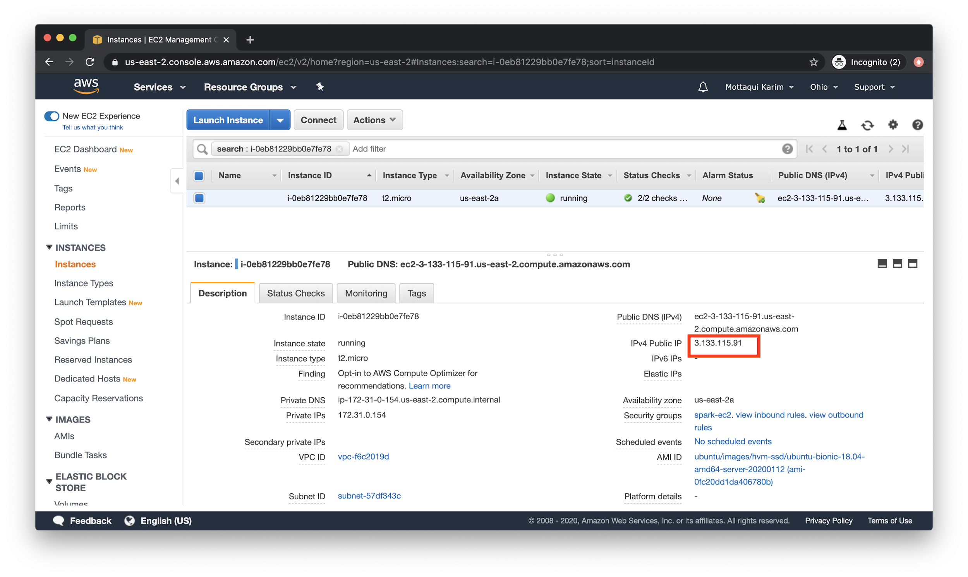

## SSH into EC2 and Starting a Webserver

To SSH into your EC2 instance, first - copy the **public ip** address from the screen above. Then, navigate to your terminal and make sure to **chmod 0400** the key file downloaded from before.

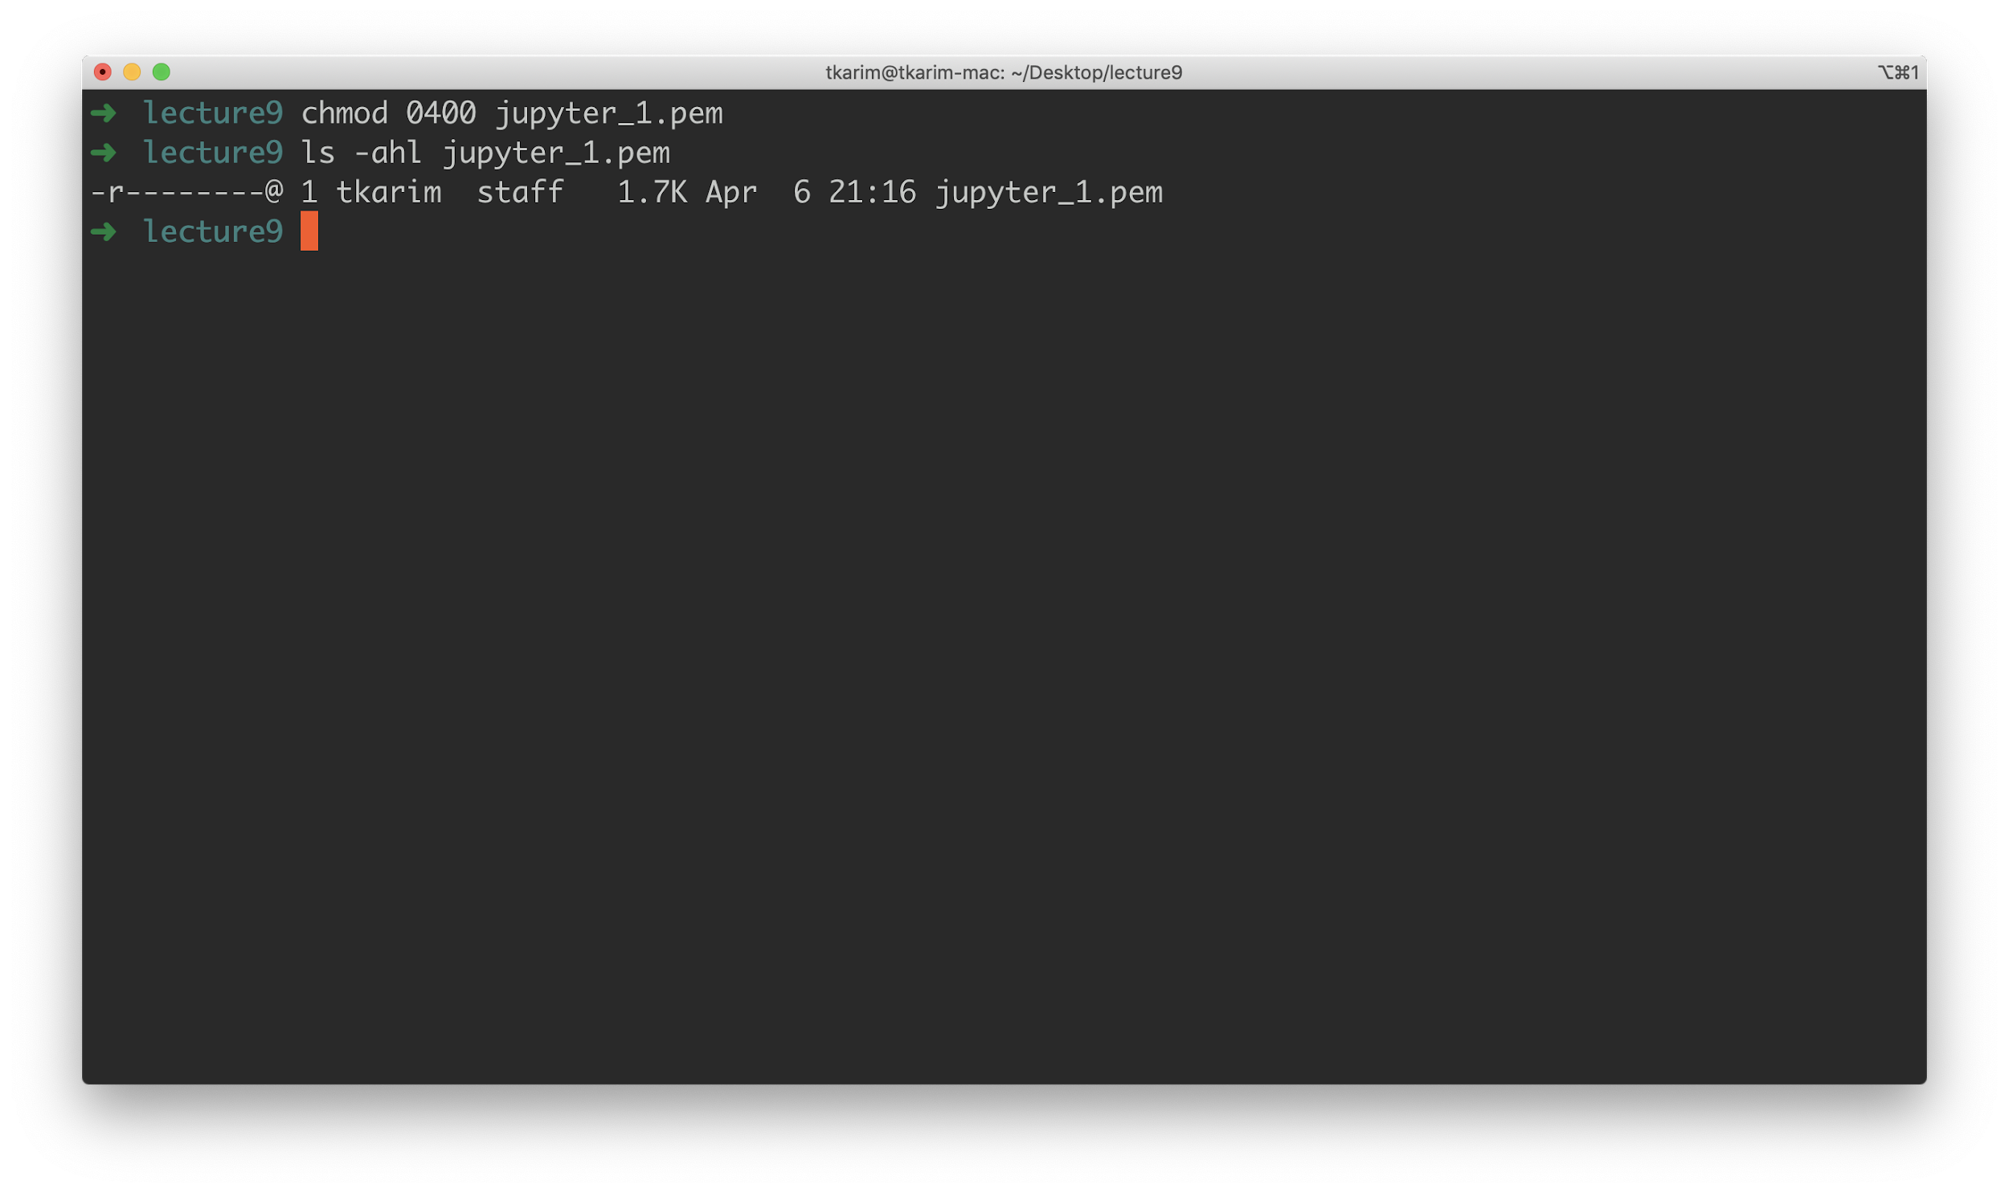

Then, from the **same folder** that you have your **.pem** file stored, run the **ssh** command to log into EC2.

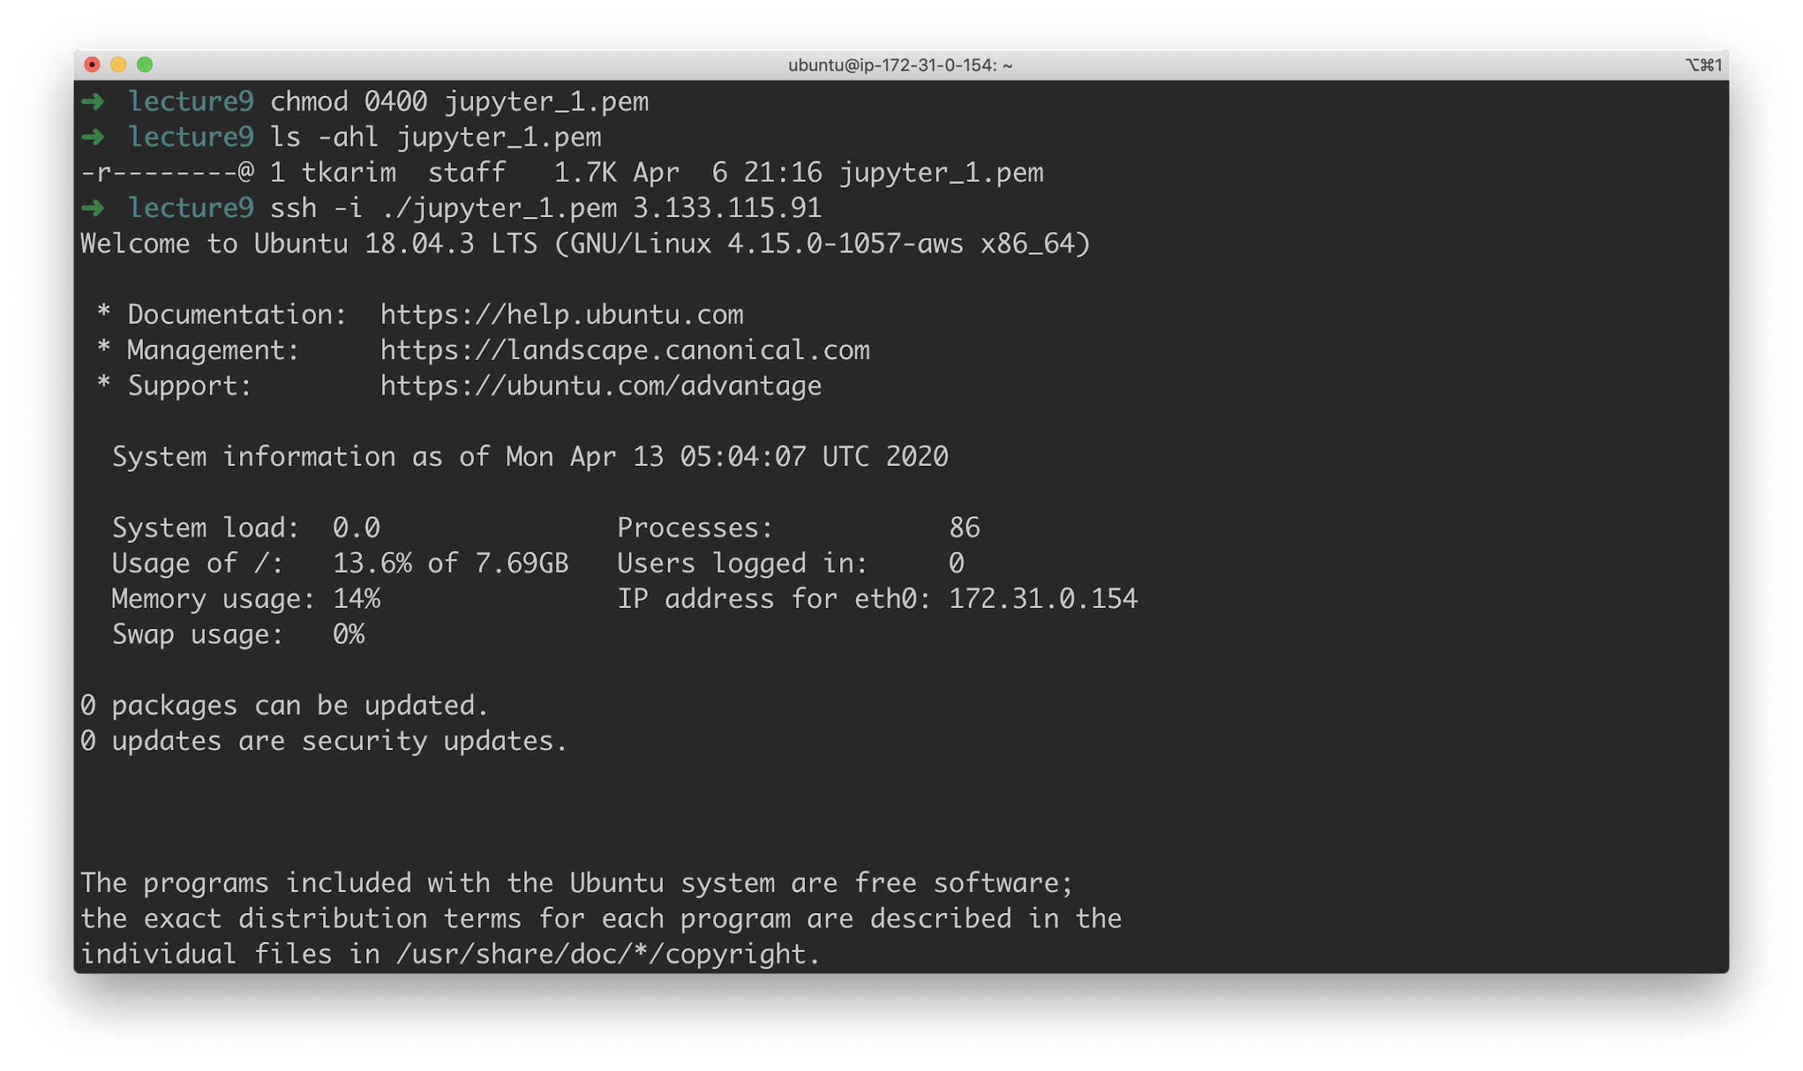

If it works, you should see something like this:

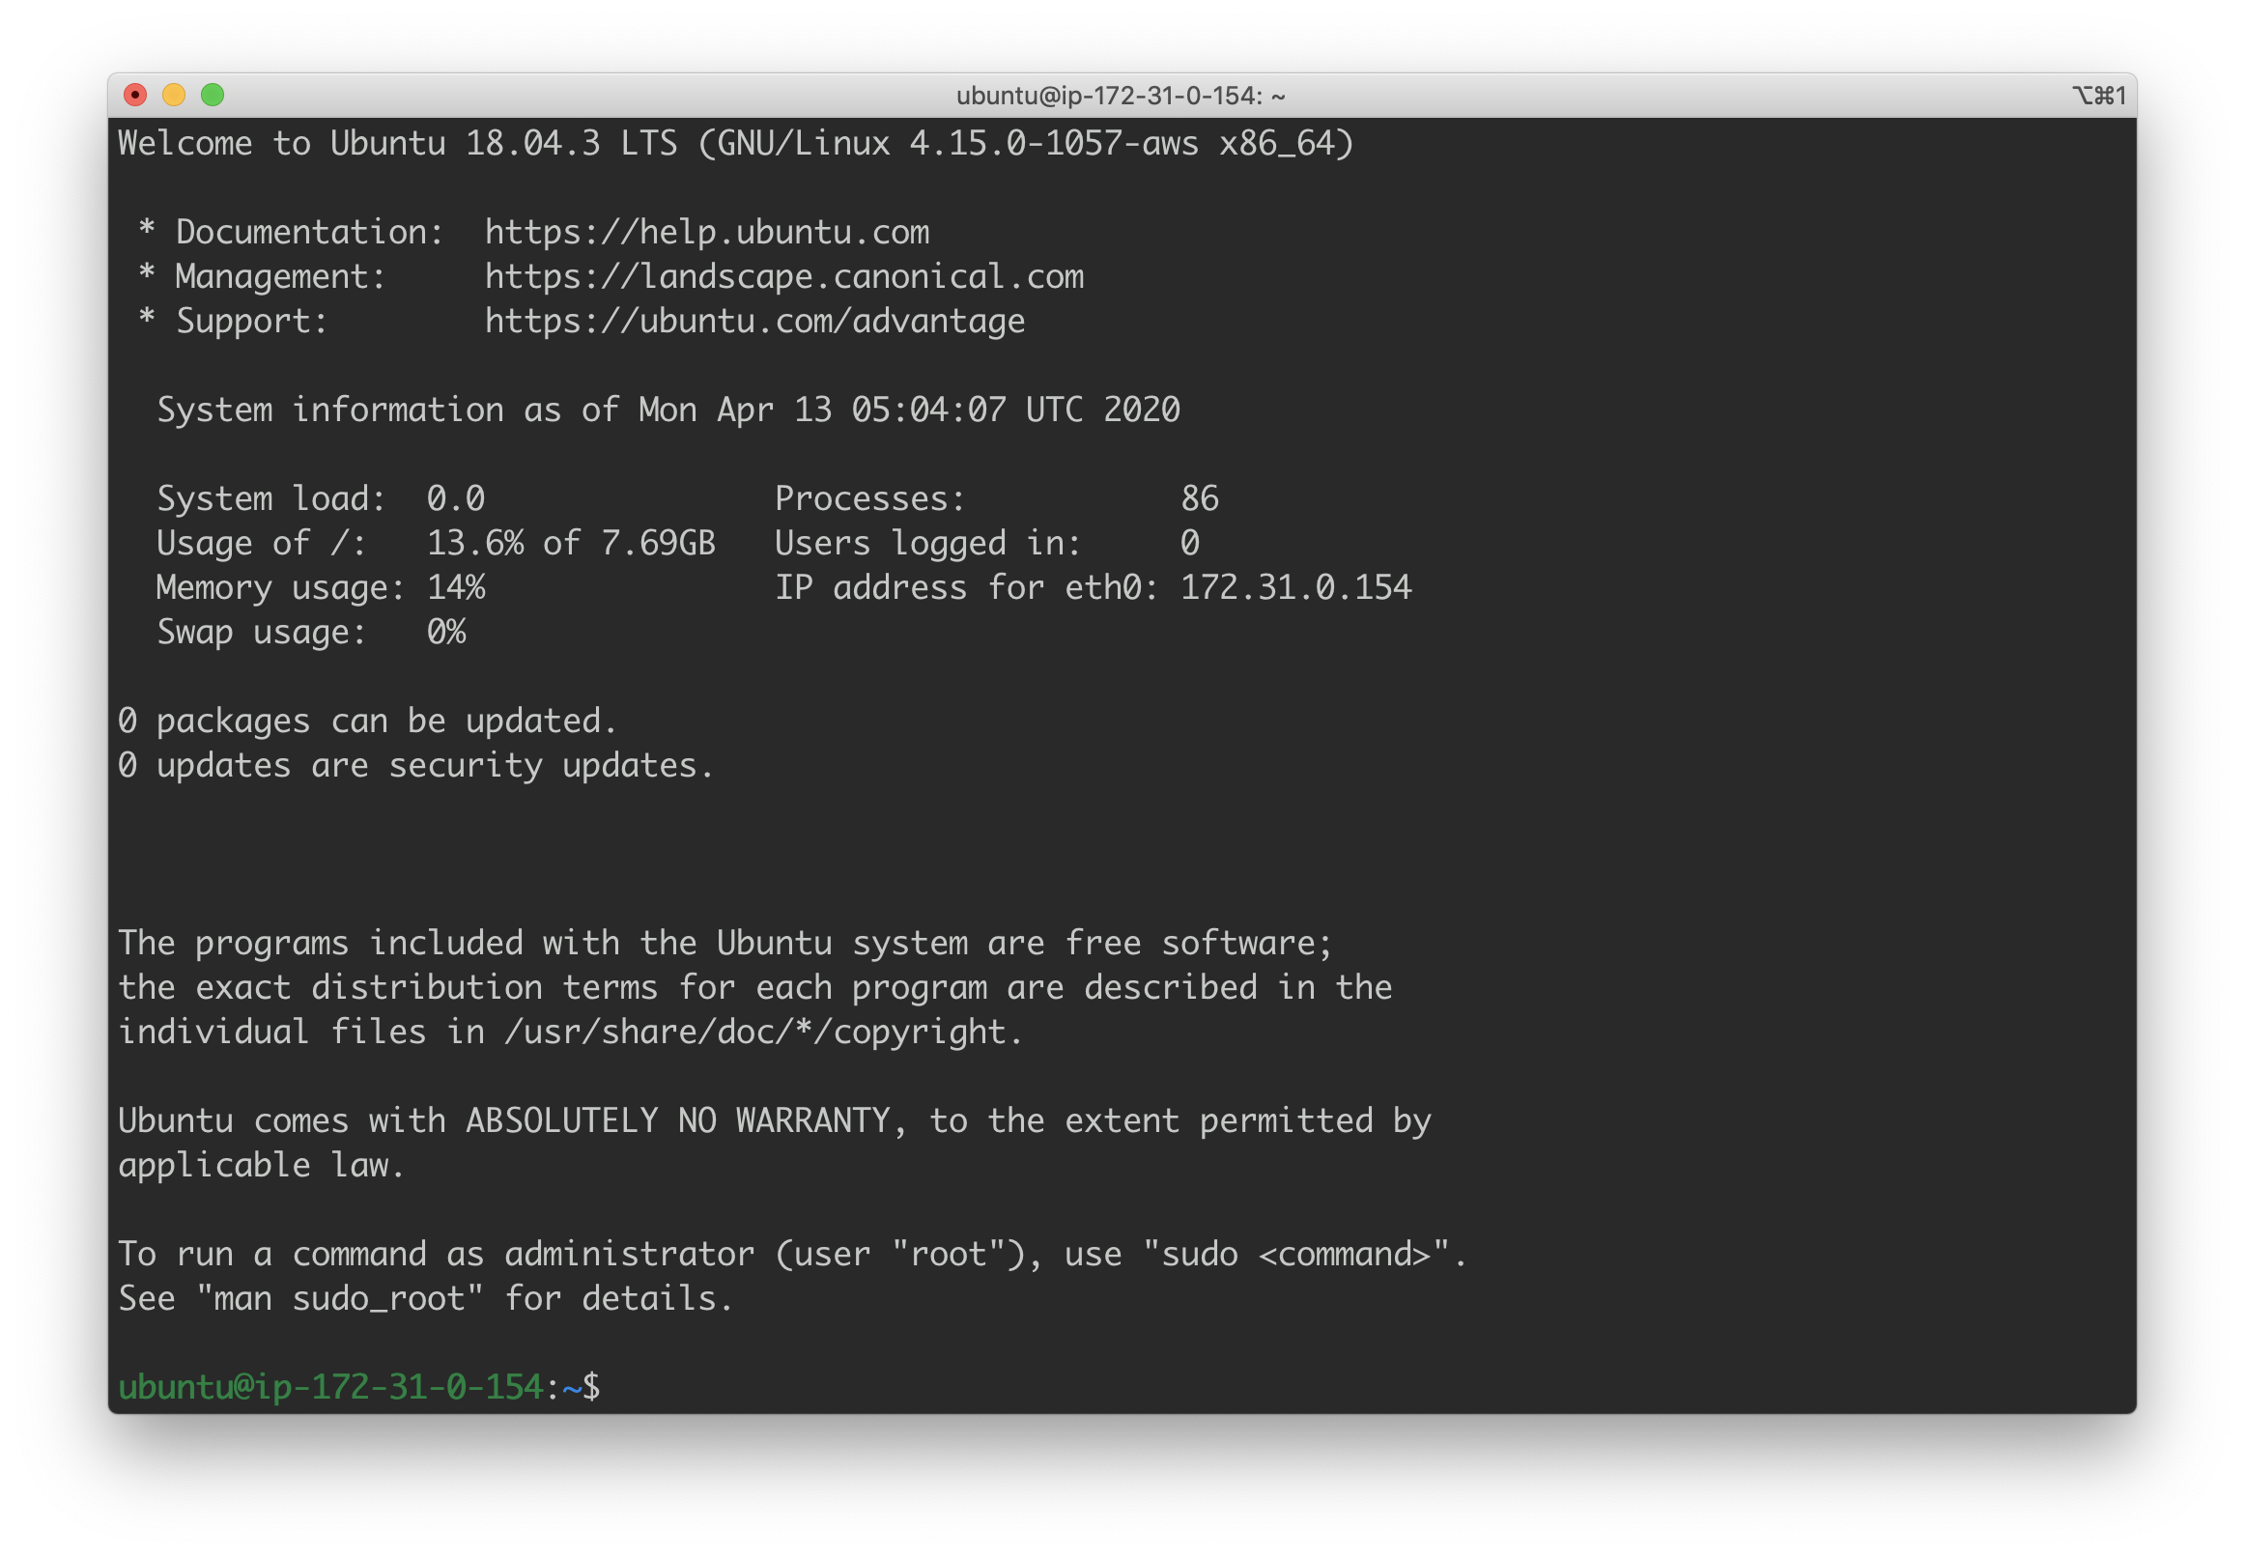

**Troubleshooting Note**: you may need to type in something like:

ssh -i ./YOUR_KEY_FILE.pem **ubuntu@**YOUR_EC2_PUBLIC_IP

Note the **ubuntu** in bold. Having done this, let’s test that this EC2 is **actually** accessible to the world:

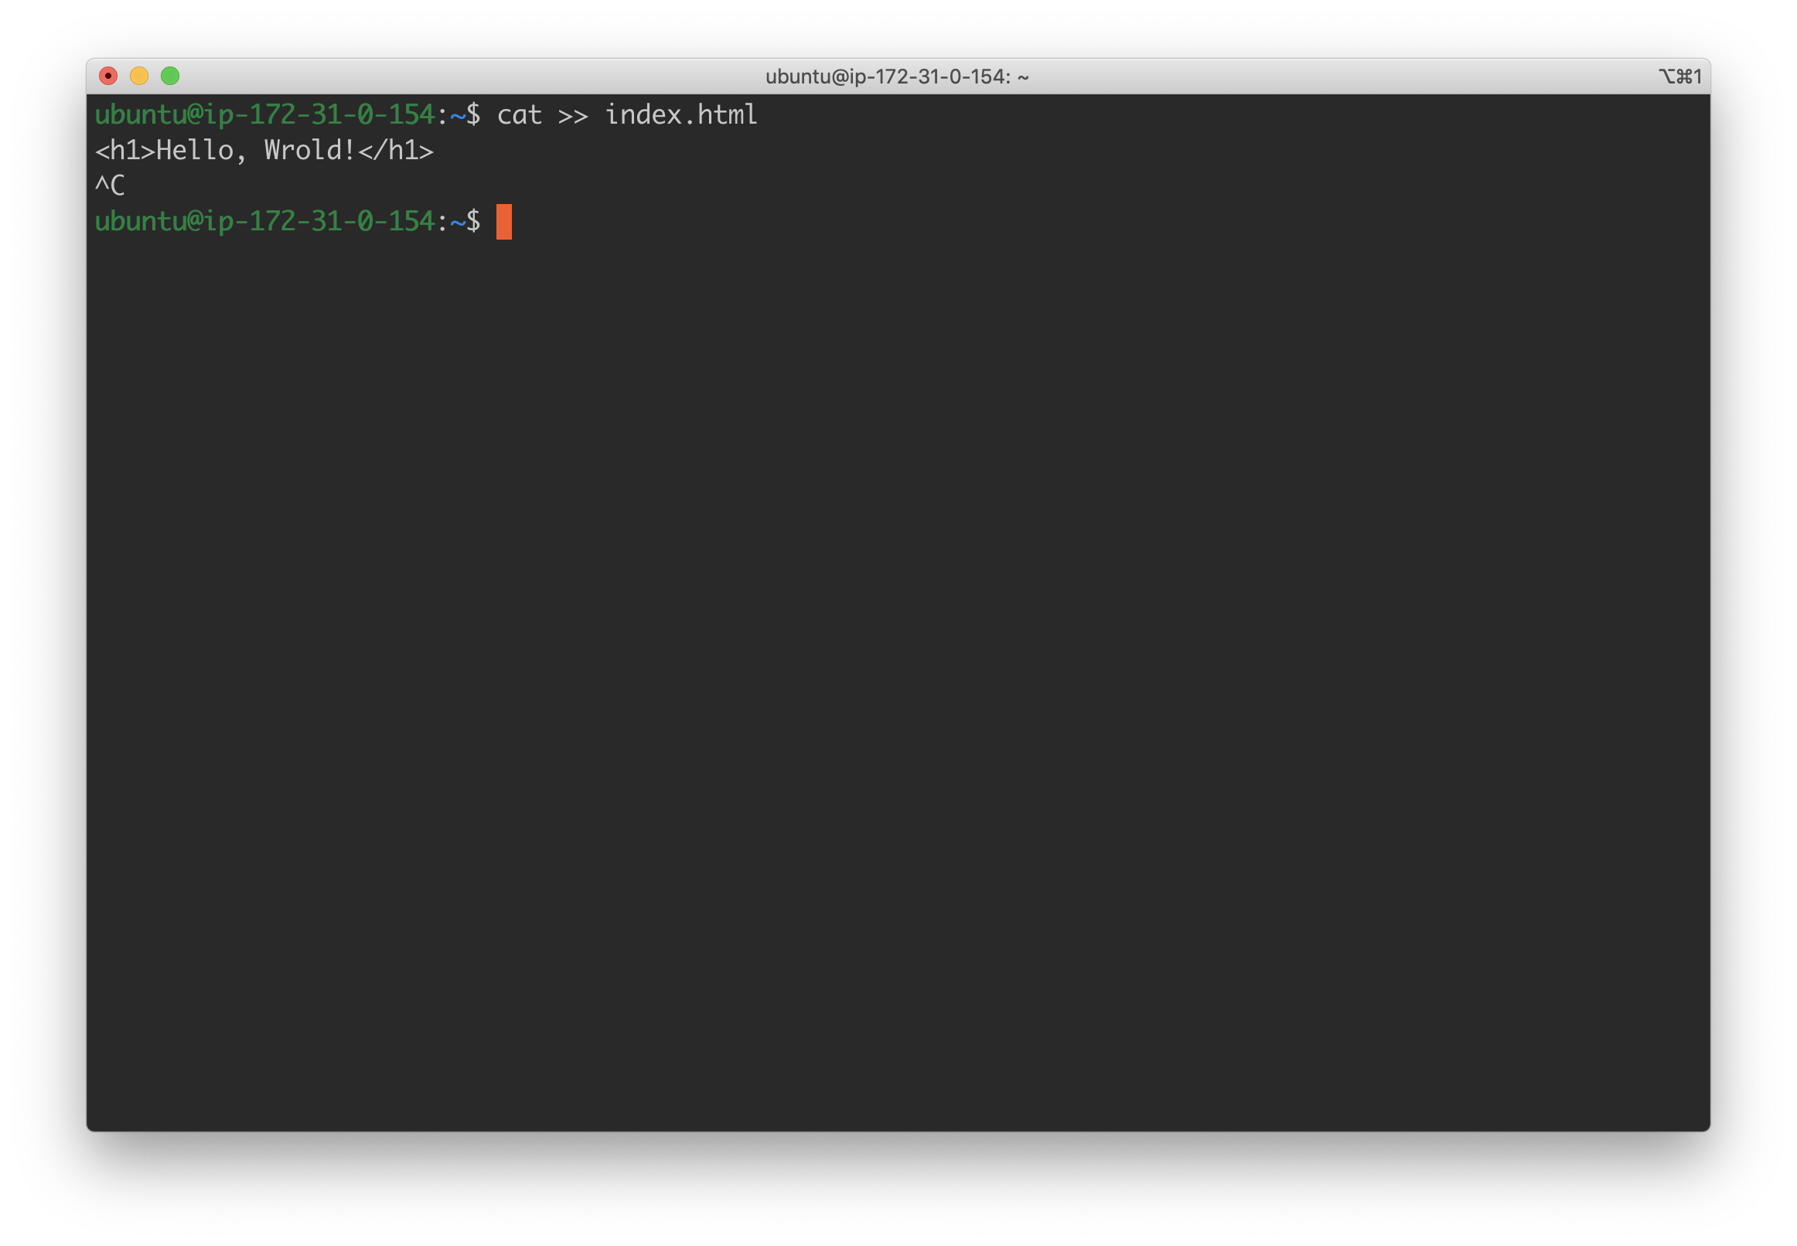

The important thing here is to remember to hit **Ctrl+C** after writing that first line to “save” the content into your **index.html** file. Finally, let’s start a simple web server and see if we can see our “Hello, Wrold” show up in the browser.

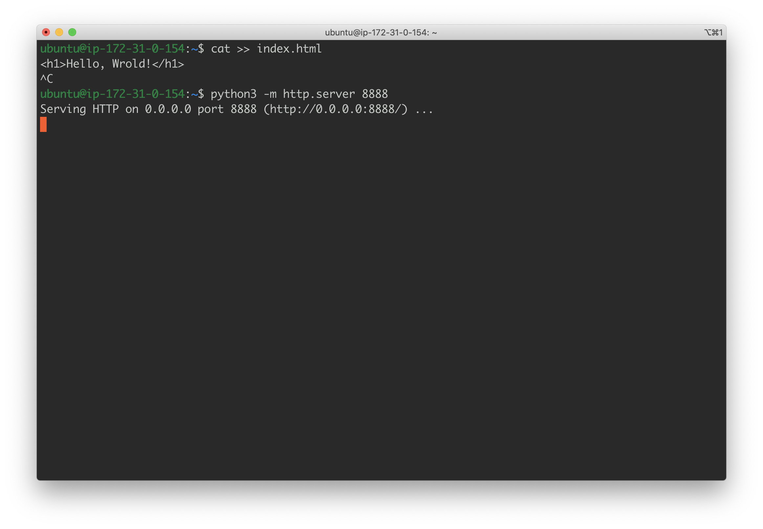

Make sure to use **port 8888**, which is the port configured in the EC2 security group. If you followed the instructions so far, **no other port will work**. To test that your “website” is accessible, simply type in the following into your web browser:

**http://**YOUR_EC2_PUBLIC_IP:**8888**

The expected result should be something like:

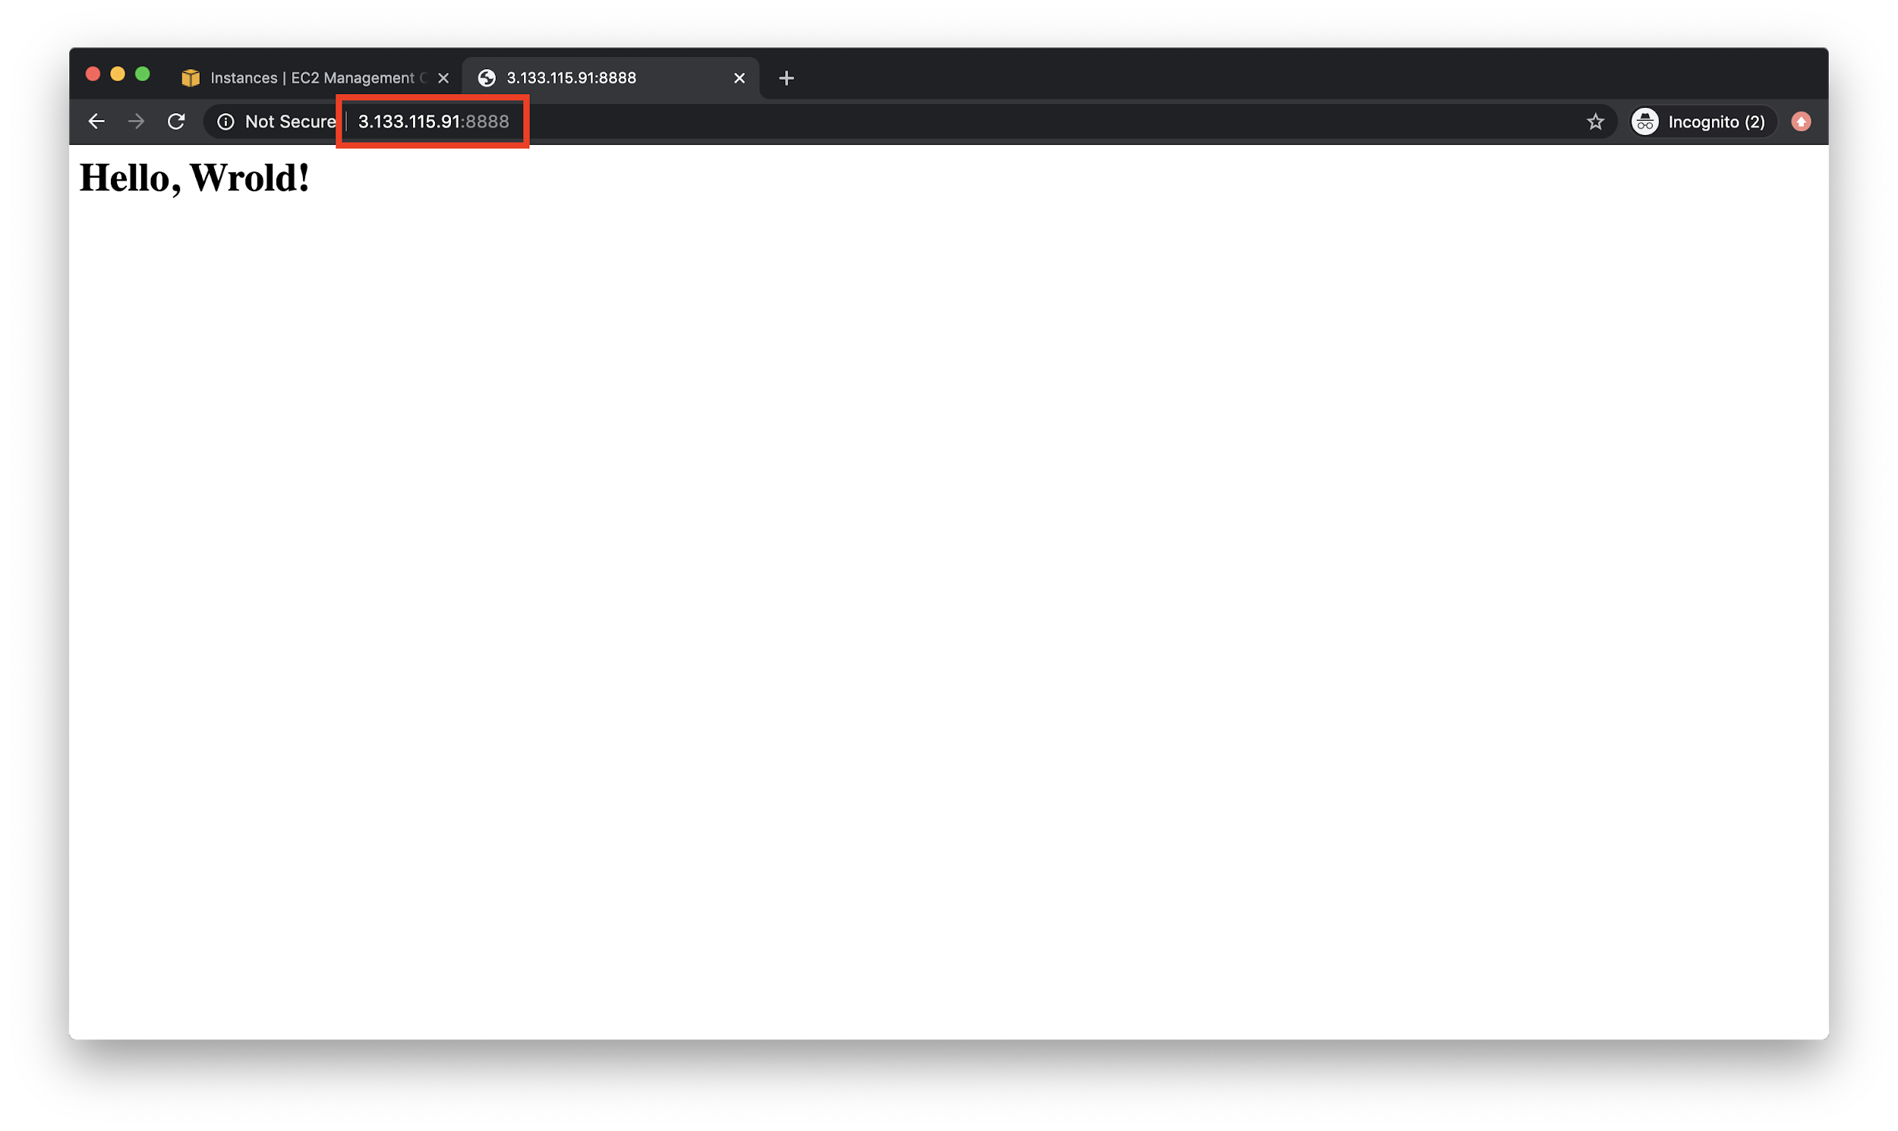

If you got here - excellent! Go back to the terminal and hit **Ctrl+C** to kill the server. Notice that now, if you refreshed your page again it will no longer display the “Hello, Wrold” text.

Now, on to installing docker so that we can run Jupyter Notebooks and Apache Spark.

# Installing Docker on EC2

There are two steps needed here - installing docker and installing docker-compose.

## Install Docker

**sudo apt-get update**

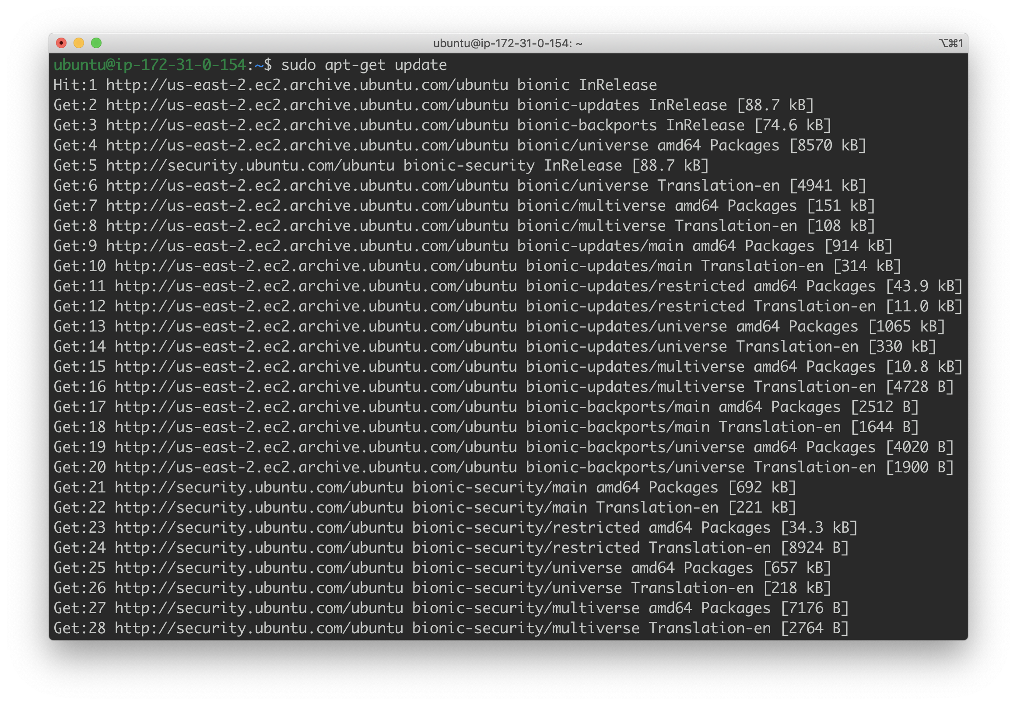

**sudo apt-get remove docker docker-engine docker.io**

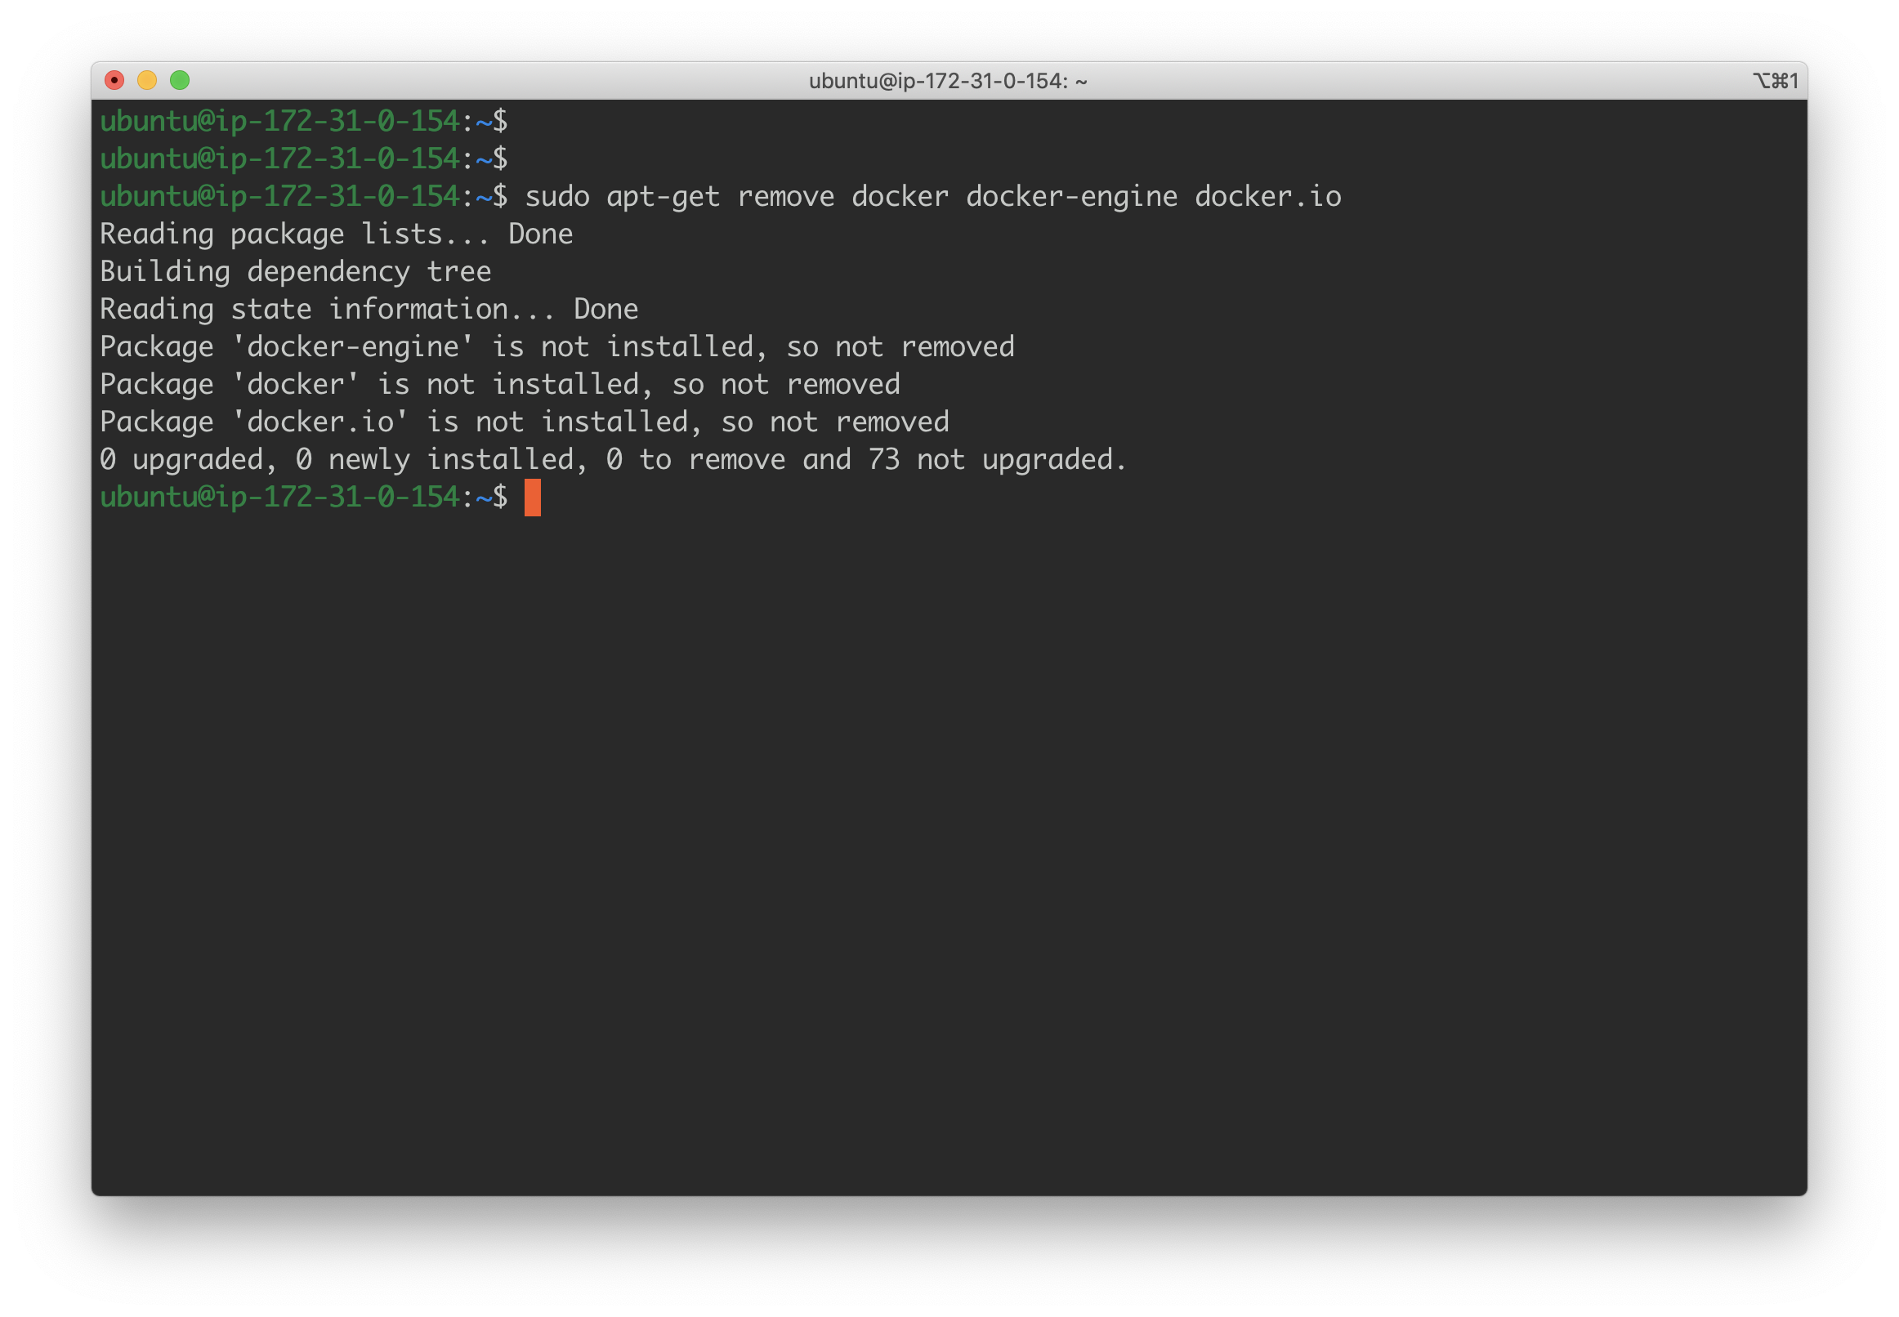

**sudo apt install docker.io -y**

Note: the **-y** flag will not ask you for permissions to install docker halfway through the install.

Next, run:

**sudo systemctl start docker**

**sudo systemctl enable docker**

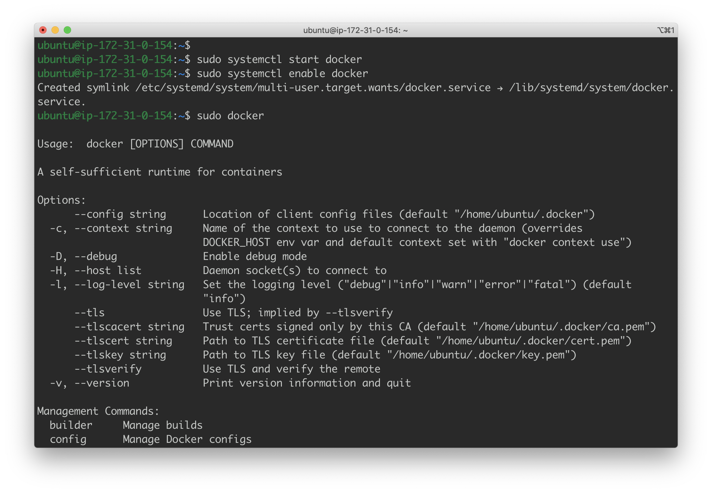

Finally, to test - run:

**sudo docker**

You should see something like:



## Install Docker-Compose

Docker-compose requires another set of instructions for installation. Luckily, fewer steps are needed. First:

**sudo curl -L https://github.com/docker/compose/releases/download/1.21.2/docker-compose-`uname -s`-`uname -m` -o /usr/local/bin/docker-compose**

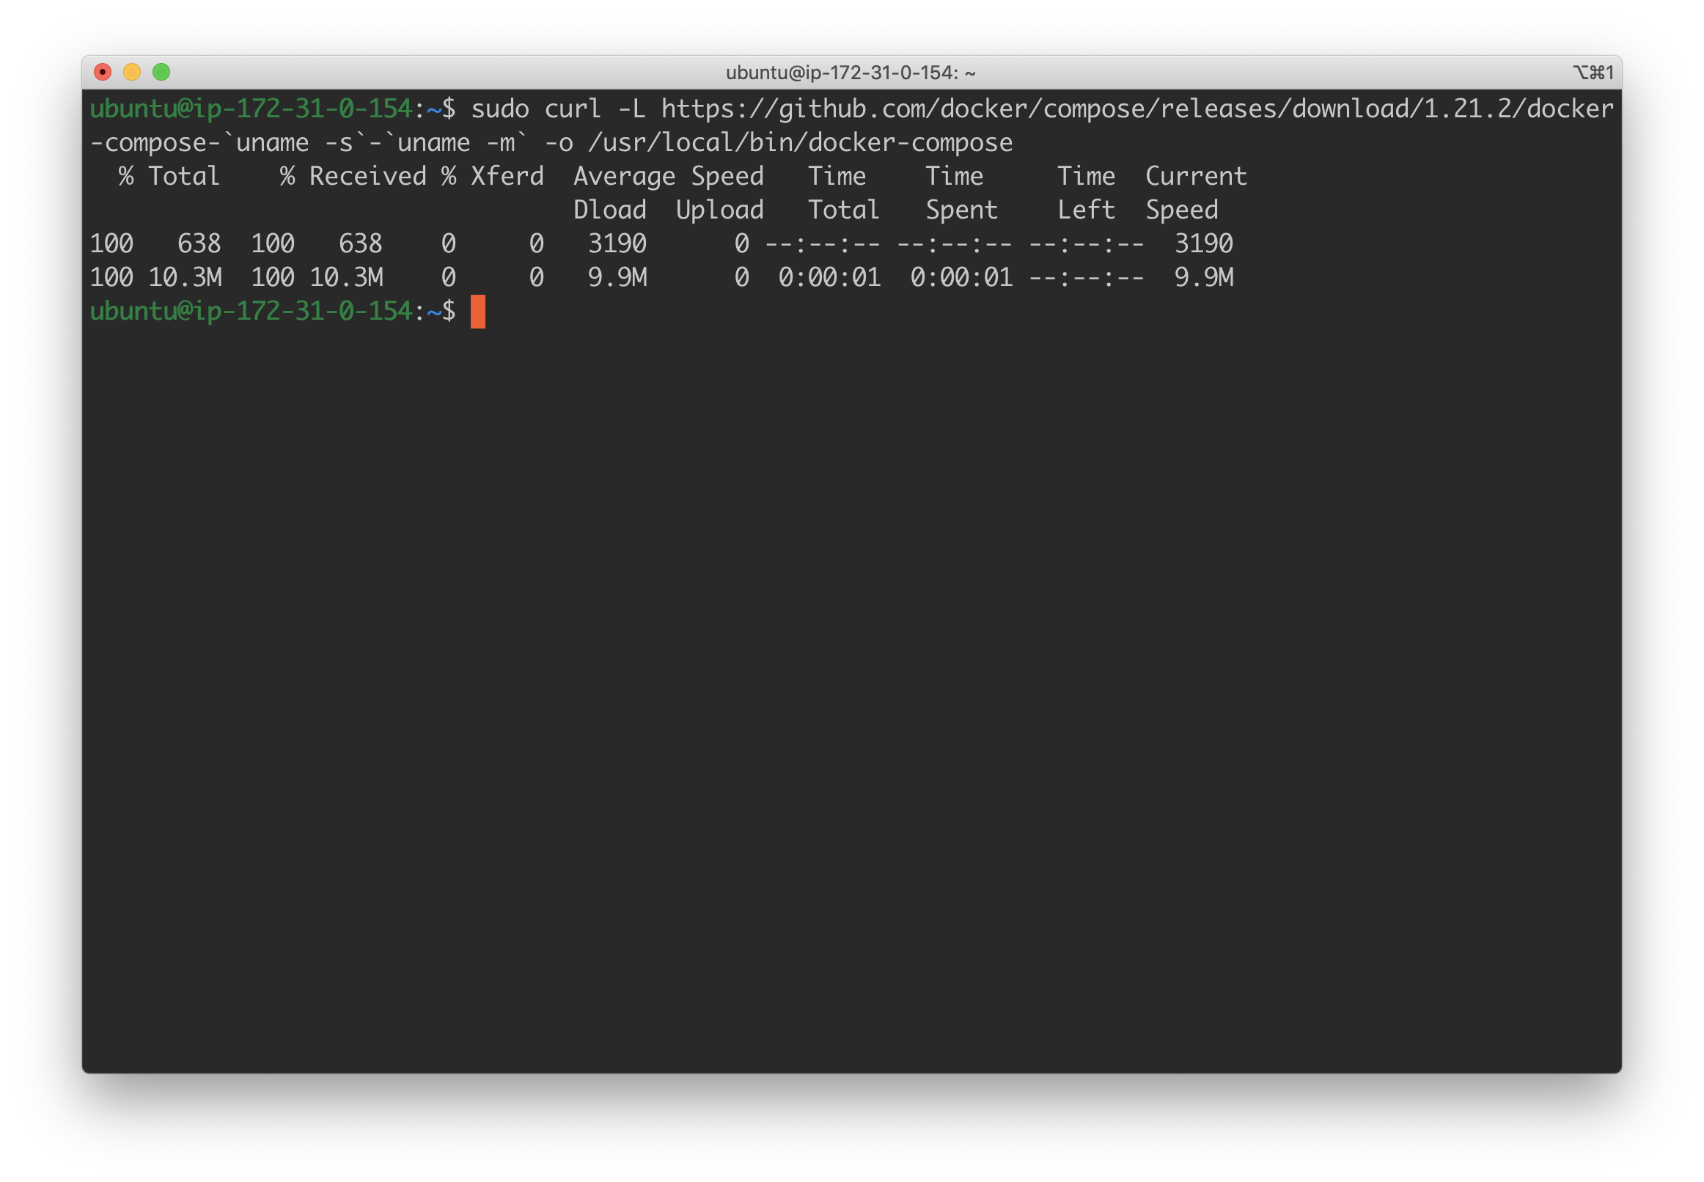

Then, we set permissions:

**sudo chmod +x /usr/local/bin/docker-compose**

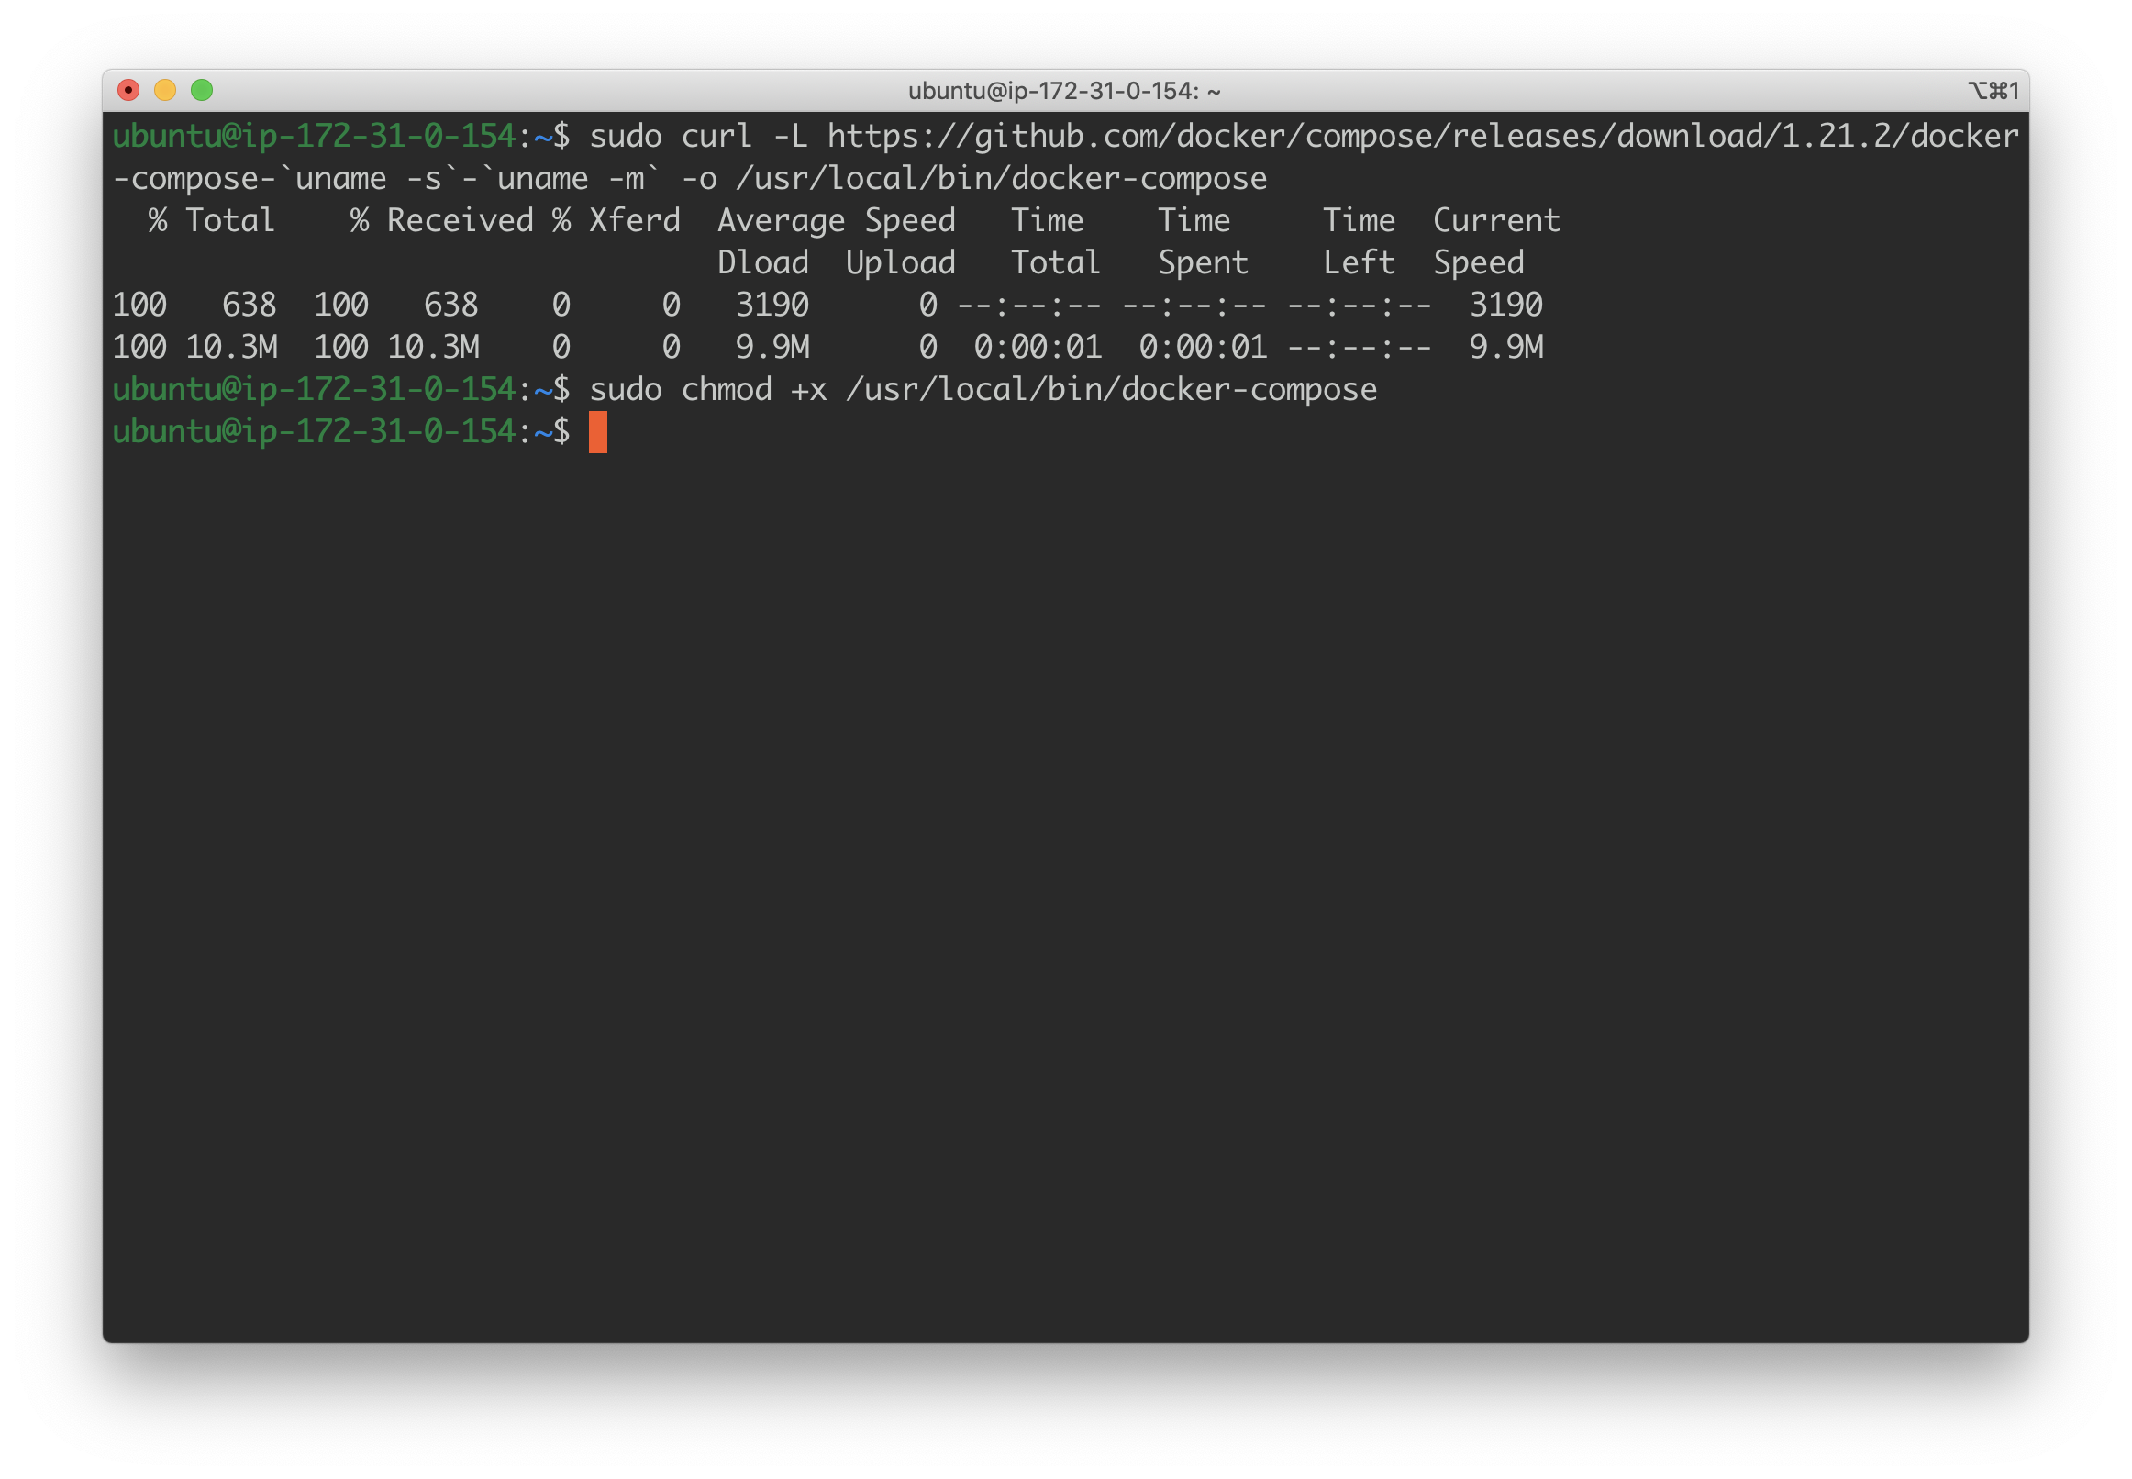

And finally, we test:

**sudo docker-compose --version**

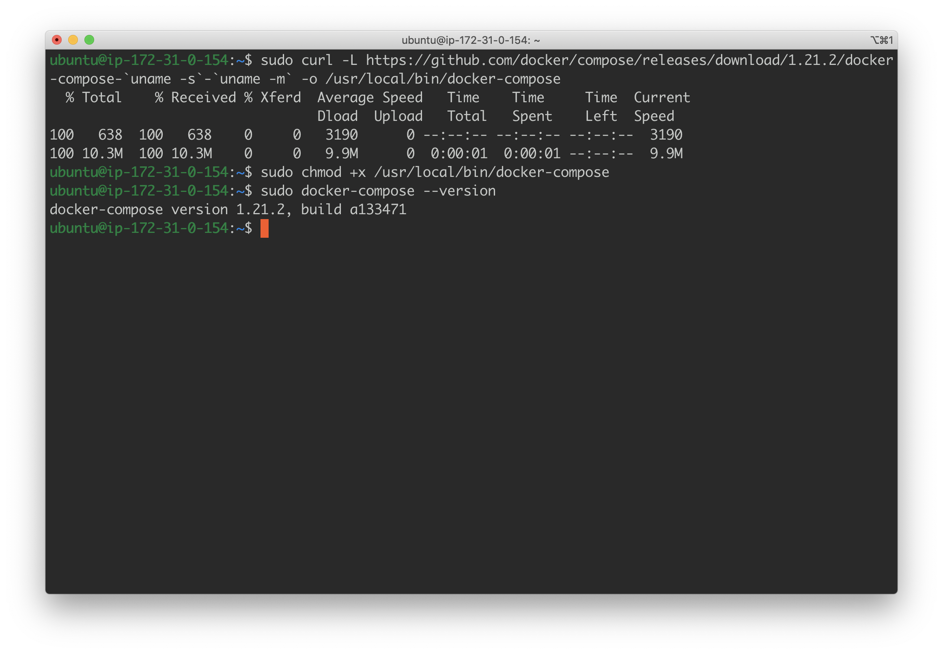

Done! Now, on to spark and Jupyter.

# Jupyter Notebook and Apache Spark

With docker, we will now run Jupyter Notebook and Apache Spark on our EC2 instance. Because we punched a hole on **port 8888**, we will be able to access our jupyter notebook online via the web browser.

## Run jupyter/pyspark-notebook Image

This is an image maintained on dockerhub, so all we have to do is:

**docker run -it -p 8888:8888 jupyter/pyspark-notebook**

In our EC2 instance.

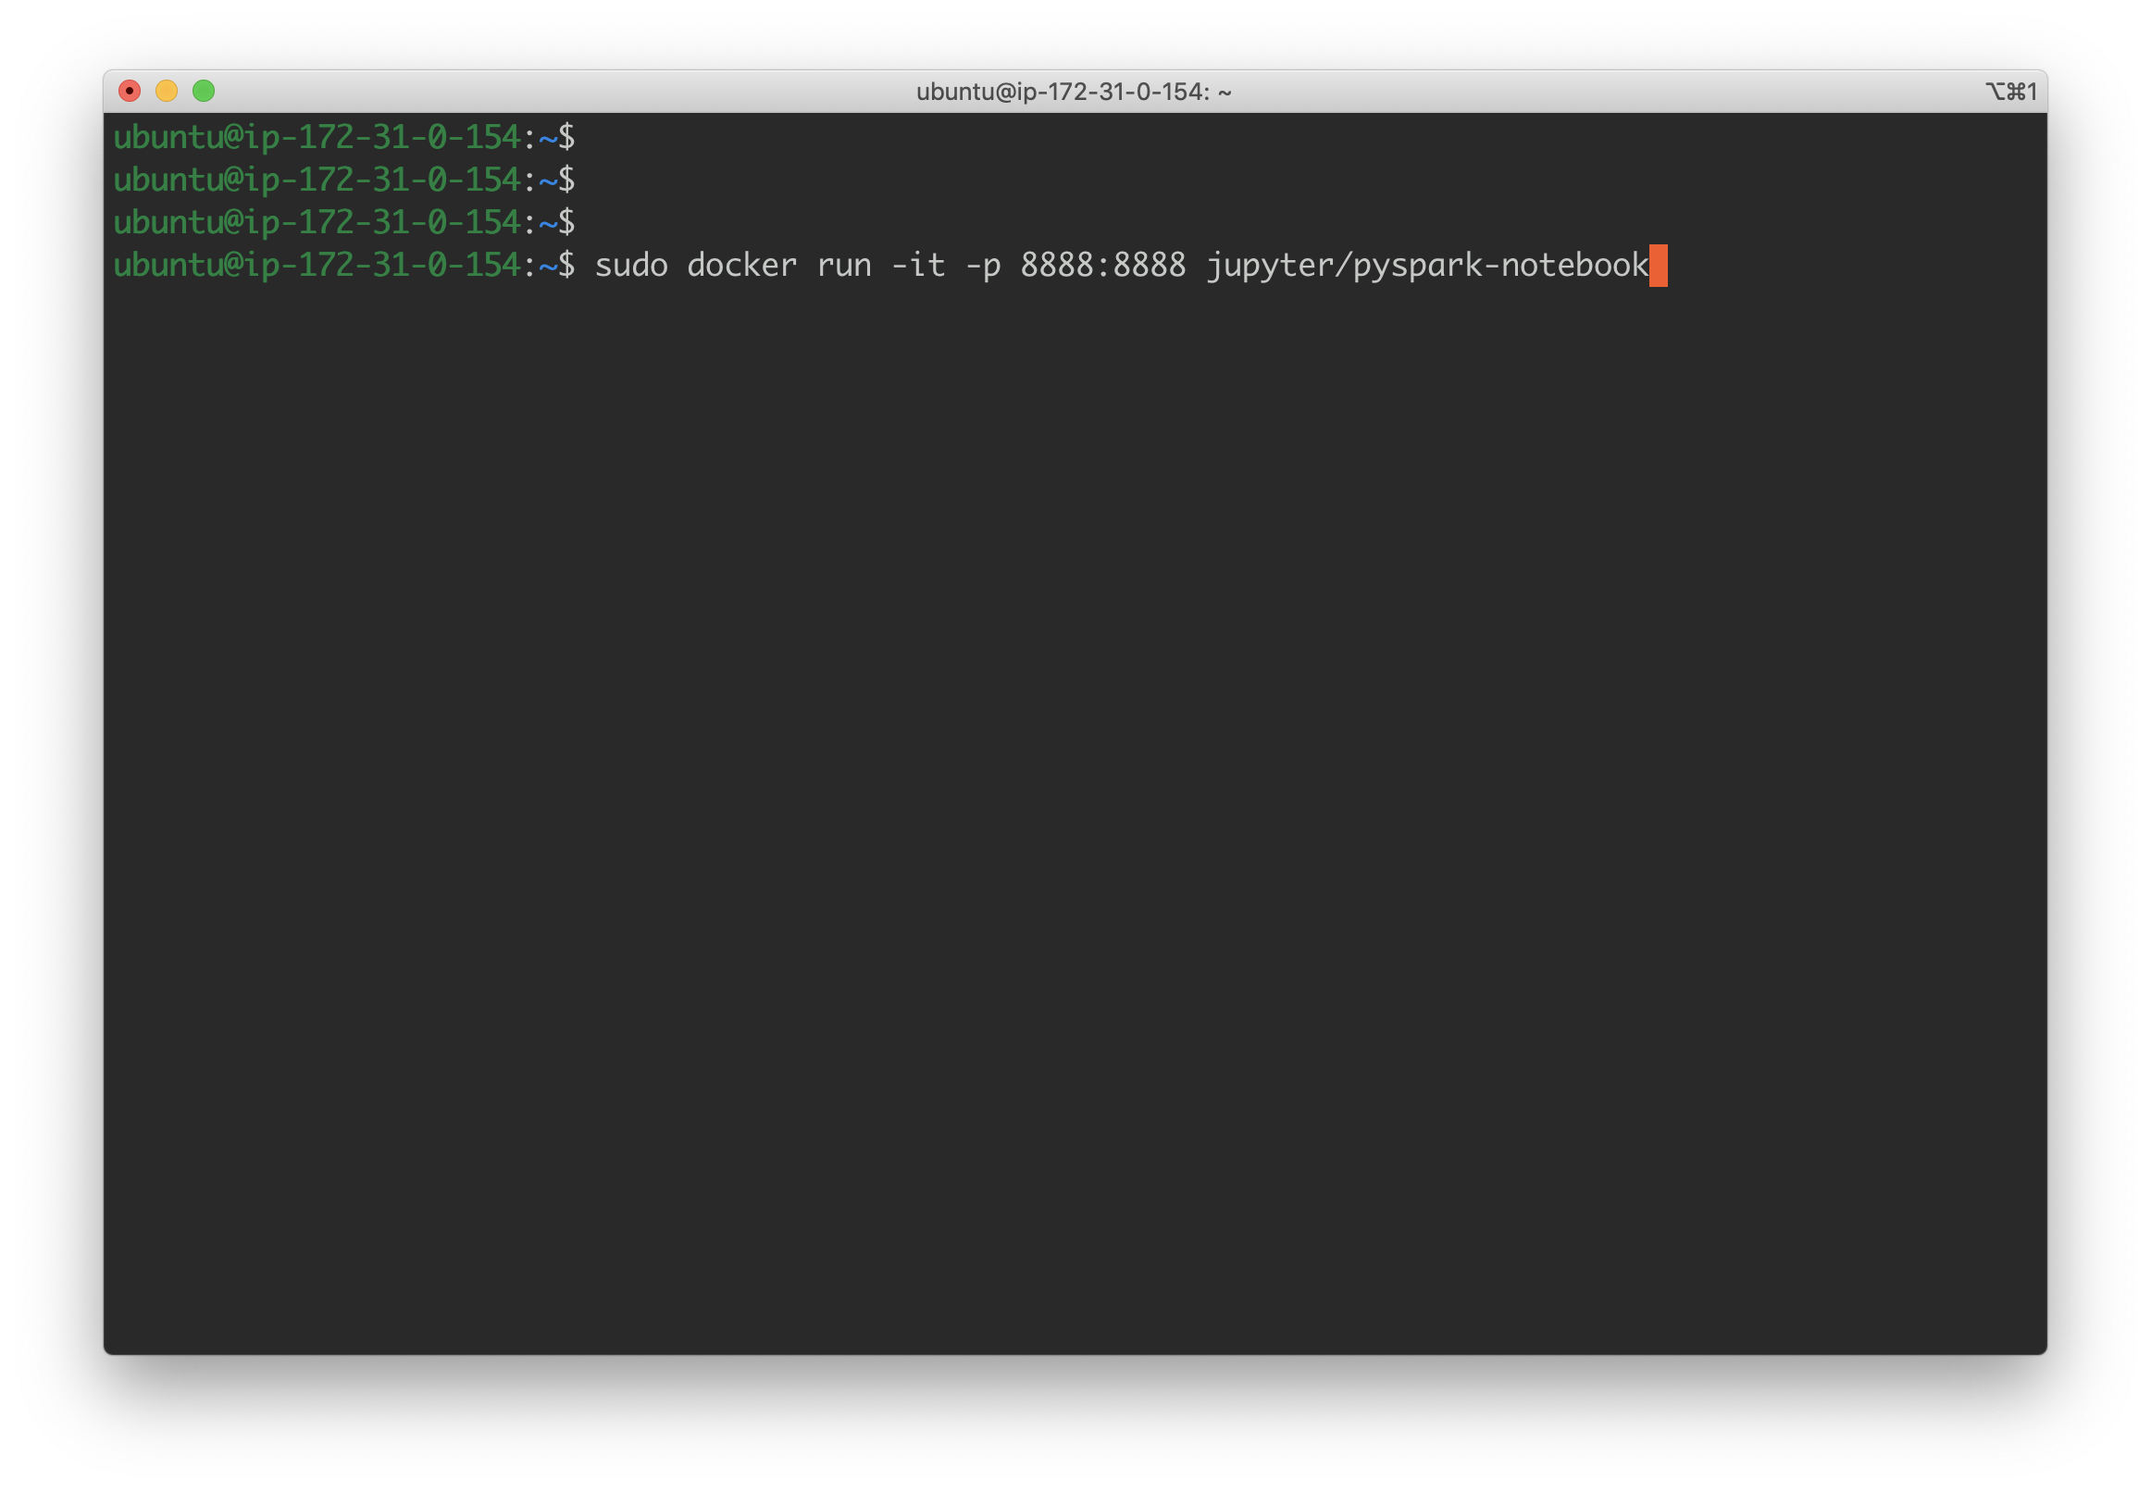

The **-p 8888:8888** maps port **8888** in the docker container to port **8888** in the host machine - which in this case is our EC2 instance.

Once this action completes, you should see something like the following on your terminal screen:

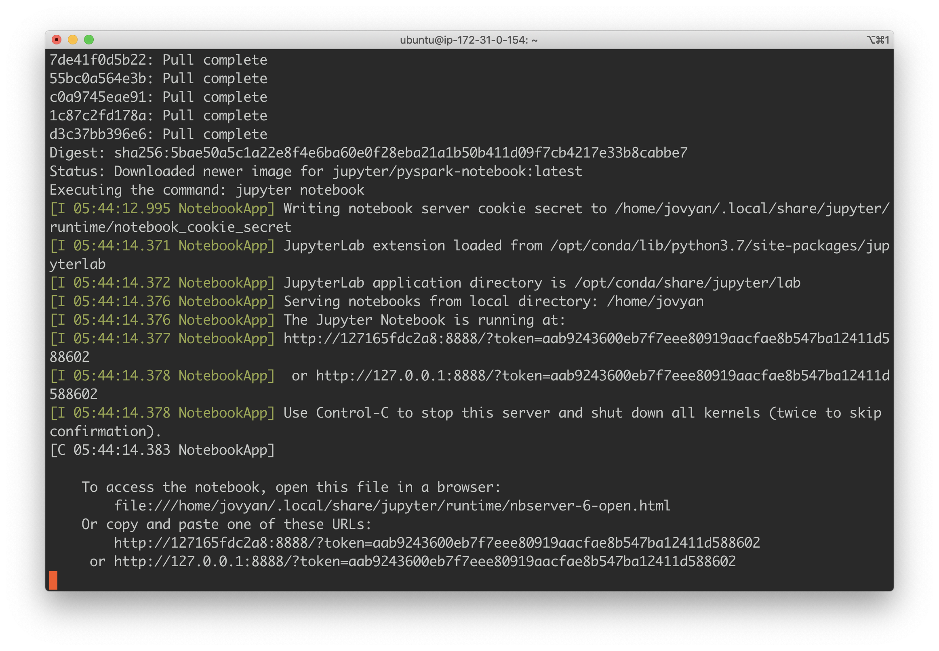

The catch here is we are not in a local environment! Instead, we must paste the following:

**http://**YOUR_EC2_PUBLIC_IP:**8888**?token=[TOKEN_FROM_YOUR_TERMINAL_SCREEN]

Into the web browser. By doing so, expect the following:

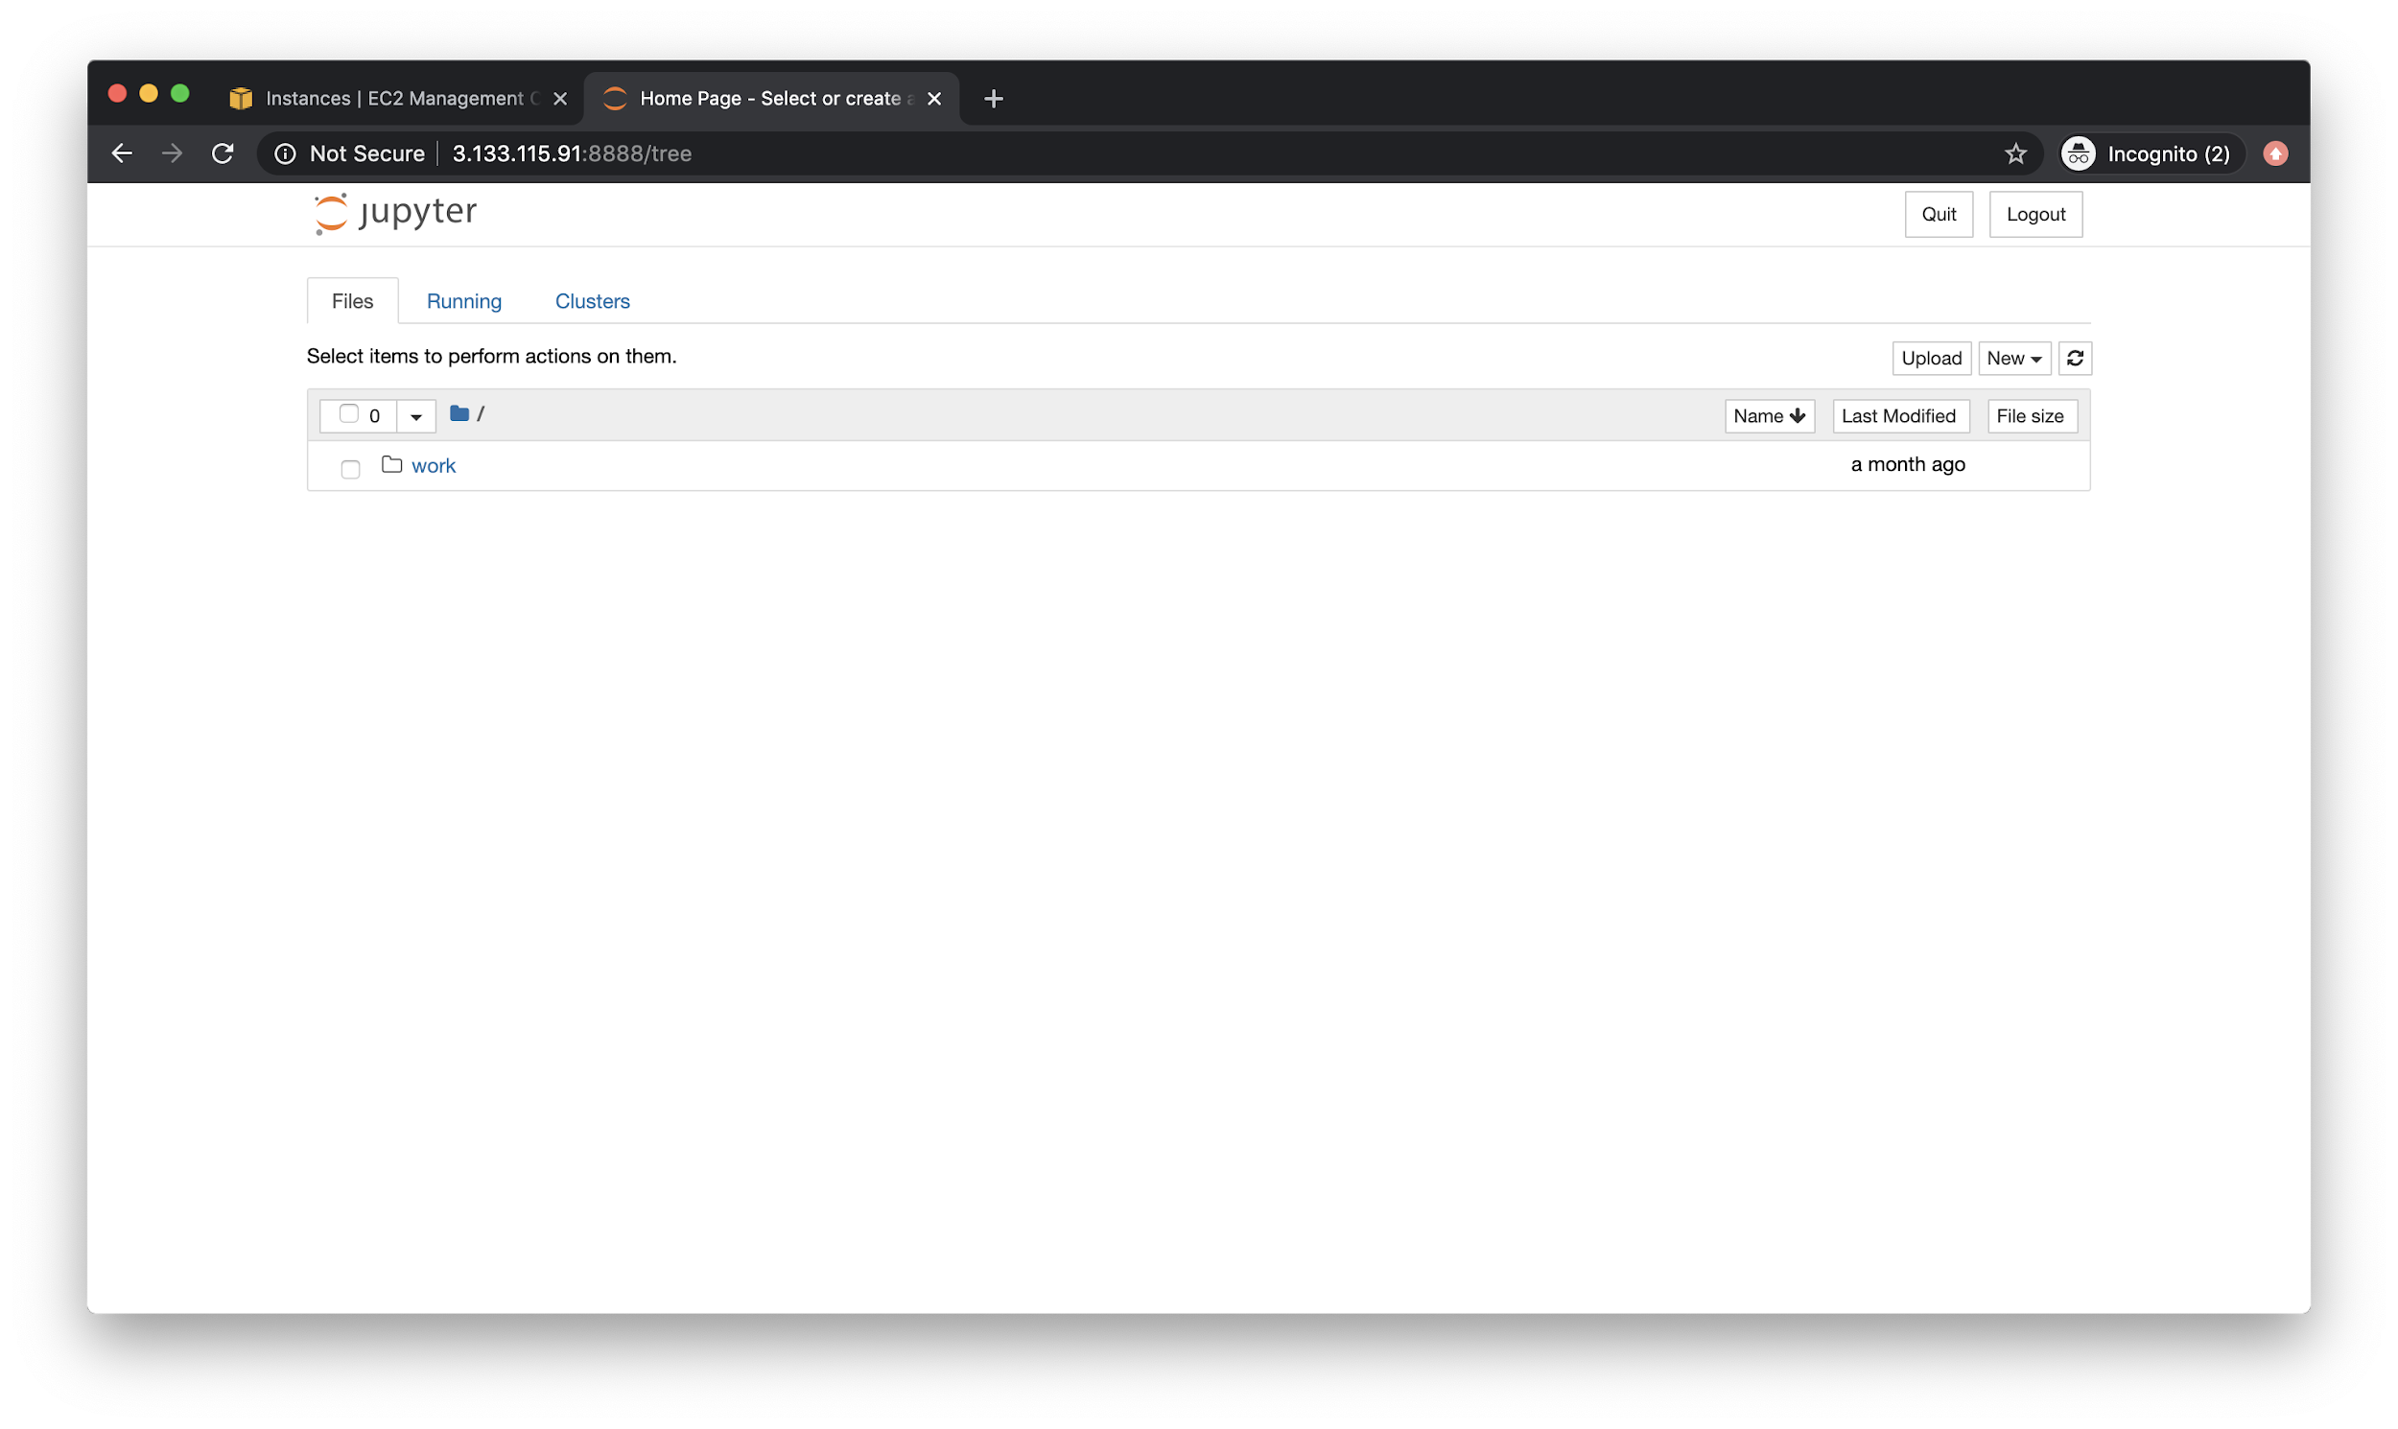

Your very own Jupyter Notebook instance! Note, it might be wise to actually **logout** and then log back in but with a reset password. This will ensure that you are able to access the instance with a more easily rememberable password.

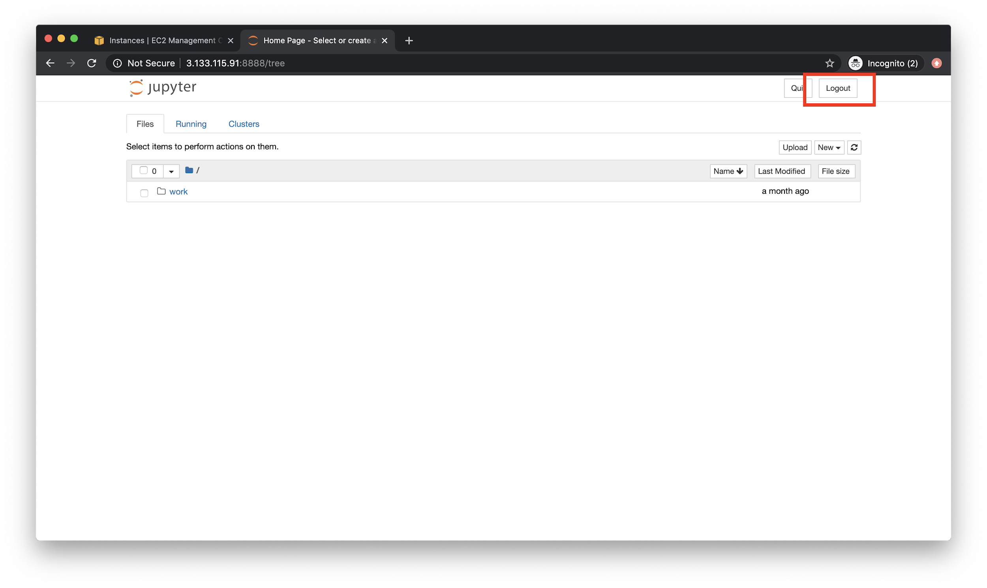

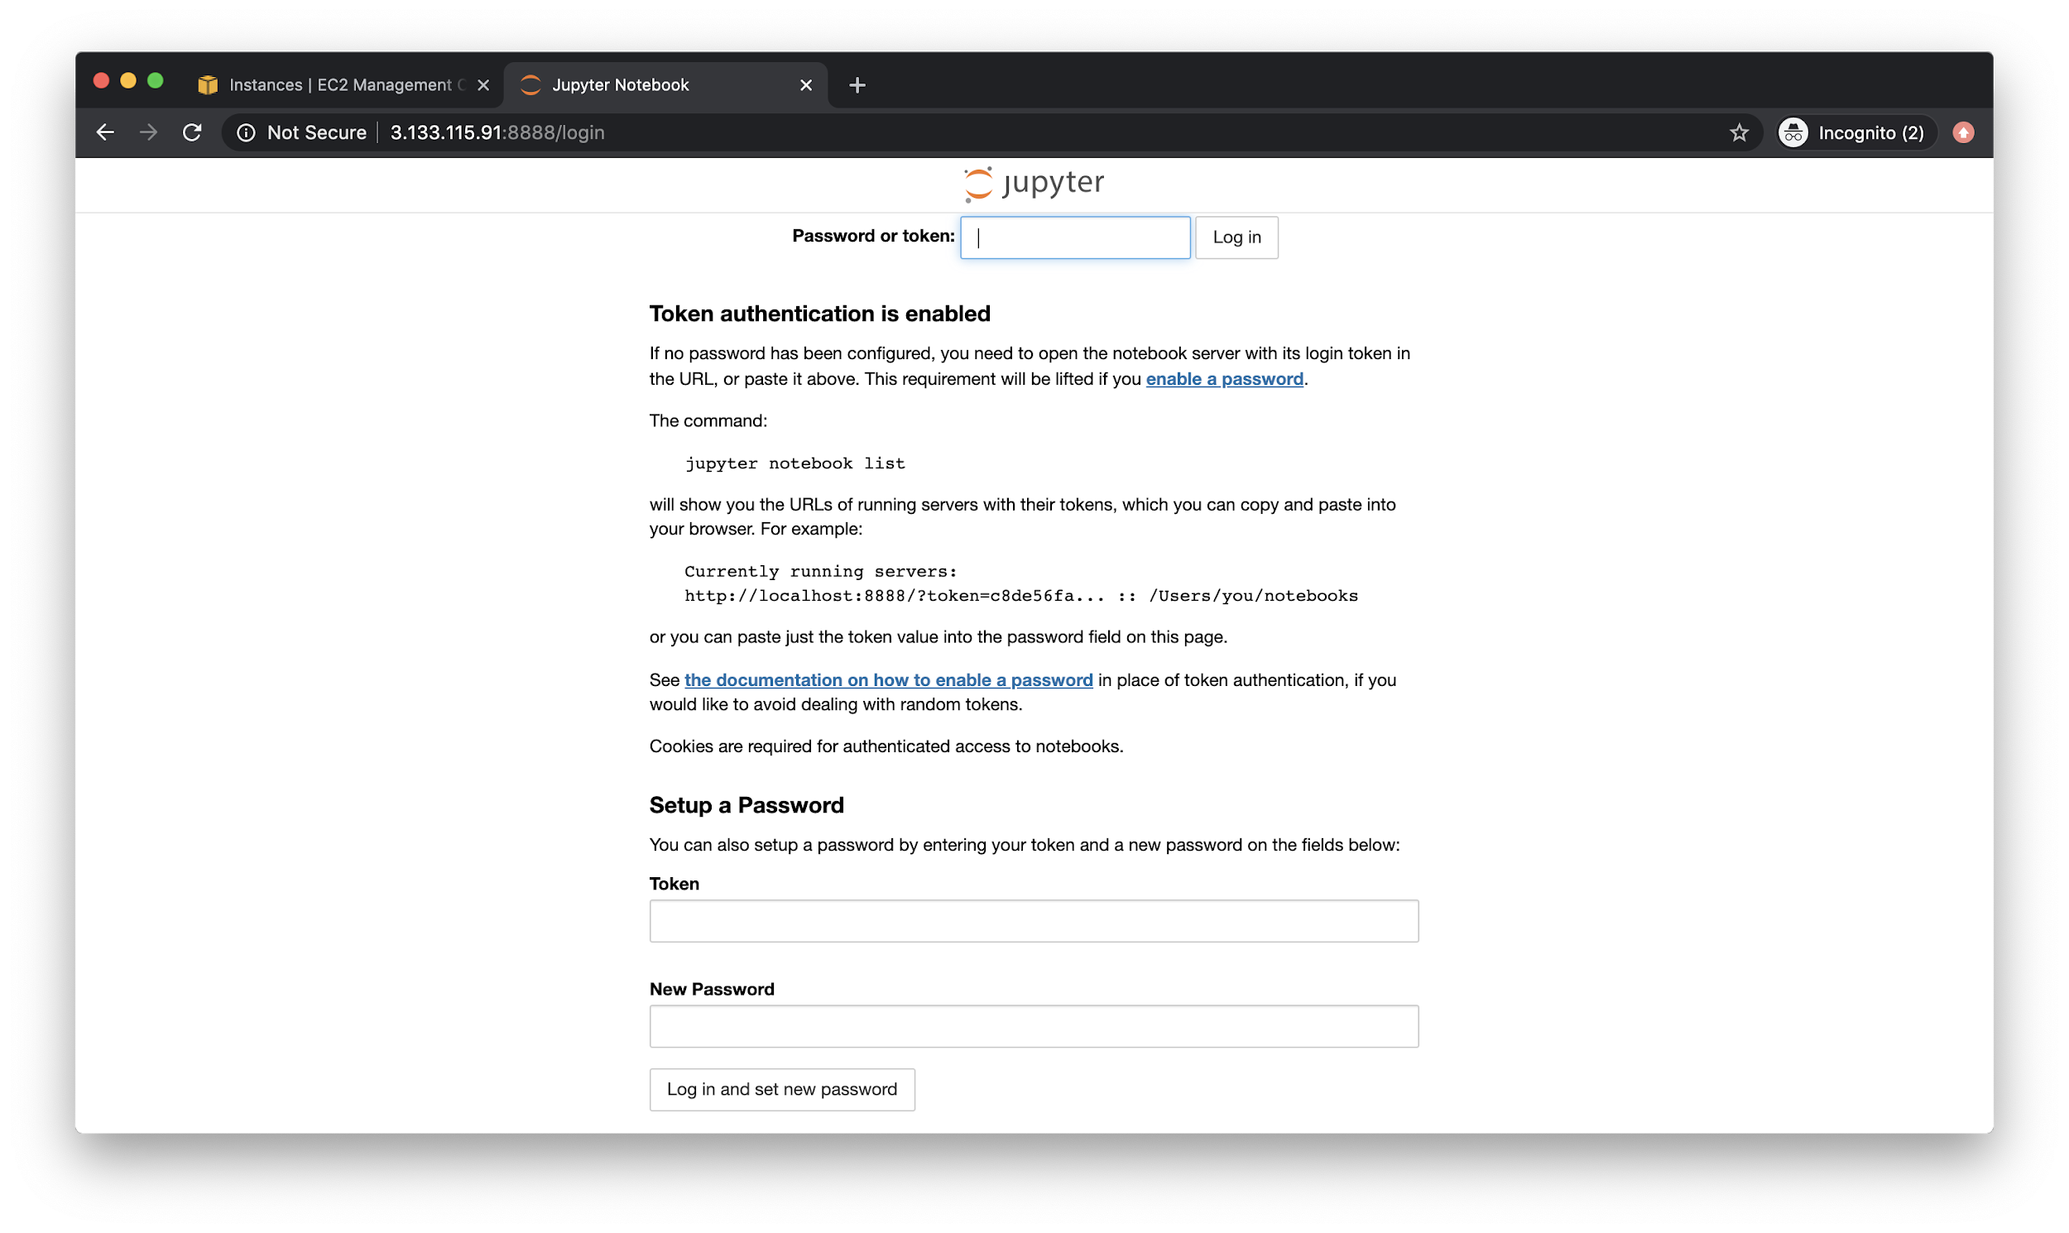

You will need the token one last time to reset password.

## Tweaking Docker Settings

There’s a few things that would be good to do before moving forward. First, stop the container by going back to the terminal and hitting **Ctrl + C**. You should see a confirmation dialog.

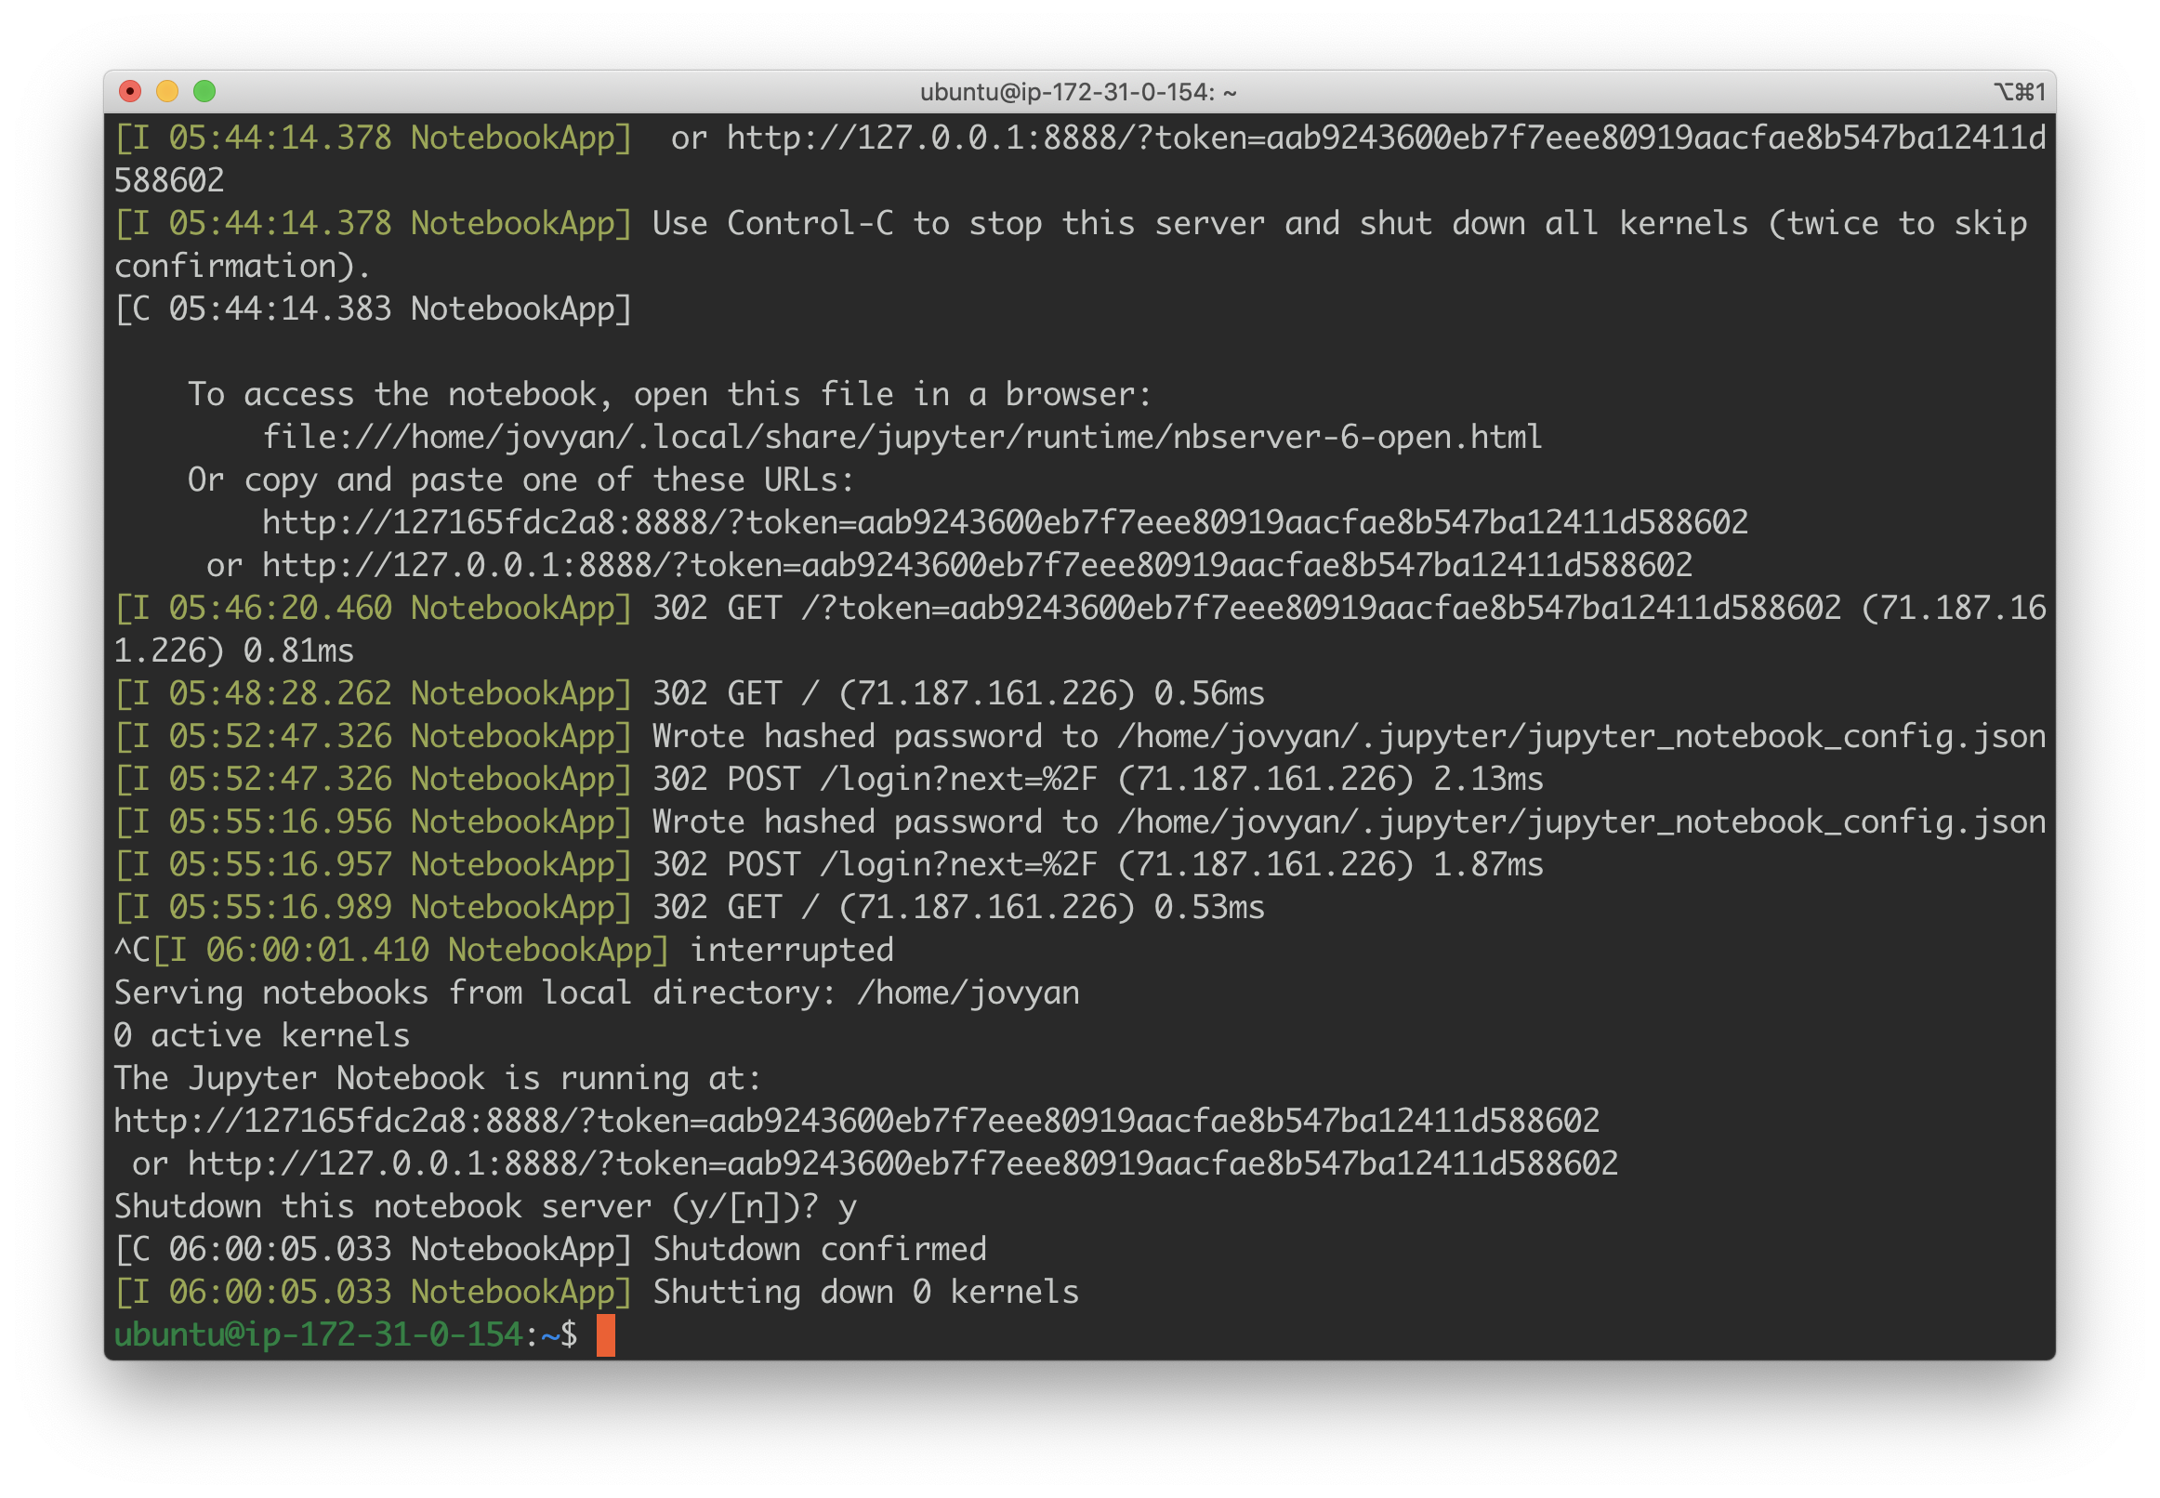

Now, run the following command instead:

**sudo docker run -d -v $(pwd):/home/jovyan/data -it -p 8888:8888 jupyter/pyspark-notebook**

What we are doing here is as follows:

* **-d** running docker in detached mode. This means it will run in the background so that we can use the terminal to do other stuff - like copying in datasets
* **-v $(pwd):/home/jovyan/data** the **WORKDIR** of this container is **/home/joyyan** so we mount our current working directory to it. This allows us to share datasets with the container - meaning we can access the datasets inside Jupyter

Also, since we are running docker in detached mode, you can safely log out of your EC2 and still access your instance. **NOTE**: as long as your EC2 is “on”, you will be burning free tier hours.

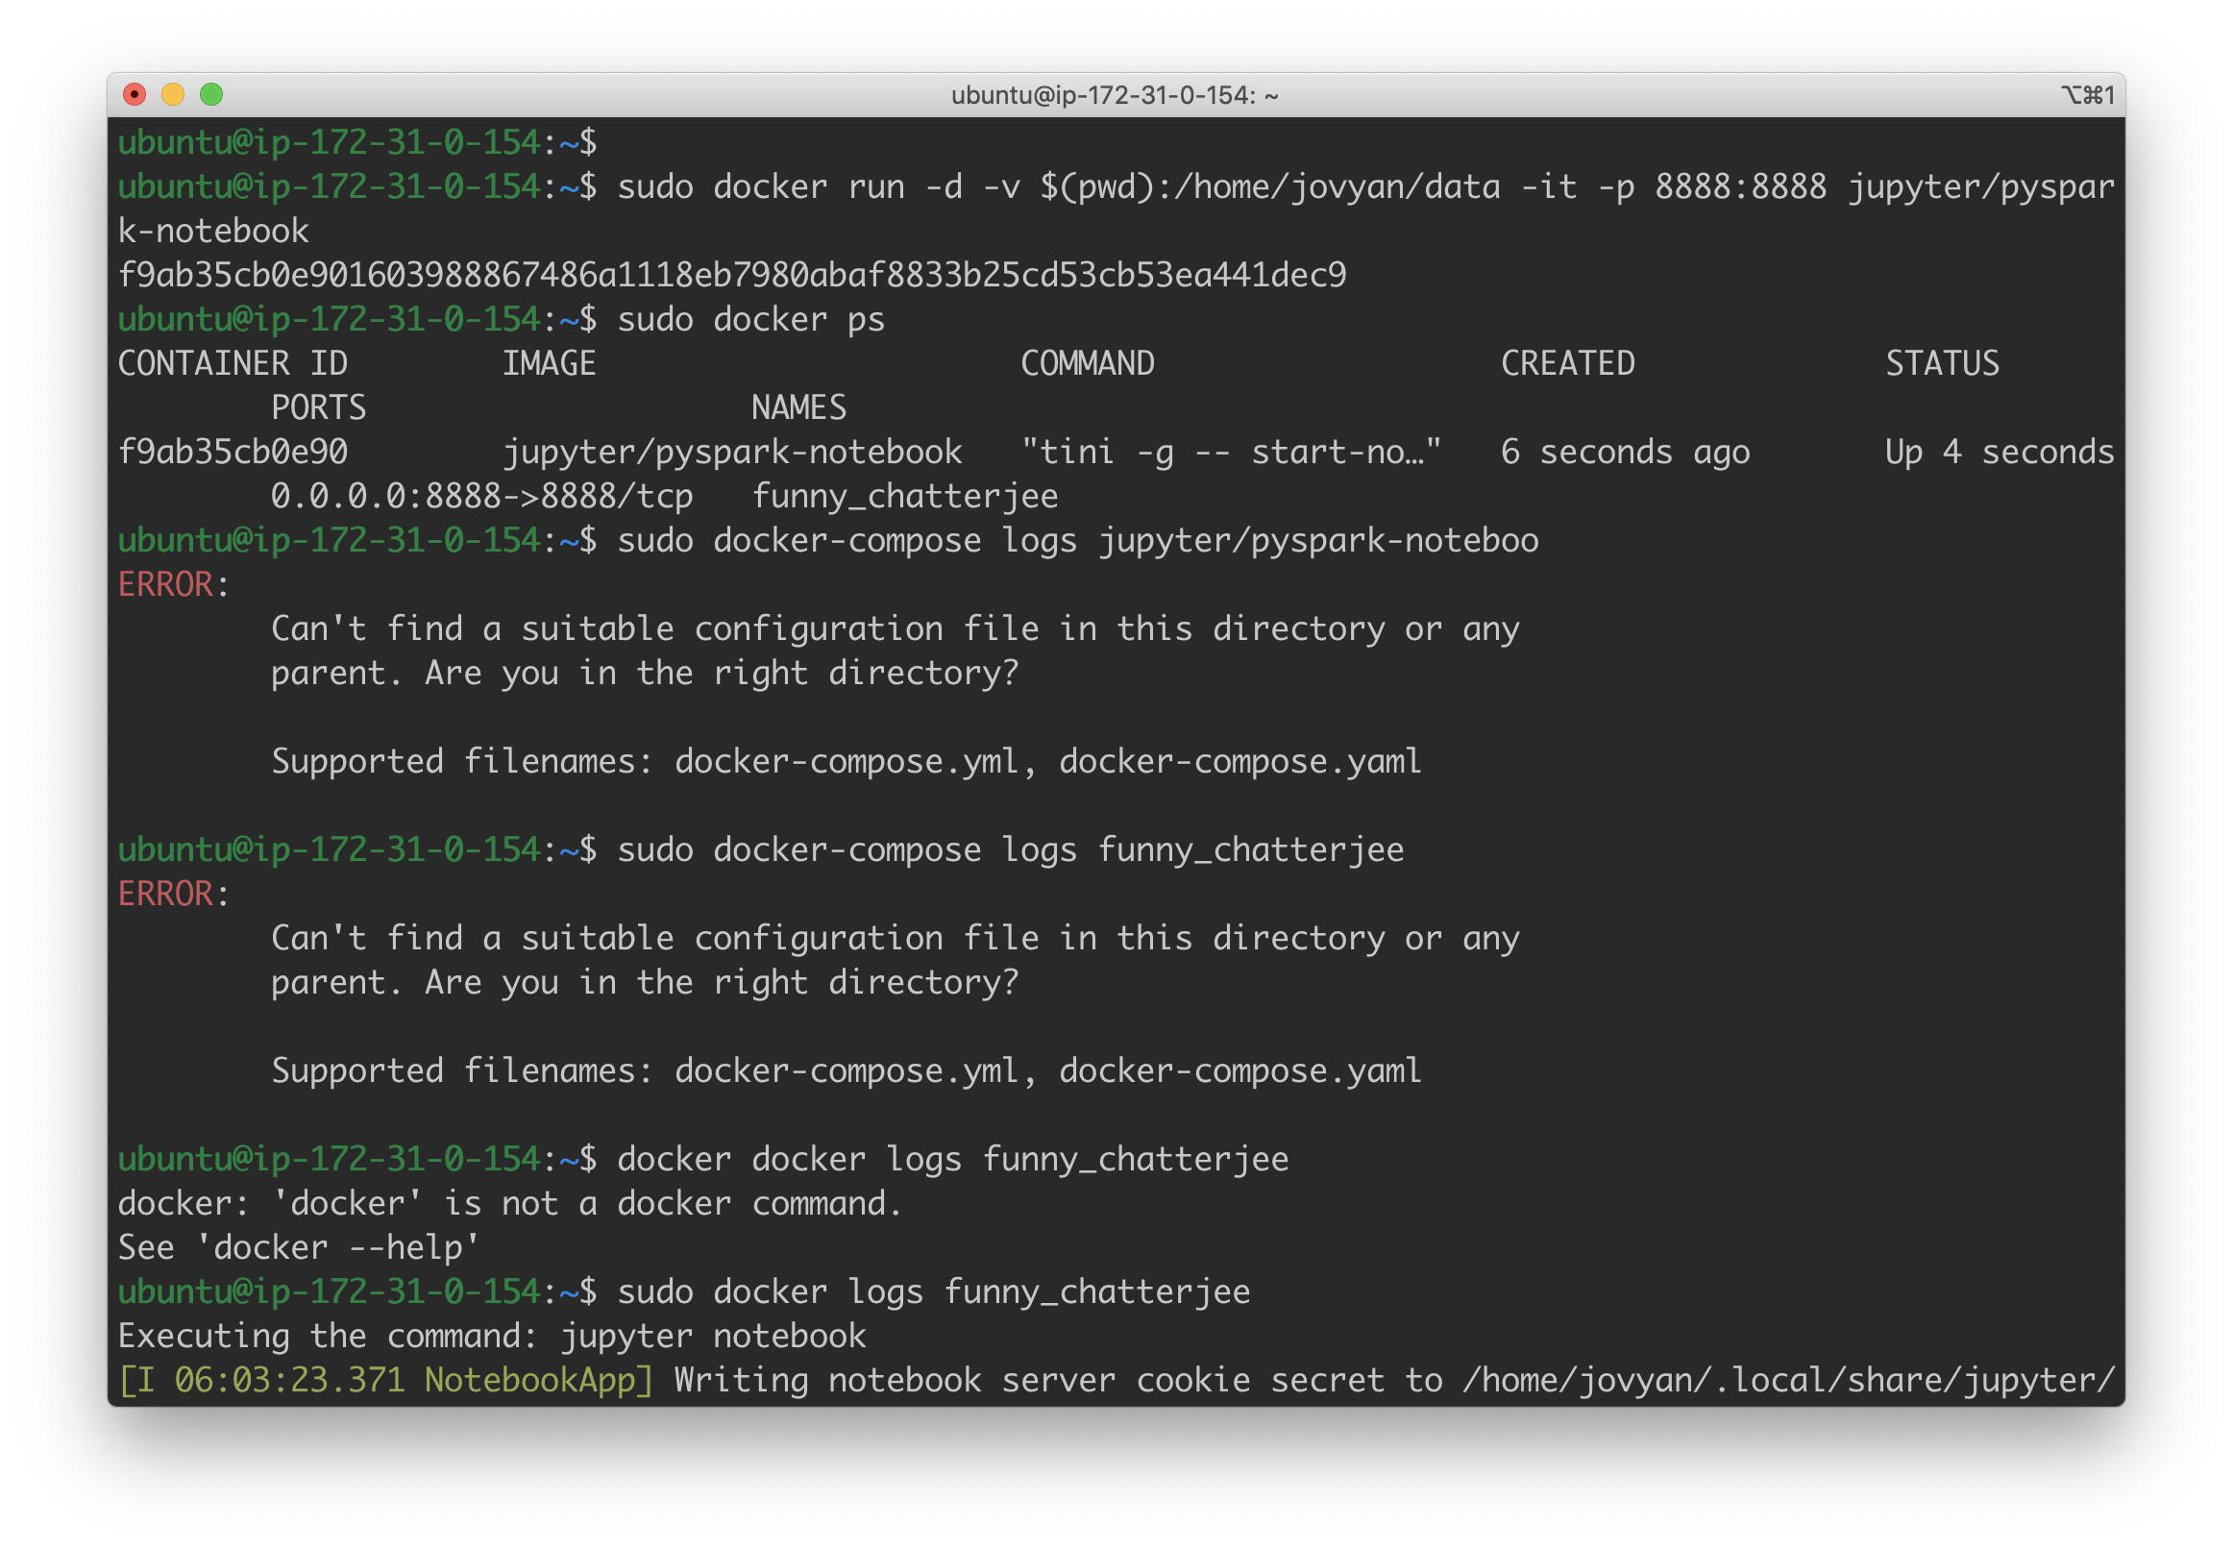

The **sudo docker ps** command is to gut check that our container is indeed running. **TAKE NOTE** of the last item above, **funny_chatterjee** is the **name** of our container. We will leverage this to access logs:

**sudo docker logs funny_chatterjee**

This is needed to once again access the token to log in (everytime jupyter is restarted, a new token is generated. For this reason, we are running in detached mode).

Reset your password and log in. You should see the following:

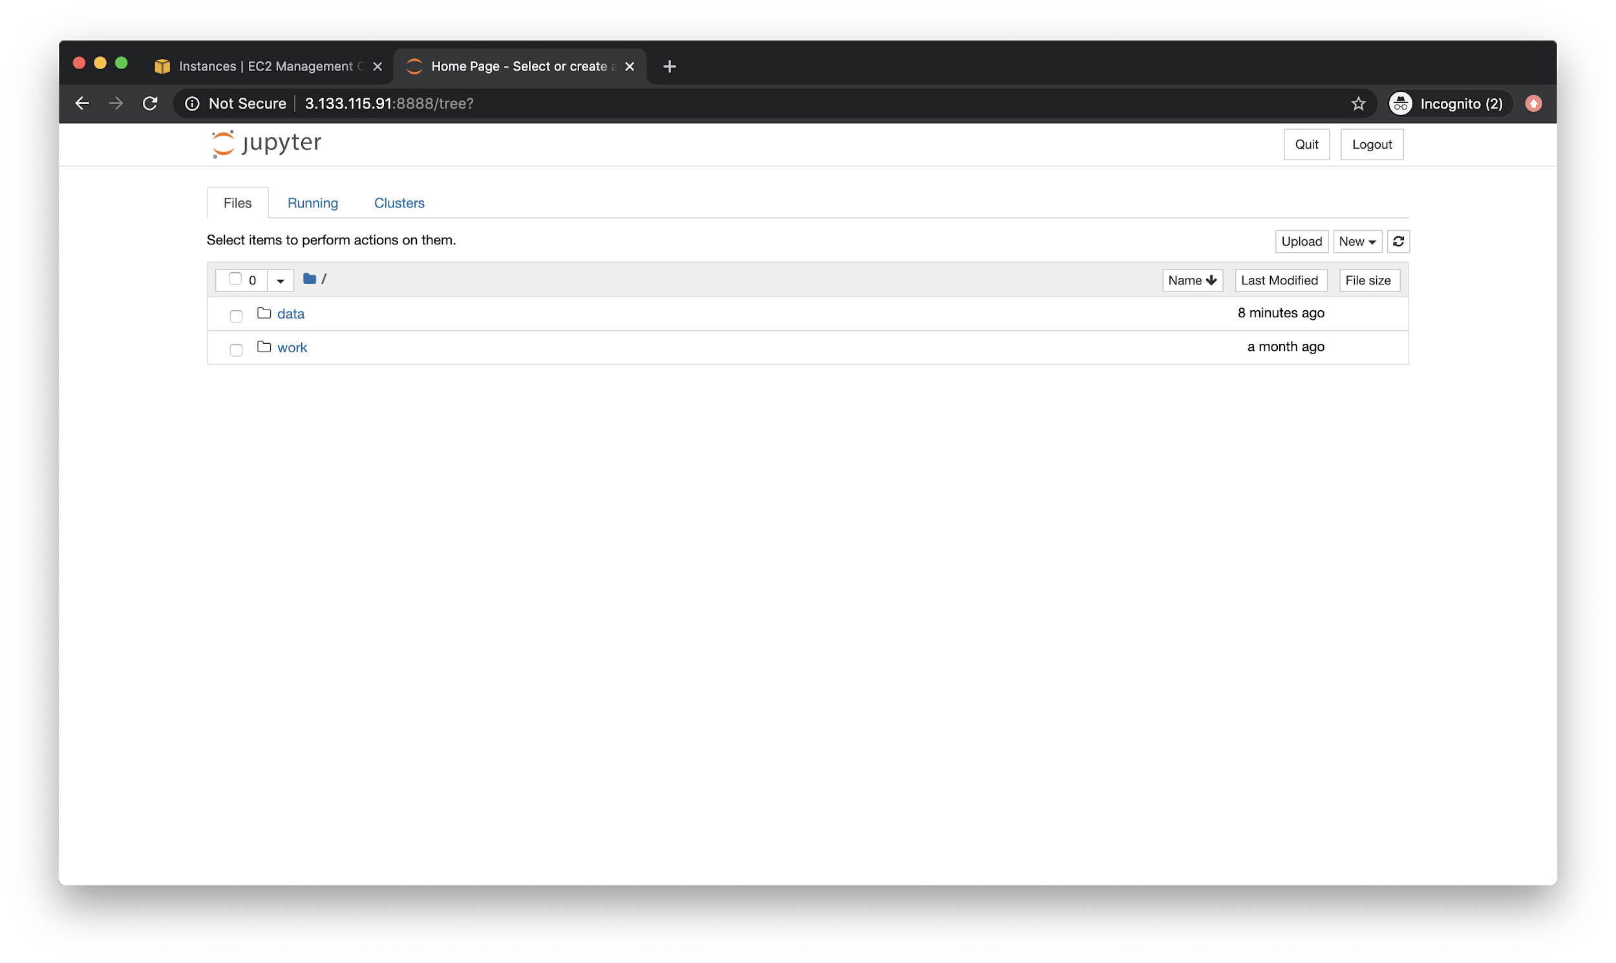

The **data** folder is you will be able to access csv files and other datasets. With that being said, let’s try and load a dataset and do some simple analysis.

Remember, your terminal is now accessible even with jupyter running in the background. Let’s download a citibike dataset (because large and kind of interesting). You can copy the link [here](https://s3.amazonaws.com/tripdata/201908-citibike-tripdata.csv.zip).

Take this link and run a **curl** in your EC2 instance:

**curl https://s3.amazonaws.com/tripdata/201908-citibike-tripdata.csv.zip >> 201908-citibike-tripdata.csv.zip**

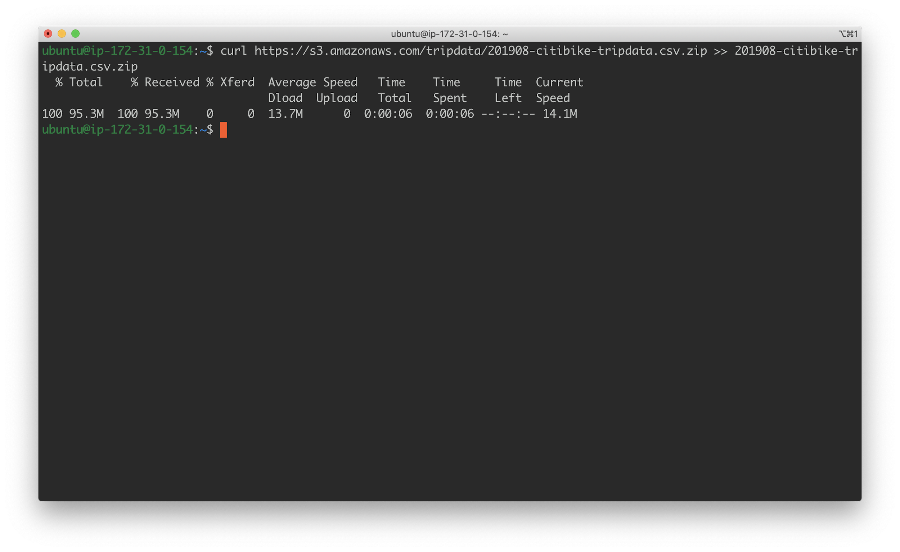

Notice that it is a zipped file. So, first we must unzip it:

**sudo apt install unzip**

This will install the **unzip** utility in our EC2 instance. Then:

**unzip 201908-citibike-tripdata.csv.zip**

Which will actually perform the unzipping.

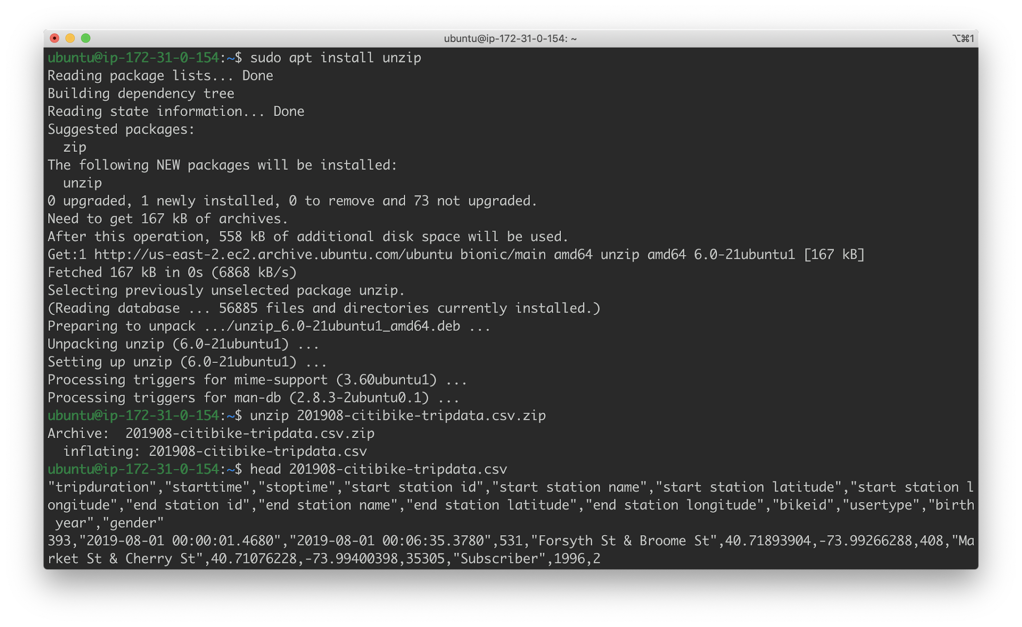

Finally, to test out if this worked, we can run:

**head 201908-citibike-tripdata.csv**

Which will allow us peek into the file itself:

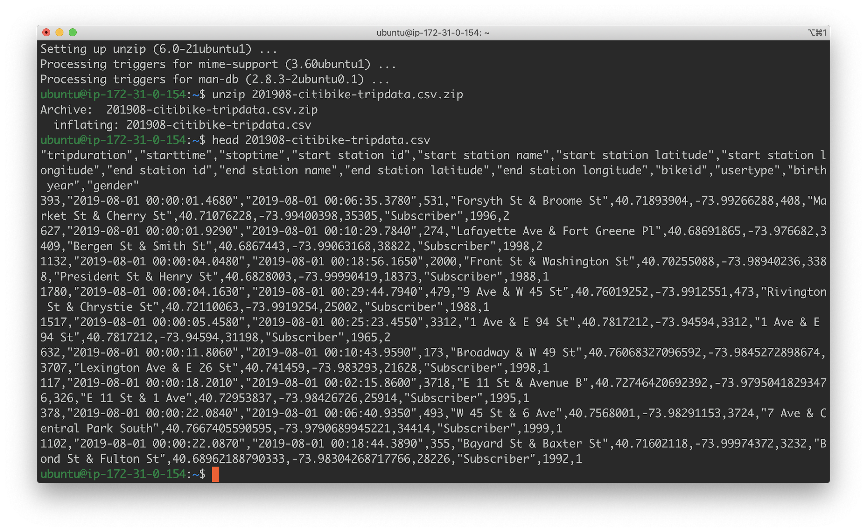

Notice that back in the web browser:

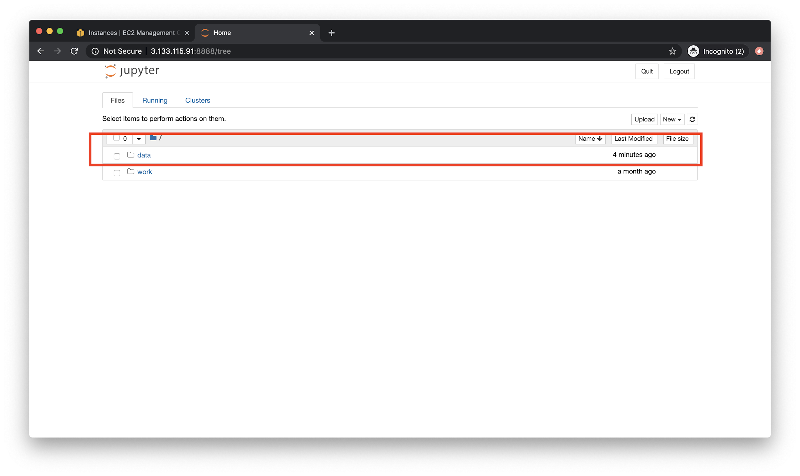

We have a folder called “data” which will reflect the files we download into our EC2 instance:

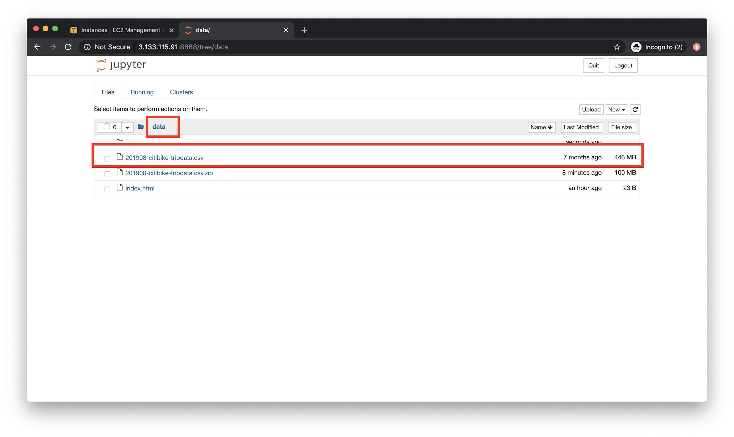

Now - let’s analyze our data here. We will begin by leveraging pandas to demonstrate some basic items and then we will reconsider them again using Apache Spark. To begin, let us quickly recap how we might be able to install external dependencies in Jupyter.

## Installing Dependencies in Jupyter

Installing pip dependencies in jupyter can be a bit of a pain. At the end of the day, you need to do this:

|  |
| --- |
| # Install a pip package in the current Jupyter kernel **import** sys !{sys.executable} -m pip install numpy |

Generally, it is good practice to do this all in one block - at the top of your notebook.

# Simple CitiBike Analysis

Let’s analyze this dataset. First, with pandas.

## Pandas Analysis

Create a new notebook.

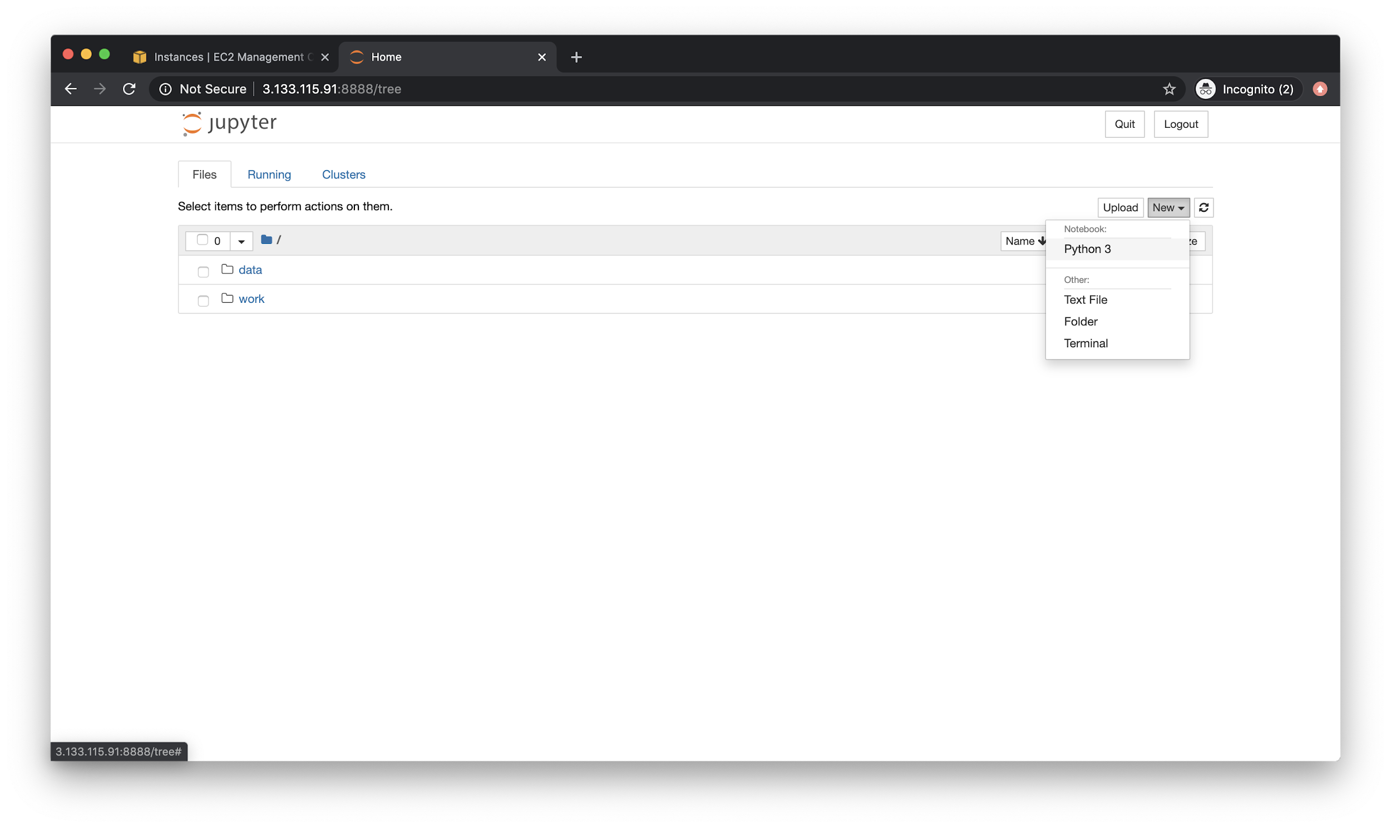

Now, let’s install stuff.

**Cell 1**

|  |
| --- |
| # Install a pip package in the current Jupyter kernel **import** sys !{sys.executable} -m pip install numpy !{sys.executable} -m pip install pandas !{sys.executable} -m pip install matplotlib |

**Cell 2**

|  |
| --- |
| **import** pandas **as** pd  **import** numpy **import** matplotlib.pyplot **as** plt   %matplotlib inline |

Should look like this:

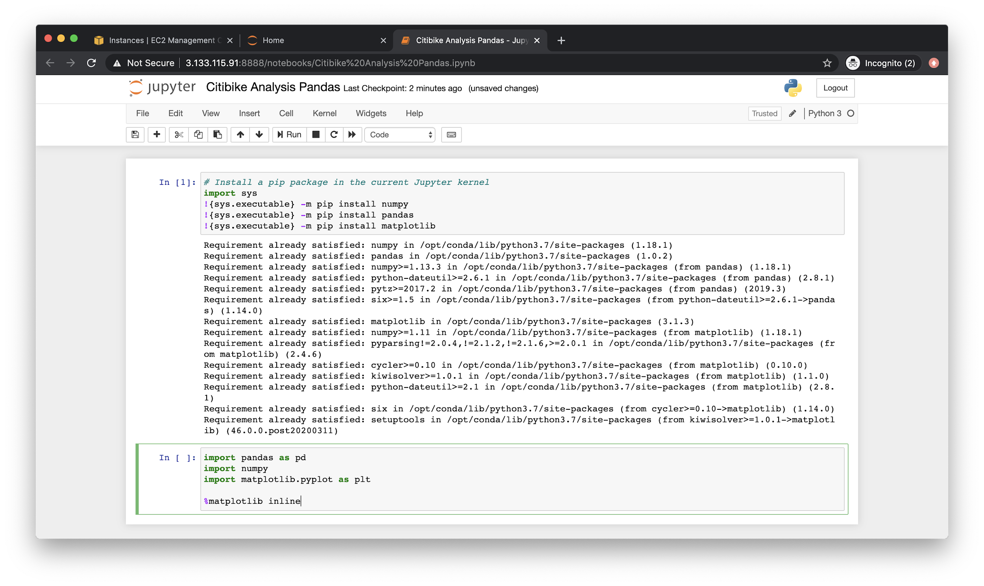

One common gotcha here is that the dataset might just be too large for the EC2 instance to manage. At which point you may see the system hang or just present with the following error (eventually)

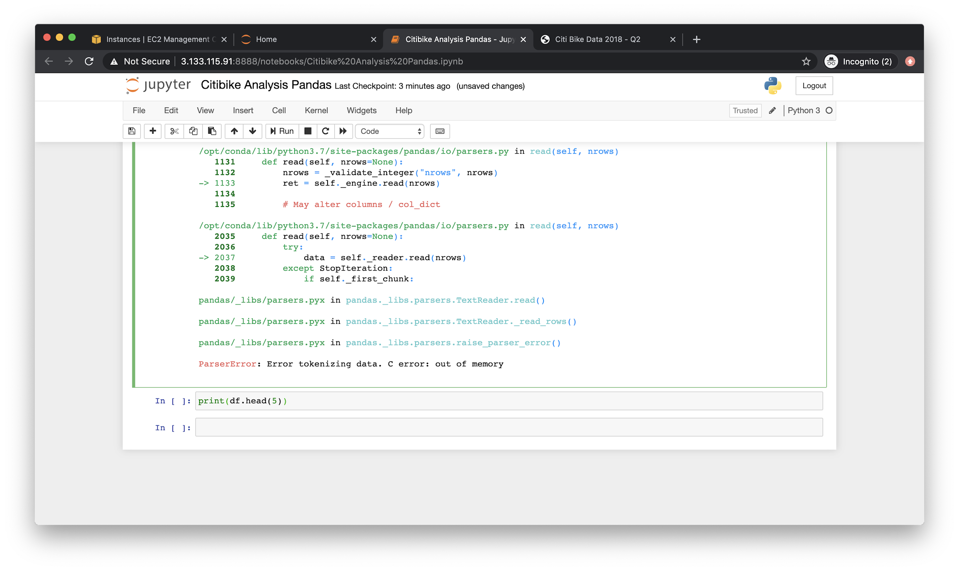

In these instances, for now - let’s just use a smaller dataset. I switched to the following:

|  |
| --- |
| curl https://s3.amazonaws.com/tripdata/JC-201811-citibike-tripdata.csv.zip >> JC-201811-citibike-tripdata.csv.zip  unzip JC-201811-citibike-tripdata.csv.zip  head JC-201811-citibike-tripdata.csv |

And success! (Heads up, if issue persists, just increase the power in EC2)

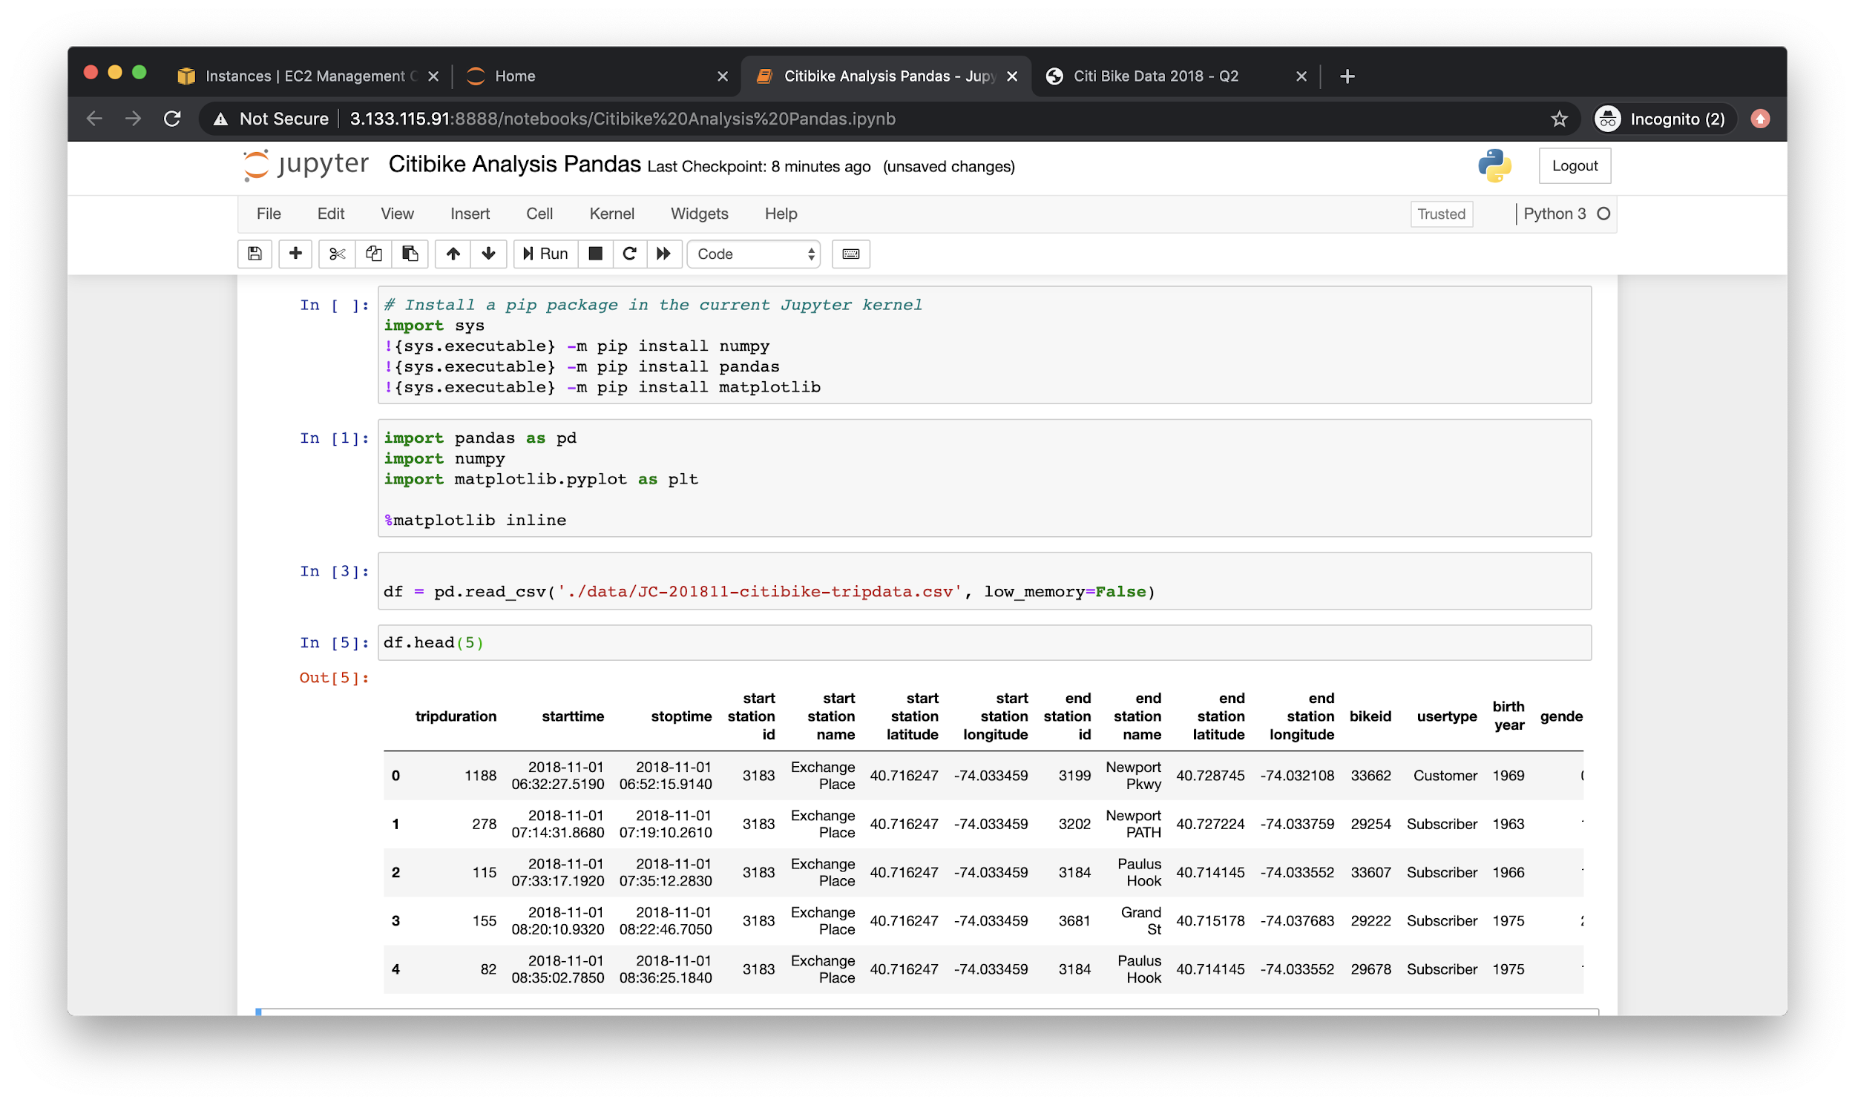

If interested, you ought to time how long it took for that dataframe to manifest:

|  |
| --- |
| **import** time  now = time.time() df = pd.read_csv('./data/JC-201811-citibike-tripdata.csv', low_memory=**False**) time.time() - now |

Note also the relative path to **data**.

Let’s figure out what the top 5 destination stations are:

|  |
| --- |
| df['end station name'] \  .value_counts() \  .sort_values(ascending=**False**) \  .head(5) |

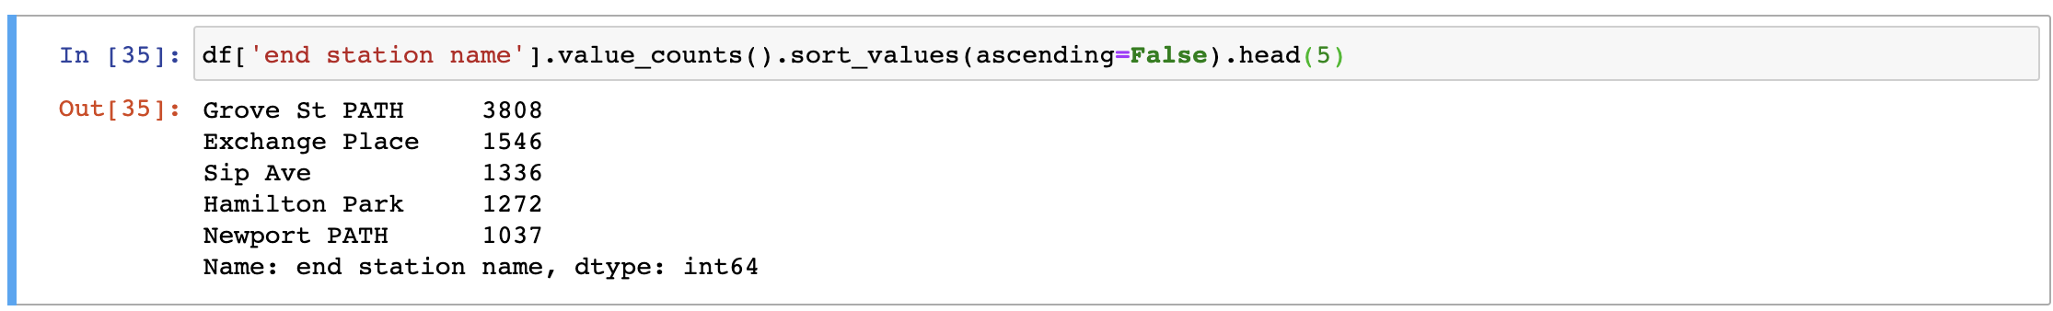

And plotting it

|  |
| --- |
| df['end station name'] \  .value_counts() \  .sort_values(ascending=**False**) \  .head(5) \  .plot \  .bar() |

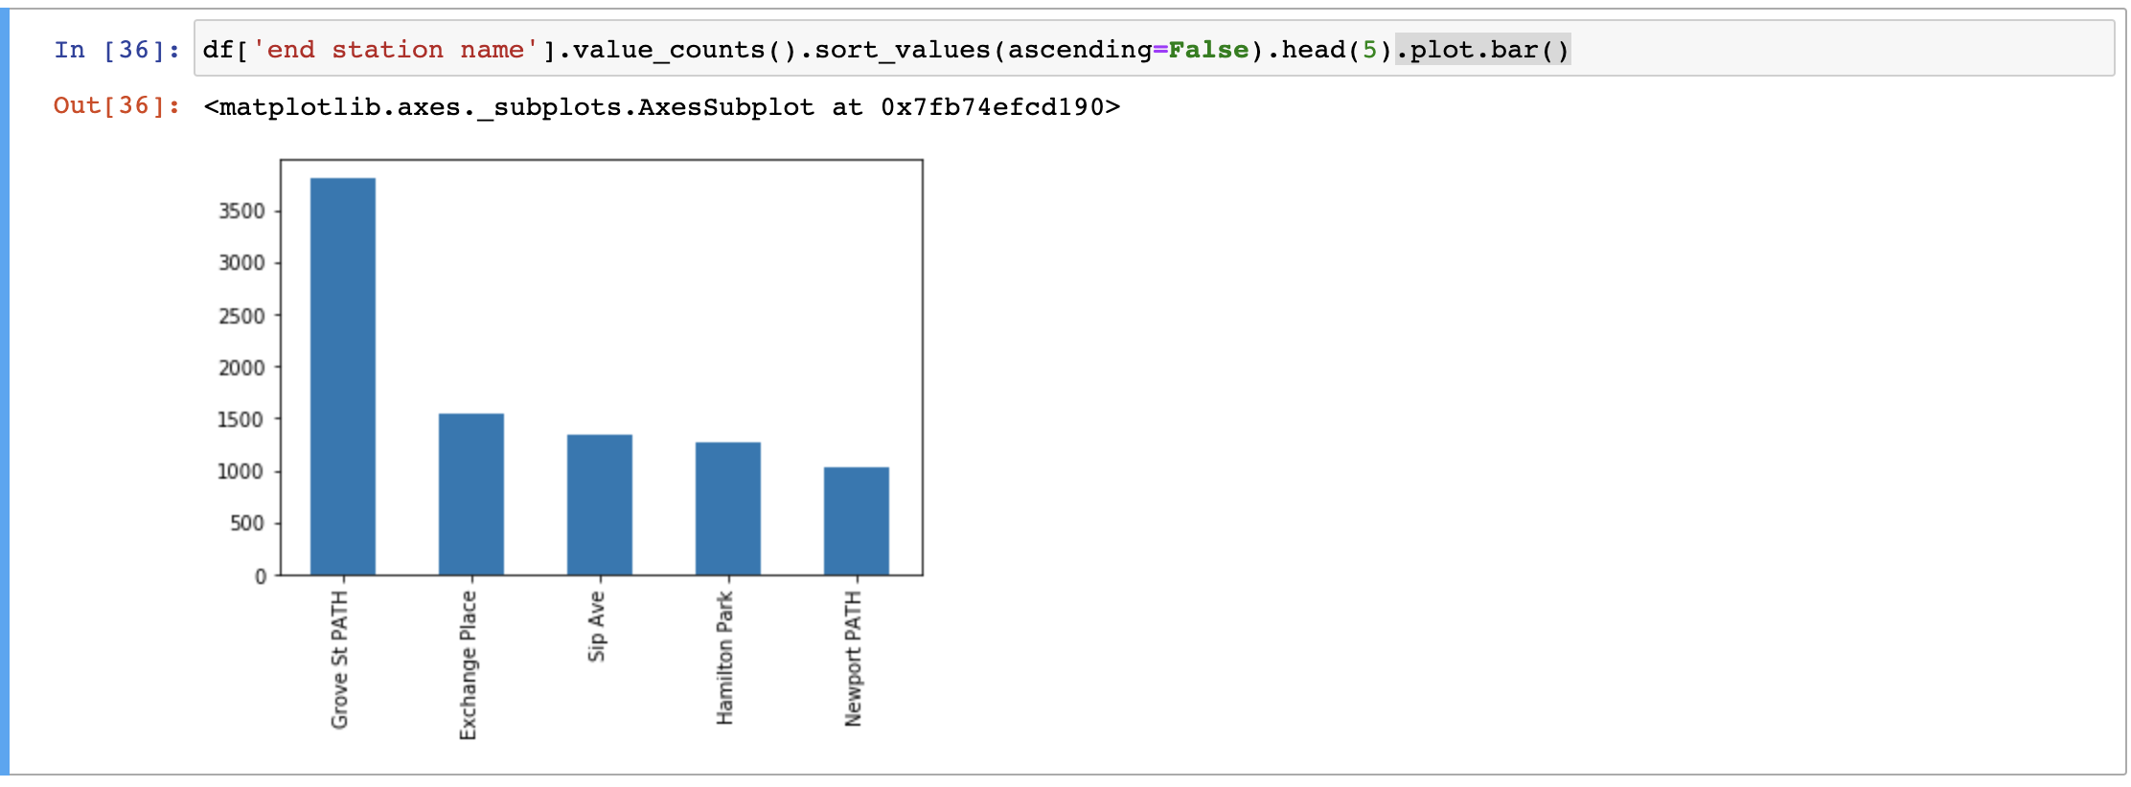

## Spark Analysis

Now, let’s run this again - but with spark. In the same notebook, run:

|  |
| --- |
| **from** pyspark.sql **import** SparkSession # create sparksession spark = SparkSession \  .builder \  .appName("CitibikeAnalysis") \  .getOrCreate() |

This starts a Spark session. Now, let’s create a spark dataframe:

|  |
| --- |
| df = spark.read.csv('./data/JC-201811-citibike-tripdata.csv', header='true', inferSchema = **True**) |

The **df.columns** property shows us columns, just like in pandas:

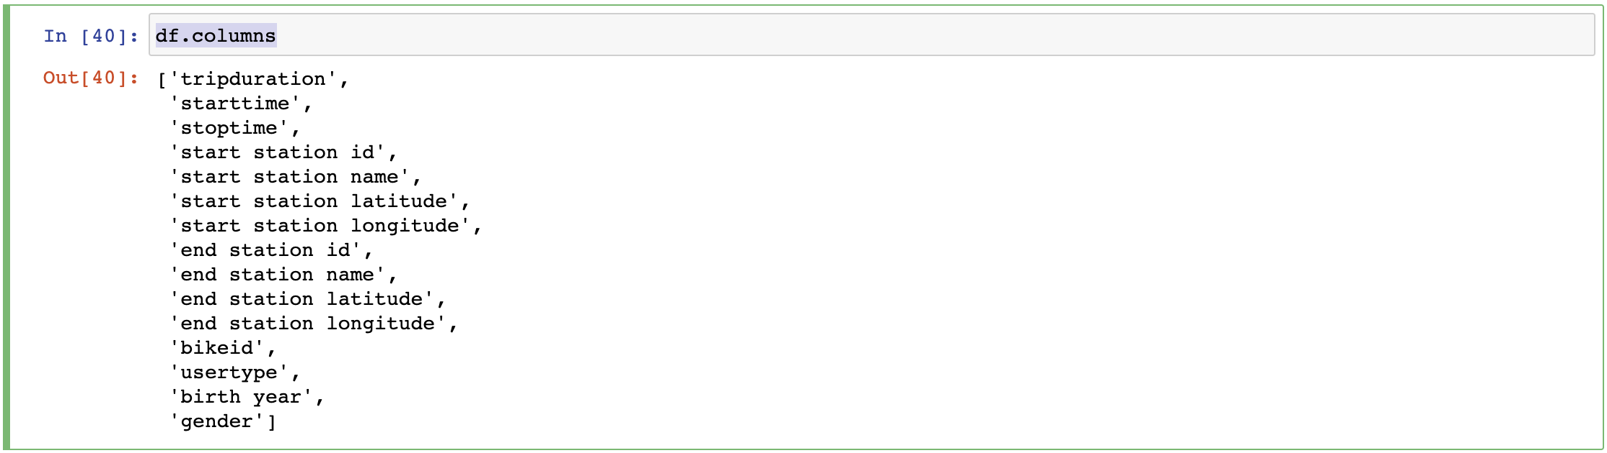

And we can view the top 5 items with:

|  |
| --- |
| df.show(5) |

Though it looks a bit gnarly:

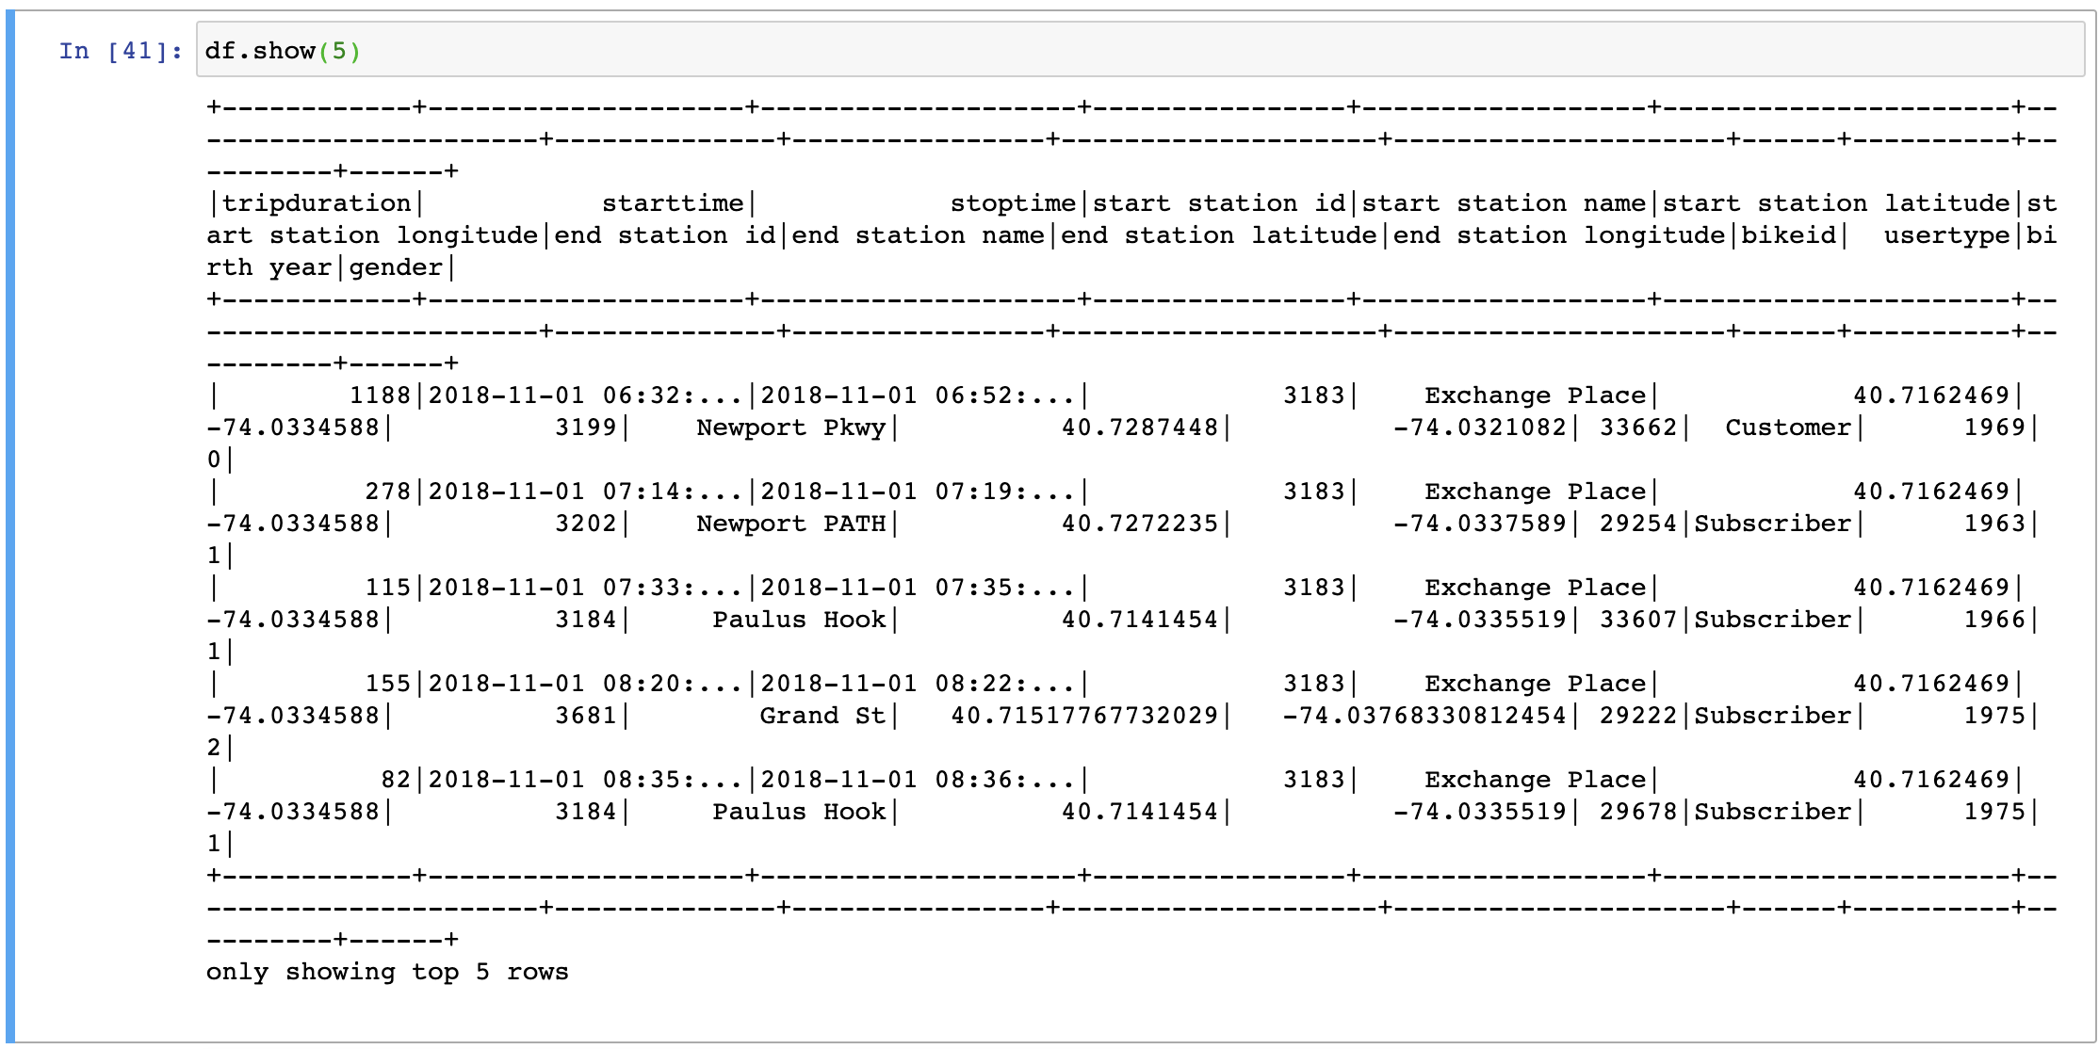

For a prettier view, consider using **df.head(n)** instead.

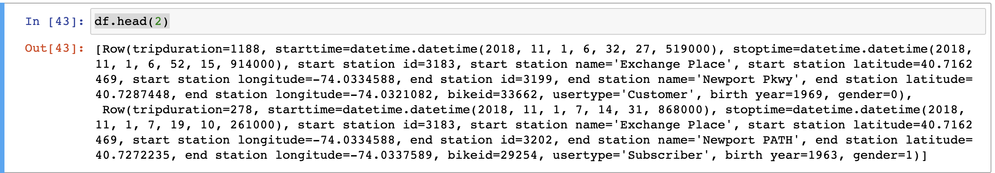

To select a column (or columns), we can leverage:

|  |
| --- |
| df.select('end station name').show(10) |

The output looks something like:

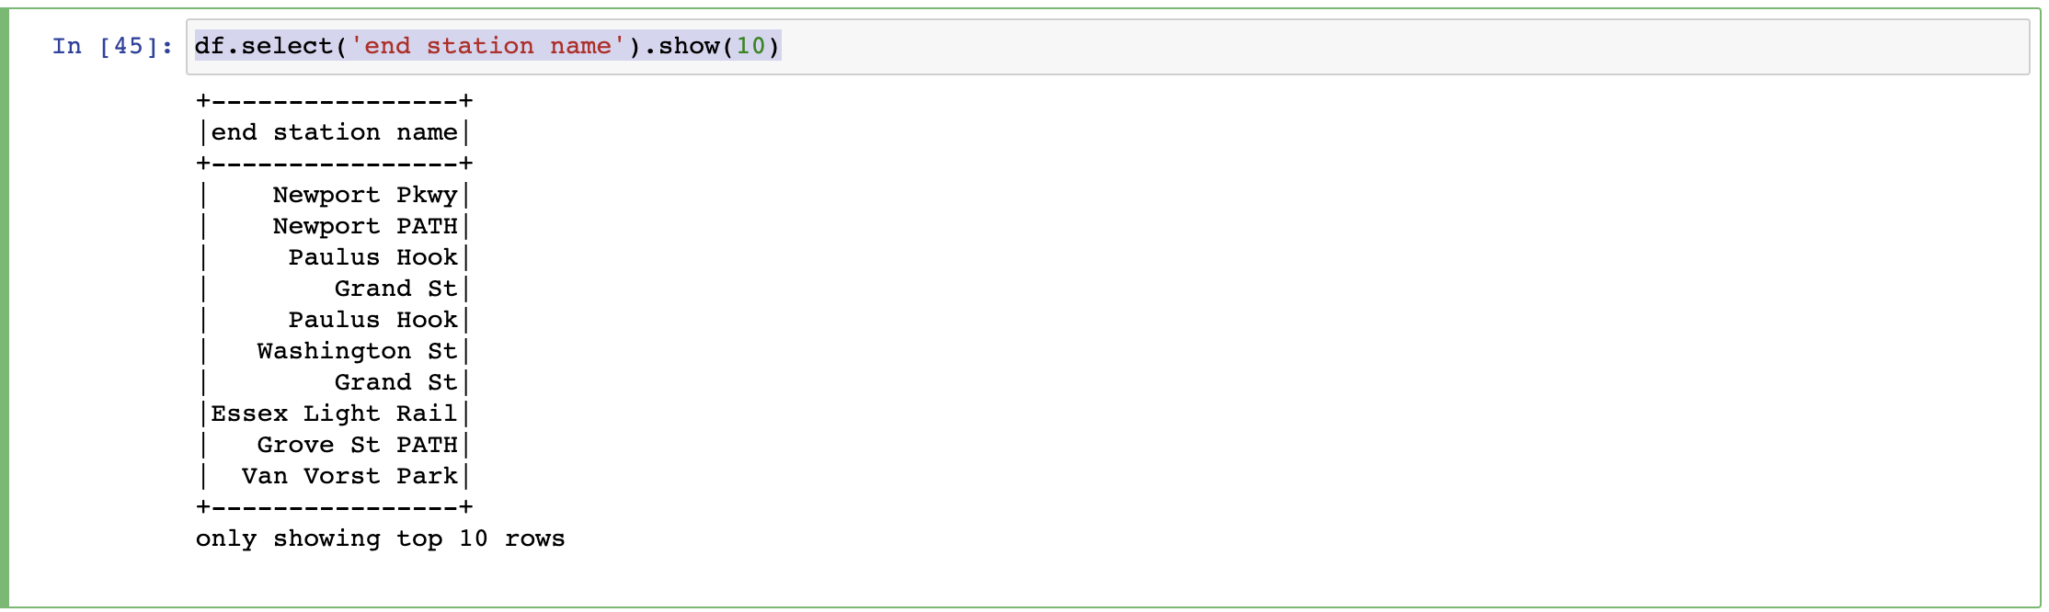

To recreate our pandas query we simply:

|  |
| --- |
| df.groupBy('end station name').count().orderBy('count', ascending=**False**).show(5) |

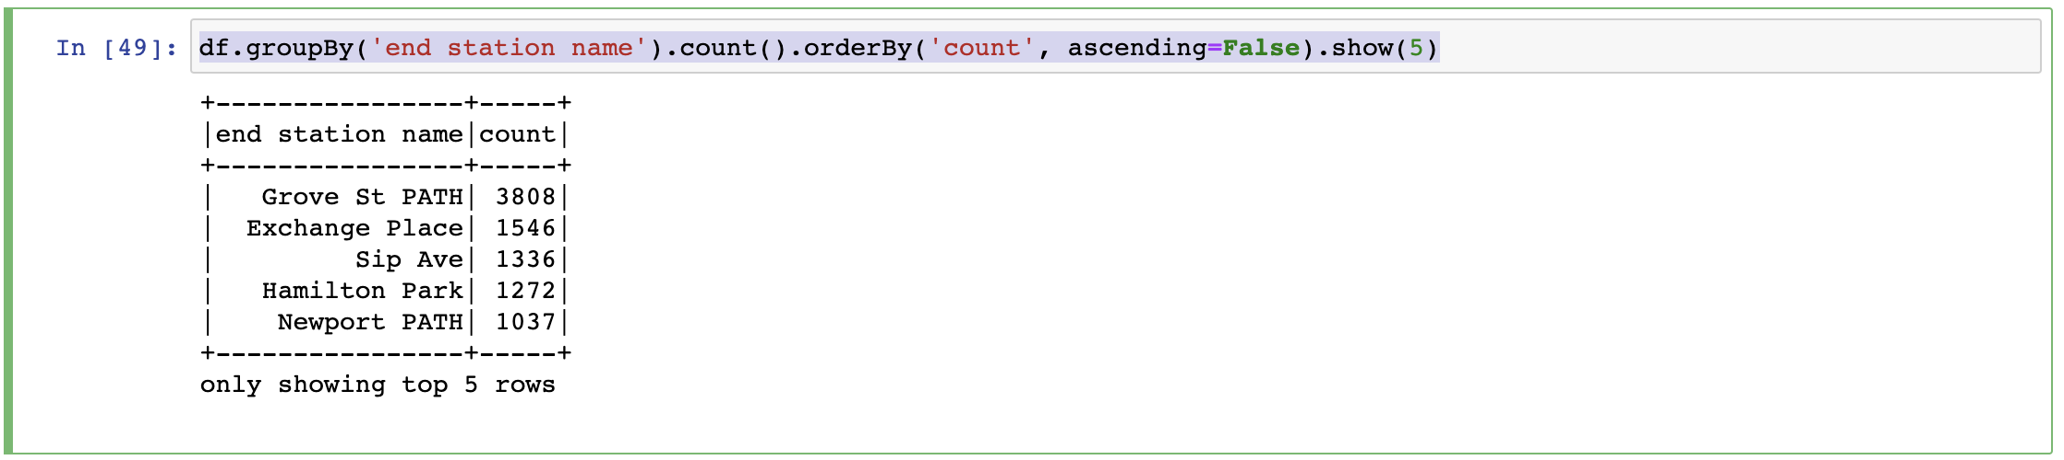

Finally, to plot this, convert to pandas:

|  |
| --- |
| pdf = df.groupBy('end station name').count().orderBy('count', ascending=**False**).toPandas() pdf.head(5).plot.bar() |

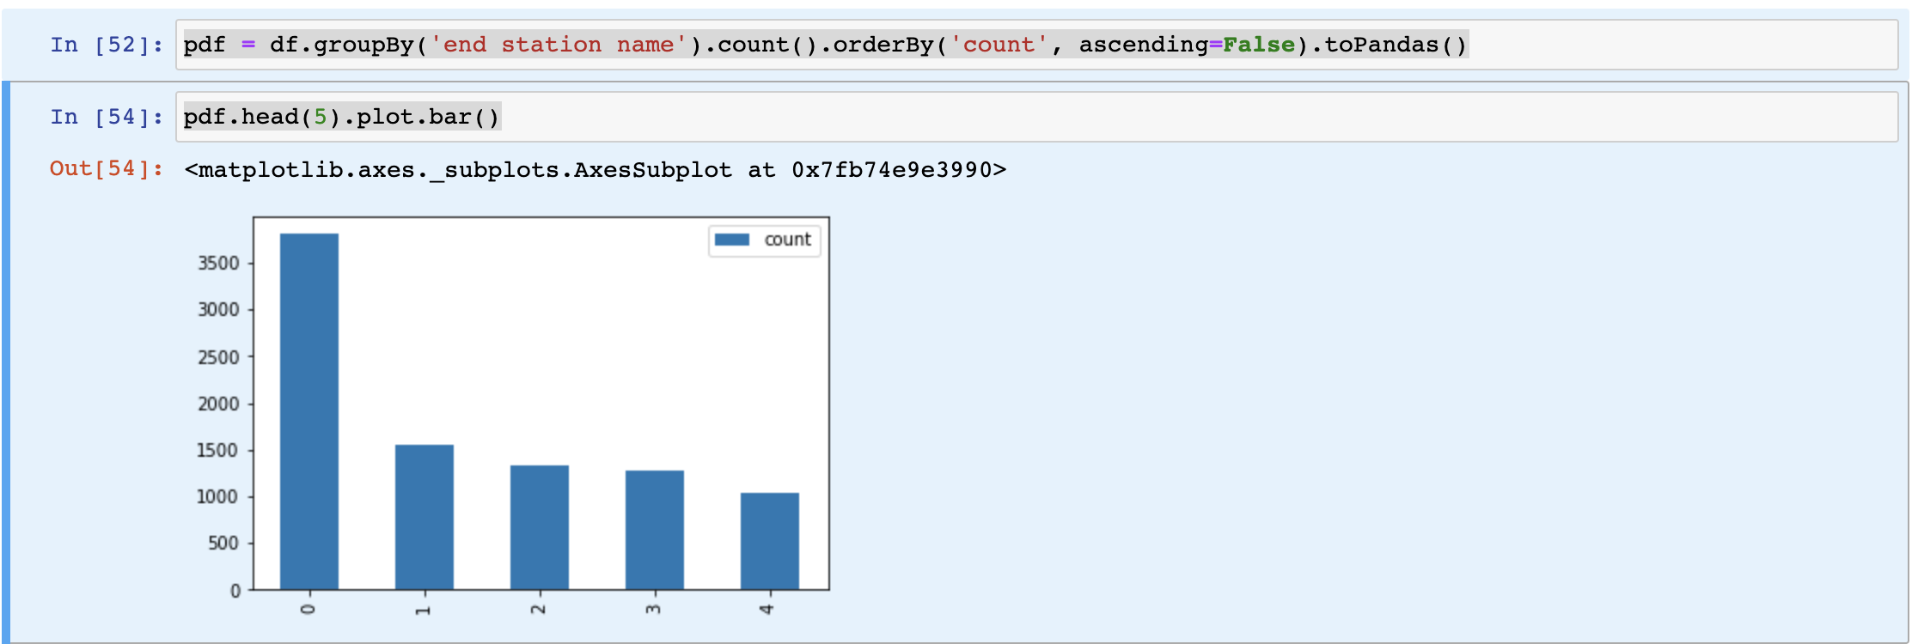

## Spark SQL Analysis

The final neat thing here is, we can also use **spark.sql** to accomplish this same task.

|  |
| --- |
| df.createOrReplaceTempView('Citibike') spark.sql( ''' SELECT `end station name` FROM Citibike LIMIT 10 ''' ).show() |

**df.createOrReplaceTempView('Citibike')** creates a temporary table representing the dataframe that we can then operate over. The sql above simply selects all **`end station name`** items from the dataframe.

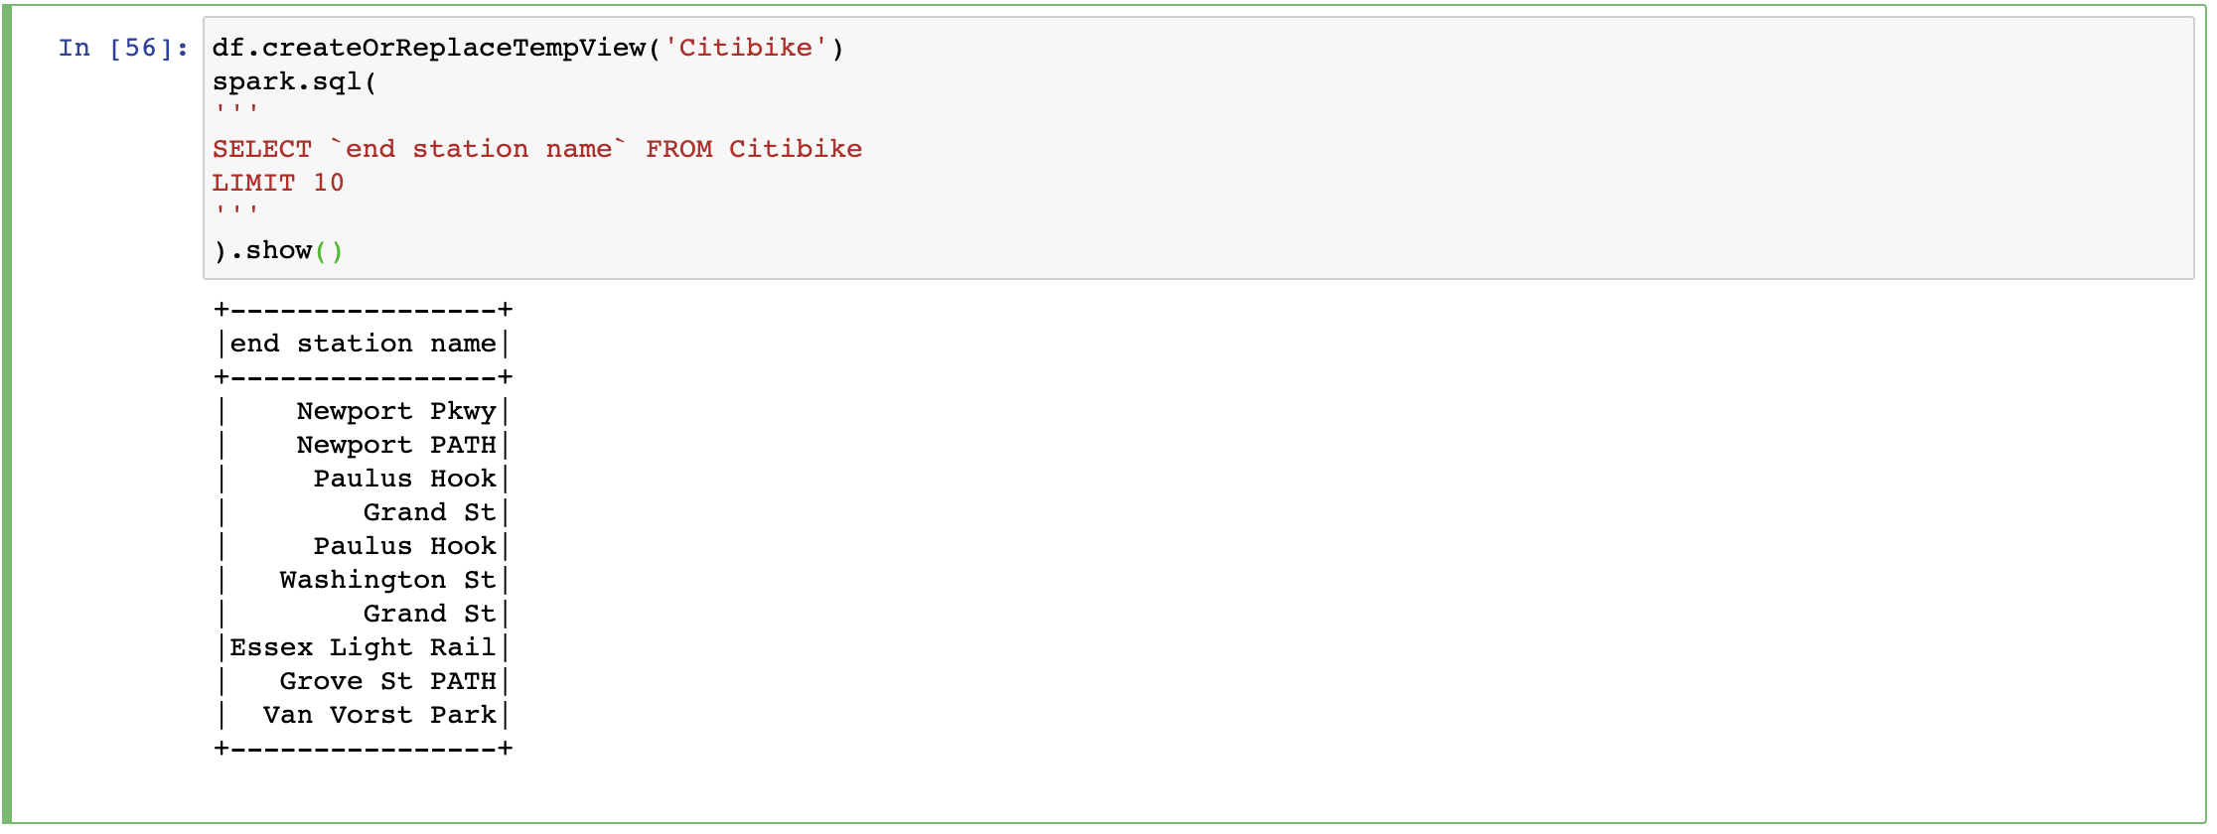

We can accomplish the exact same operation we did with dataframes (in spark) with:

|  |
| --- |
| spark.sql( ''' SELECT `end station name`, COUNT ( `end station name`) as most_popular_stations FROM Citibike GROUP BY `end station name` ORDER BY most_popular_stations DESC LIMIT 5 ''' ).show() |

Which yields us:

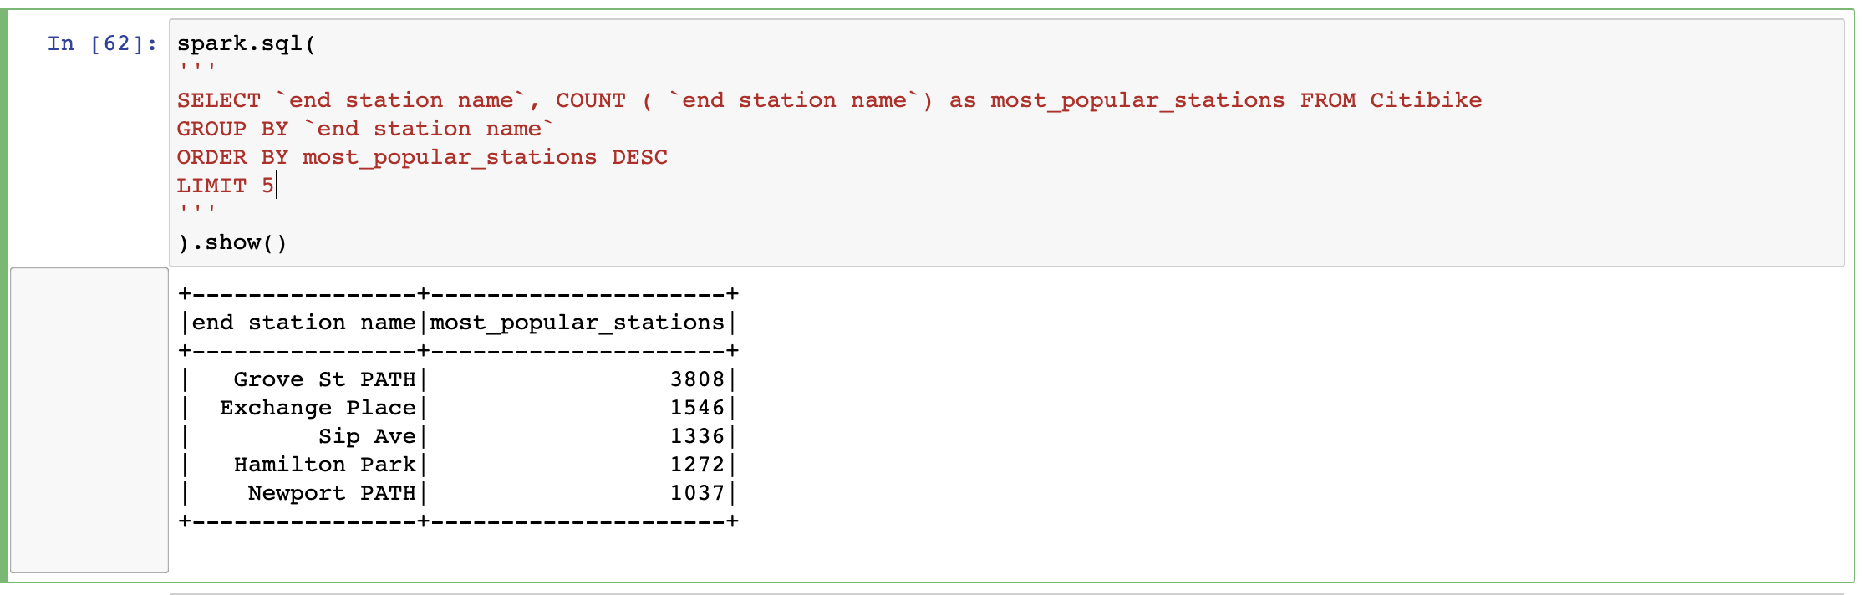

The same results as above. Finally, we can convert this to a pandas dataframe for graphing by:

|  |
| --- |
| sqldf = spark.sql( ''' SELECT `end station name`, COUNT ( `end station name`) as most_popular_stations FROM Citibike GROUP BY `end station name` ORDER BY most_popular_stations DESC LIMIT 5 ''' )  sqldf.toPandas().plot.bar() |

Which results in the same output as above, but now with SQL instead.

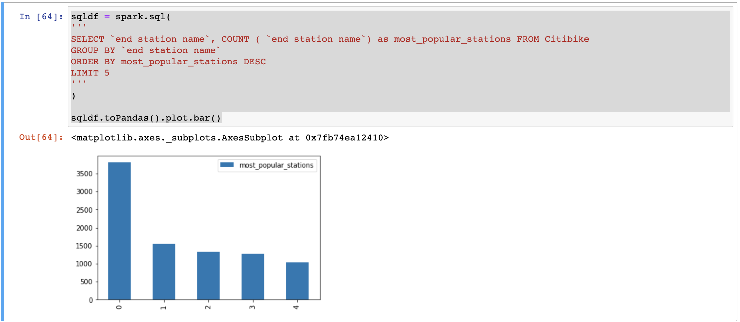

## Resources

* [Citibike Data Resources](https://s3.amazonaws.com/tripdata/index.html)